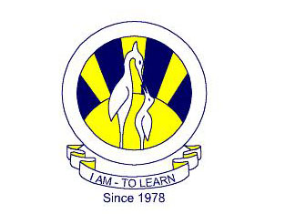
The City School
North Nazimabad Boys Branch

Teacher: Uzma Aamir

Syllabus second scheduled test oct’17
BIOLOGY 9
- DIFFUSION,OSMOSIS AND ACTIVE TRANSPORT
BIOLOGY 10
- EXCRETION
- KIDNEY DIALYSIS

