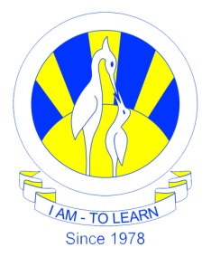
The City School
North Nazimabad Boys Campus
MYE Syllabus Session 2016-17
Date: 16-11-2016
Subject: Biology
Class: 10
Teacher: Humaira Imran
1.Excretion

2.Homeostasis

3.Nervous sytem

4.Hormones

5.Receptor organ

6.Support,movement and locomotion

