The City School
North Nazimabad Boys Campus
Chemistry: revision work sheet
Topic :redox reactions
Class :11
Teacher :Zubaida Aslam

Q1 a Is this a redox reaction? Give your evidence.
A 2Mg (s) + CO2 (g) 2MgO (s) + C (s)
B SiO2 (s) + C (s) Si (s) + CO2 (g)
C NaOH (aq) + HCl (aq) NaCl (aq) 1 H2O (l)
D Fe (s) + CuO (s) FeO (s) + Cu (s)
E C (s) + PbO (s) CO (g) + Pb (s)
b For each redox reaction identify,
i the oxidising agent
ii the reducing agent.

Q2: Potassium chromate(VI) is yellow. In acid it forms
orange potassium dichromate(VI). These are the
ions that give those colours:

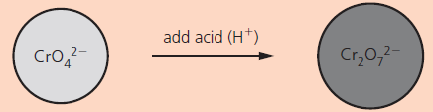

a What is the oxidation state of chromium in:
i the yellow compound?
ii the orange compound?
b This reaction of chromium ions is not a redox reaction. Explain why.

Q3: The oxidising agent potassium manganate(VII) can be used to analyse the % of iron(II) present in iron tablets. Below is an ionic equation, showing the ions that take part in the reaction:

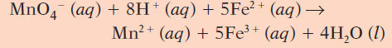

a What does the H+ in the equation tell you this reaction?
b Describe the colour change.
c Which is the reducing reagent in this reaction?
d How could you tell when all the iron(II) had reacted?
e Write the half-equation for the iron(II) ions.

Q4:The oxidation states in a formula add up to zero.
Give the oxidation state of the underlined atom in each formula below:
i aluminium oxide, Al2O3
ii ammonia, NH3
iii H2CO3 (aq), carbonic acid

