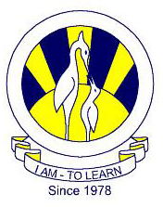
The City School
North Nazimabad Boys Campus

Chemistry class 9
Date: 30-04-2016
Teacher: Uzma Amir

Q.1.choose the best answers:

1. | What system is the heart of?

A. | Circulatory

B. | Respiratory

2. | The circulatory system transfers blood throughout the body

A. | True

B. | False

3. | What does the respiratory system do?

A. | Help you play games

B. | Help you pump blood

C. | Help you breath

D. | Help you eat

4. | The respiratory systems work together

A. | True

B. | False

5. | The stomach is part of your respiratory system

A. | True

B. | False

6. | The right lung is larger than the left slightly

A. | True

B. | False

7. | Do hairs in the nose help to clean air?

A. | Yes

B. | No

8. | How many times a minute does a person breathe a minute at rest

A. | 10-20

B. | 3-6

C. | 9-12

D. | 12-15

9. | The breathing rate in adults is faster than children

A. | True

B. | False

10. | How many times does a average persons heart beat in their lifetime?

A. | 2 million

B. | 1 thousand

C. | 20 billion

D. | 3 billion

11. | Within a tiny droplet of blood how many blood cells are there?

A. | 50 million

B. | 10 thousand

C. | 5 million

D. | 1 billion

12. | About 8 million blood cells die in the human body every second

A. | True

B. | False
13. Ribs moves upwards and outwards when we
A. inhale
B. exhale
C. digestion
D. defecate
14. More than half of total blood volume is the
A. red and blood cells
B. plasma
C. platelets
D. all of them
15. Special organ in mammals, birds and reptiles is
A. lungs
B. air sacs
C. stomata
D. spiracles
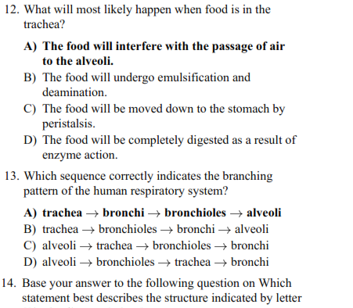
16

17

18
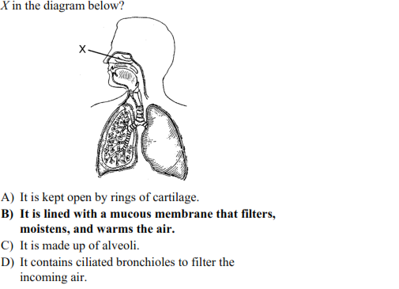

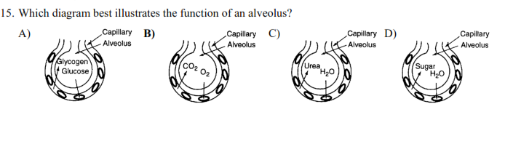
19

20

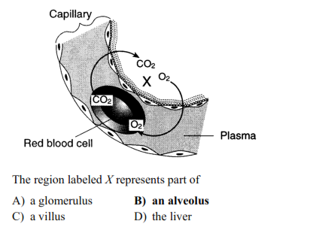

Q.2. Answer the following questions?

What is the anatomical reason for the left bronchus to be more elevated than the right bronchus? When children breathe in foreign materials, why is the object most often found in the right bronchus?

Which respiratory muscles are present in mammals?

How are inhalation and exhalation carried out?

What is hematosis? Where does hematosis occur in humans?

