The City School
BLOG WORKSHEET
BIOLOGY CLASS 9

Teacher Name: Uzma Amer Class: 9 Biology Date: 19-1-19
Q.1. In an experiment to investigate starch production by a plant, three similar plants, each with variegated(green and white) leaves were set up as shown I fig 2.1

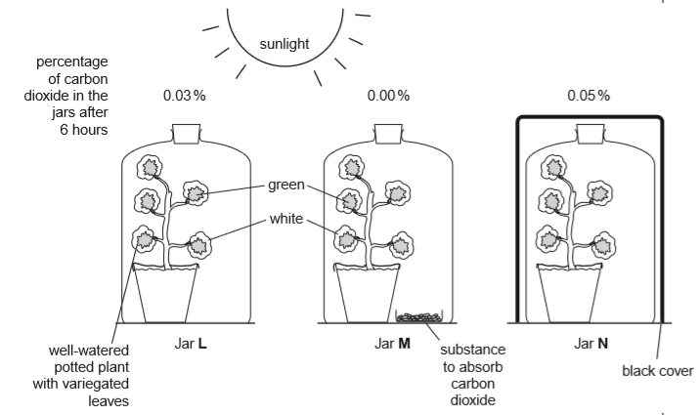
Fig 2.1
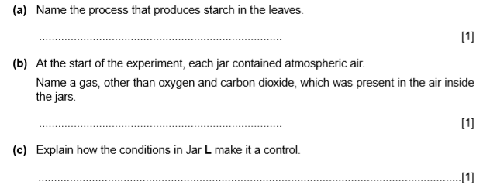r