The City School
BLOG WORKSHEET
BIOLOGY CLASS 9

Teacher Name: Uzma Amer Class: 9 Biology Date: 1st Dec’18

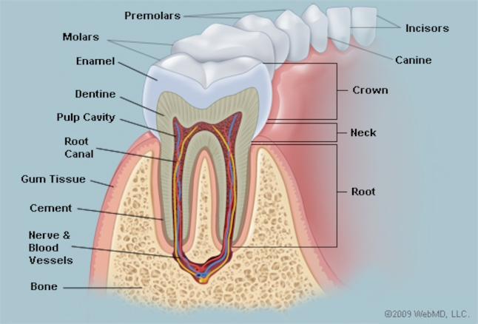

The teeth are the hardest substances in the human body. Besides being essential for chewing, the teeth play an important role in speech. Parts of the teeth include:
• Enamel: The hardest, white outer part of the tooth. Enamel is mostly made of calcium phosphate, a rock-hard mineral.
• Dentin: A layer underlying the enamel. It is a hard tissue that contains microscopic tubes. When the enamel is damaged, heat or cold can enter the tooth through these paths and cause sensitivity or pain.
• Pulp: The softer, living inner structure of teeth. Blood vessels and nerves run through the pulp of the teeth.
• Cementum: A layer of connective tissue that binds the roots of the teeth firmly to the gums and jawbone.
• Periodontal ligament: Tissue that helps hold the teeth tightly against the jaw.
A normal adult mouth has 32 teeth, which (except for wisdom teeth) have erupted by about age 13:
• Incisors (8 total): The middlemost four teeth on the upper and lower jaws.
• Canines (4 total): The pointed teeth just outside the incisors.
• Premolars (8 total): Teeth between the canines and molars.
• Molars (8 total): Flat teeth in the rear of the mouth, best at grinding food.
• Wisdom teeth or third molars (4 total): These teeth erupt at around age 18, but are often surgically removed to prevent displacement of other teeth.
The crown of each tooth projects into the mouth. The root of each tooth descends below the gum line, into the jaw.

Teeth Conditions
- Cavities (caries): Bacteria evade removal by brushing and saliva and damage the enamel and deeper structures of teeth. Most cavities occur on molars and premolars.
- Tooth decay: A general name for disease of the teeth, including cavities.
- Periodontitis: Inflammation of the deeper structures of the teeth (periodontal ligament, jawbone, and cementum). Poor oral hygiene is usually to blame.
- Gingivitis: Inflammation of the surface portion of the gums, around and between the crowns of the teeth. Plaque and tartar buildup can lead to gingivitis.
- Plaque: A sticky, colorless film made of bacteria and the substances they secrete. Plaque develops quickly on teeth after eating sugary food, but can be easily brushed off.
- Tartar: If plaque is not removed, it mixes with minerals to become tartar, a harder substance. Tartar requires professional cleaning for removal.
- Overbite: The upper teeth protrude significantly over the lower teeth.
- Underbite: The lower teeth protrude significantly past the upper teeth.
- Teeth grinding (bruxism): Stress, anxiety, or sleep disorders can cause teeth grinding, usually during sleep. A dull headache or sore jaw can be symptoms.
- Tooth sensitivity: When one or more teeth become sensitive to hot or cold, it may mean the dentin is exposed.

