The City School
North Nazimabad Boys Campus

Biology class 9
Date: 30-04-2016
Teacher: Uzma Amir

Q.1. Balance the given equations
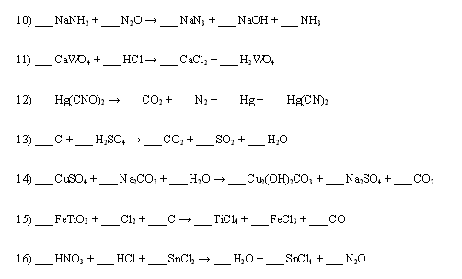
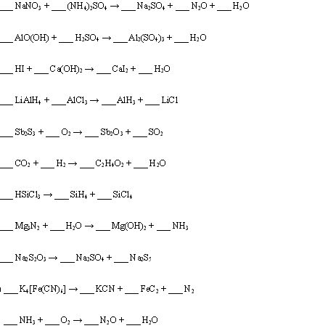
Q.2.choose the best answers:
1. | An alloy is:

A. | A compound

B. | A solution of metals

C. | A solution of gases

2. | In sweetened tea, the sugar is called a:

A. | Solute

B. | Solution

3. | The substance that does the dissolving (the tea), is called a

A. | Solute

B. | Solvent

4. | Na is the chemical symbol for:

A. | Sodium

B. | Tin

C. | Nebraska

5. | C is the chemical symbol for:

A. | Calcium

B. | Carbon

C. | Chlorine

6. | A mixture is two or more substances. It __________ be separated?

A. | Can

B. | Can not

7. | Are mixtures chemically combined?

A. | Yes

B. | No

8. | An Element is a simple pure substance. It __________ be separated?

A. | Can

B. | Can not

9. | A _______________ is two or more elements that are chemically combined.

A. | Element

B. | Compound

C. | Mixture

10. | A compound __________ be separated?

A. | Can

B. | Can not

11. | Are compounds chemically combined?

A. | Yes

B. | No

12. | Carbon Dioxide (CO2) is an ELEMENT?

A. | True

B. | False

13. | An element can be broken down by physical or chemical means.

A. | True

B. | False

14. | Elements, compounds and mixtures are pure substances.

A. | True

B. | False

15. | Frying pans are usually made from non-metals because non-metals are good conductors of heat.

A. | True

B. | False

16. | Helium, which is put in balloons, is less dense than air.

A. | True

B. | False

17. | A compound has different properties than the elements that react to form it.

A. | True

B. | False

18. | Sugar water is an example of a heterogeneous mixture.

A. | True

B. | False

19. | Colloids are mixtures that will settle out.

A. | True

B. | False

22. | A person may put the following on his or her french fried:

A. | NaCl

B. | Sn

C. | HCl

24. | If a drink container tells you to "SHAKE WELL" before drinking, the mixture in the container is most likely a:

A. | Solution

B. | Suspension

C. | Colloid

25. | A _________ ____________ is made of only one type of particle.

A. | Pure substance

B. | Compound

C. | Solution

26. | Check 3 ways to speed up dissolving:

A. | Stirring

B. | Boiling

C. | Freezing

D. | Heating

E. | Filtering

F. | Crushing

G. | Burning

H. | Nothing
Q.3. differentiate between:
- Strong acid and weak acid
- Distillation and fractional distillation.
- Alkali and base
- Compound and mixtures

