Worksheet#1
Chemistry class 9

Teacher Name: Uzma Amer Class: 9 Subject: chemistry Date: 14th April’17

Q.1 (a) Define the following terms:
- Kinetic Energy
- Relative molecular mass
- Electron negativity
- Ionizing Energy
(b).calculate the Relative molecular masses of the given compounds:
- A compound XCl having molecular mass (Mr) of 58.5.Find out Mr of XCO3.
- A compound X2O having molecular mass (Mr) of 62 Find out Mr of X2SO4
- A compound XCl2 having molecular mass (Mr) of 111.Find out Mr of X(NO3)2
Q.3.Look at following diagrams and answers the questions given below:
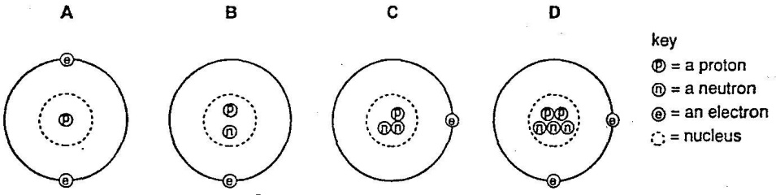
- Which atom has a mass of 5?
- Which atoms are isotopes of each other?
- What is the charge on above atoms?
- Explain your answer of part c.

Worksheet#2
Chemistry class 9

Q.1. Choose the best answers:
- Metals are solids except
- helium
- selenium
- mercury
- Potassium
- Potassium Oxide is formed through
- two potassium ions and one oxygen ion
- one potassium ion and one oxygen ion
- two potassium ions and two oxygen ion
- one potassium ion and two oxygen ion
- In forming an ionic bond in Potassium Fluoride (KF), Potassium ion (K⁺)
- gets a single positive charge
- gets a double positive charge
- gets a single negative charge
- gets a double negative charge
- When an acid (H⁺) is added to alkali (OH⁻), product is
- hydroxides
- water
- salts
- hydrogen gas
- Due to mobile valence electrons,
- metals are rigid
- metals are not rigid
- metals are poor electrolytes
- metals are poor insulators
- K₂O + H₂O →
- K(OH)₃
- KOH
- KOH.H₂O
- KO + H₂ + O₂
- Excess acidity caused by acid rain can be neutralized by adding
- more fertilizers
- by removing acidified soil
- by adding P₂O₅
- by adding limeswer D
- More corrosive acid is
- H₂CO₃
- H₂SO₃
- HNO₃
- C₆H₈O₇
Q.2. Differentiate between:
- Base and Alkali
- Basic and Acidic oxides
- Ionic and Covalent bonding

Worksheet#3
Chemistry class 9

Q.1. choose the best answers:
- Brass is an example of
- An alloy
- a compound
- a mixture
- an elementAnswer A
- A particle may be
- an atom
- a molecule
- an isotope
- all of theseAnswer D
III. Other than O and C, main elements of a brick wall includes
- Silicon (Si)
- Calcium (Ca)
- Aluminum (Al)
- Both A and BAnswer D
IV. Symbol of Magnesium is
- Mg
- Mn
- Hg
- M
Answer A
V.. Naturally occurring elements are
- 82
- 92
- 99
- above 100 by nowAnswer B
VI. Electronic thermometers
- are mercury in glass thermometer
- alcohol in glass thermometer
- are used to reduce risk of mercury poisoning if broken
- are greatly replaced by alcohol in glass thermometerAnswer C
VII. Unit for volumes does not include
- ccm
- cdm
- liters
- tonesAnswer D
VIII. 100 cm³, 250 cm³ and 1 dm³ can be measured using
- measuring cylinder
- beaker
- volumetric flask
- burette
Q.2. Cite four differences between compounds and mixtures:

Worksheet#4
Chemistry class 9
I. Chemical formula of Zinc Hydroxide is
- Zn(OH)₂
- ZNO₂
- Zn₂(OH)₃
- ZnOH
- Valency of Carbon (C) is
- 1
- 2
- 3
- 4
- Chemical formula of silver bromide is
- Ag₂Br₃
- AgBr
- AgBrO
- AgBr₃.H₂O
- Crude oil can be fractionally distillated to produce
- diesel
- petrol
- paraffin
- all of these
- Mixtures have
- a range of boiling points
- a range of melting points
- a lack of exact concentrations
- all of these
Q.2. Look at the given diagram
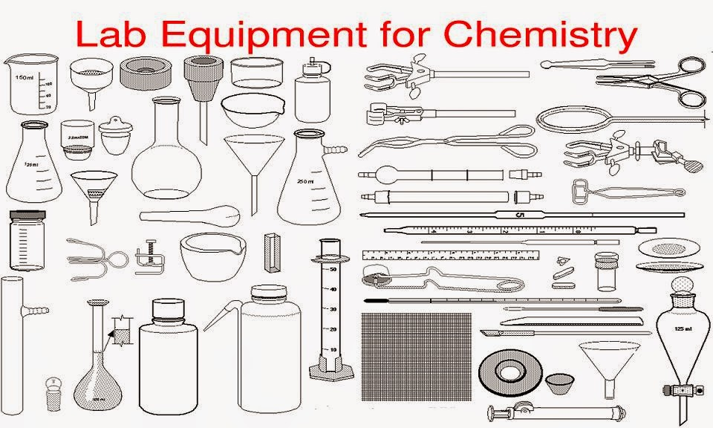
- Identify at least five equipments and write down their names:
- Describe the uses of those equipments:

