Teacher Name: Uzma Amer Class: 9 Subject:Chemistry Date:15-11-18
Q.1. Look at the pictures and give the answers:
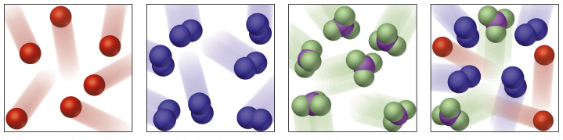
A B C D
- Which picture is showing molecules of an element?_________
- Which picture is showing molecules of a compound? _________
- Which picture does not show a pure substance? ____________
- What is the difference between molecules of elements and compounds?
__________________________________________________________________________________________________________________________________________________________________________________________
Q.3. Choose a substance from the following list to answer the questions below:
Argon, carbon dioxide Air, hydrochloric acid, carbon, iron, bromine, sodium chloride, mercury
Which substance:
- Is a noble gas____________
- Is a liquid metal_____________
- Is a mixture _____________
- Is a metal____________
- Is a solid element________
- Is a salt__________
- Is an acid______________
- Is a liquid non metal______________

Q4 Identify the given substances (element, compound or mixture)
- Ice cream_____________
- Blood______________
- Pure water_______________
- Lime _______________
- Carbon ________________
- Salt_________________
- Orange juice_________________
- Iron _______________
- Air ______________
- Sea water ______________
Q.5. Cite two differences between compounds and mixtures

