The City School
North Nazimabad Boys Campus
Alkane and Alkene
Class11

Teacher: Ms.Zubaida

1:Petroleum is separated into fractions, like this:

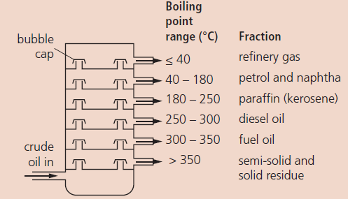

a i What is this process called?
ii It uses the fact that different compounds
have different ……… ………. What is missing?
b i Is naphtha just one compound, or a group of
compounds? Explain.
ii Using the terms evaporation and condensation,
explain how naphtha is produced.
c Give one use for each fraction obtained.
d A hydrocarbon has a boiling point of 200 ° C.
i Are its carbon chains shorter, or longer, than
those found in naphtha?
ii Is it more viscous, or less viscous, than
the compounds found in naphtha?

2:Hex-1-ene is an unsaturated hydrocarbon. It melts
at 2140° C and boils at 63° C. Its empirical formula
is CH2. Its relative molecular mass is 84.
a i To which family does hex-1-ene belong?
ii What is its molecular formula?
b i Hex-1-ene reacts with bromine water. Write
an equation to show this reaction.
ii What is this type of reaction called?
iii What would you see during the reaction?

