REVISION WORKSHEET FOR BLOG
CLASS 9 CHEMISTRY
Q.1. choose the best answers:

- Which of the following has a nucleon (mass) of 3?
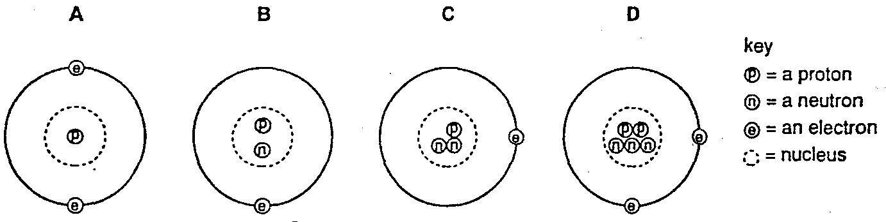

- An atom of any element must contain equal numbers of
A electrons and neutrons.
B electrons and protons.
C neutrons and protons.
D electrons, neutrons and protons.

- How many protons, neutrons and electrons are present in an atom of the element with proton (atomic) number 6 and nucleon (mass) number 14?
 | Protons | neutrons | electrons
A | 6 | 8 | 6
B | 6 | 8 | 8
C | 8 | 6 | 6
D | 8 | 6 | 8

- The Table shows the particles in an atom.
Particle | charge | approximate relative mass
Proton | +1 | 1
Electron |  | 1/2000
Neutron | 0 | 1
Which number completes the table?
A -1 B 0 C +1 D +2

- The diagram shows the electronic structure of an atom. What is the number of protons in the nucleus?
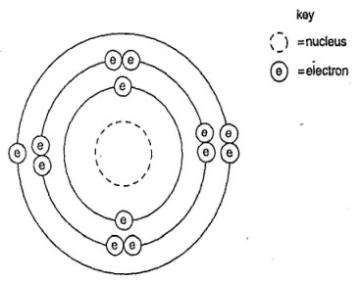
A.7 B.13 C.6 D.8

- Deuterium and tritium are isotopes of hydrogen. What are the correct numbers for X and Y?
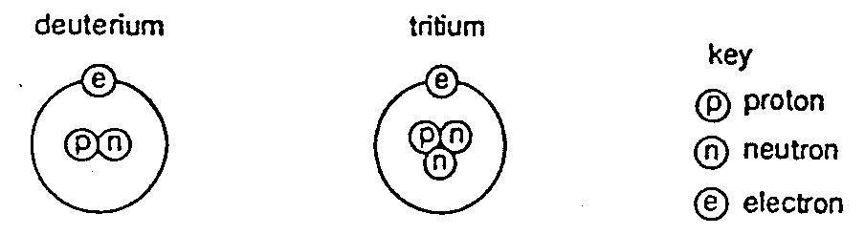

Isotope | number of protons | number of neutrons | number of electrons | nucleon (mass) number
Deuterium | 1 | 1 | 1 | X
tritium | 1 | 2 | 1 | Y

 | X | Y
A  B  C | 1  1  2 | 1  2  3
D | 3 | 4

- Which two diagrams show two different types of atom of the same element?

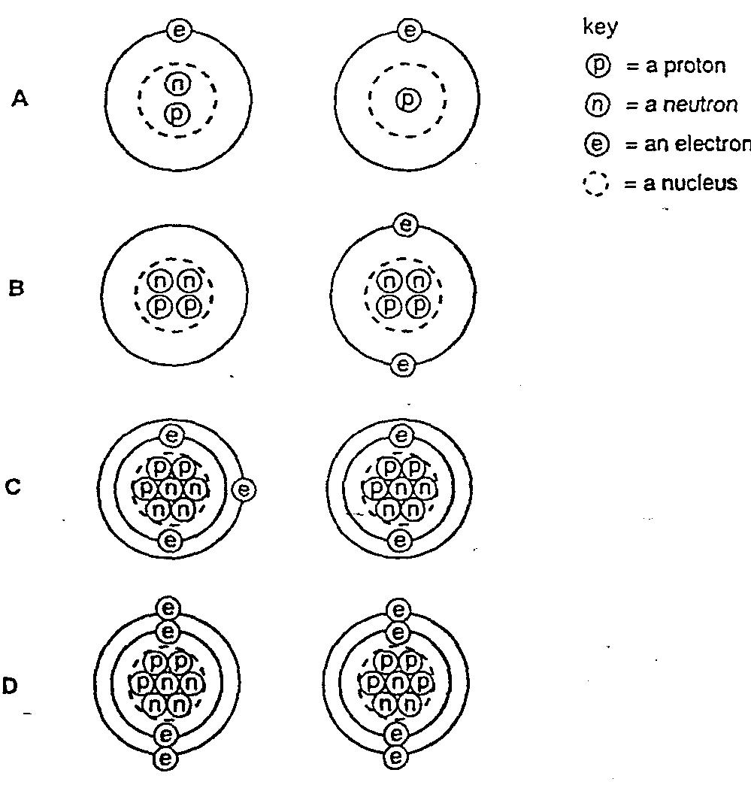

- Look at given atomic structures
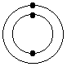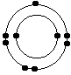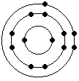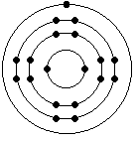
Which electron arrangement corresponds to the first element on period 2 of the Periodic Table?
- electron arrangement X
- electron arrangement Y
- electron arrangement W
- electron arrangement Z

- look at the periodic table;
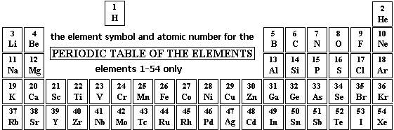
Where in the Periodic Table are you MOST LIKELY to find an element that is a low melting solid and a good conductor of heat?
- Group 7
- Group 1
- Transition series
- Group 4
- Which four quantities A, B, C and D are required to balance the equation? (Note: 1's are not written in the equation BUT they are needed in the 'balancing ratio thinking'.)
A Na₂O_{(s)} + B H₂SO_{4(aq)} ==> C Na₂SO_{4(aq)} +D H₂O_{(l)}
- 1 2 1 2
- 2 2 2 1
- 2 1 2 2
- 1 1 1 1
- Which is TRUE about the compound formed on combining an Alkali Metal with the Halogen element chlorine to form the metal chloride?
- the solution of it in water conducts electricity
- the solid conducts electricity
- insoluble in water
- is an ionic compound
- I is only
- I and II only
I, II and III only
- I an IV only
- Which of the following is TRUE about the trend DOWN the Group 7 Halogens with increase in atomic number?
- the colour of the element gets darker
- the melting points decrease
- the reactivity increases
- the atoms get smaller

- The equation for the reaction between aqueous lead(II) nitrate and aqueous potassium iodide is shown.
Pb(NO3) 2(aq) + 2KI(aq) → PbI2(s) + 2KNO3(aq)
Colourless colourless yellow colourless
Which method could be used to separate the products?
A chromatography
B crystallization
C distillation
D filtration
- The table shows the electronic structures of four atoms.

Atom | electronic structure
W  X  Y  Z | 2,8,1  2,8,4  2,8,7  2,8,3

Which two atoms are metals?
- W and X
- W and Y
- X and Y
- W and Z

- Which of the following is NOT a trend that varies systematically in the periodic table?
- Electro negativity
- symbols of elements
- ionization energy
- atomic radius
- following picture are showing some methods of Purification

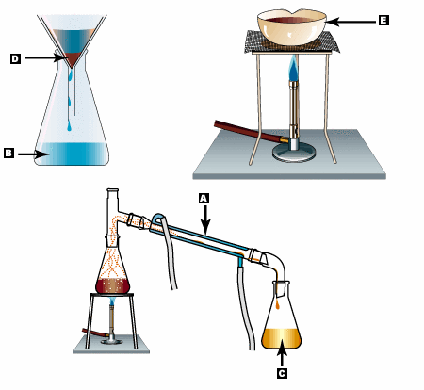
What are C,D and E showing?
 | Distillate | Residue | Evaporation
a)  b)  c)  d) | C  D  E  D | D  E  D  C | E  C  C  E

- The atomic radius of F, Br, and I are 64, 114, and 138 pm respectively. From this information estimate a reasonable atomic radius of Cl.
- 53 pm
- 89 pm n
- 126 pm
- 162 pm

- Use the periodic table to predict which element has the largest atomic radius.
- Na
- He
- Li
- Ca
- Look at the pictures and find out the correct sequence in the given table.
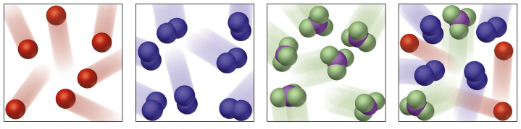
W X Y Z

 | Mixture | Molecule of Elements | Molecule of compounds
A  B  C  D | X  Z  W  Z | Y  X  X  W | Z  Y  Y  X

- Which statement is correct, about the diffusion of one gas into another?
- Once the gases are fully mixed, the particles stop moving.
- The particles of both gases continue moving in a random way.
- The heavier gas sinks to the bottom of the mixture.
- The gases combine to form a new product.
- You are asked to prepare copper II sulphate by using copper oxide and sulphuric acid Which set of apparatus will you need?
- Pipette , test tube, china dish
- Burette , balance, stop watch
- Test tube, meter scale, balance
- Pipette, balance, thermometer

- Which diagram represents the structure of the metal sodium?
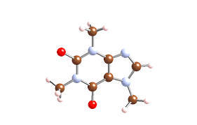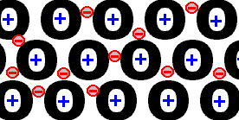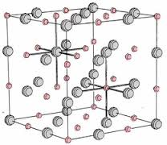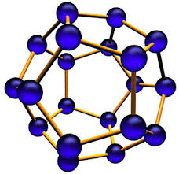
A B C D

Section A
Answer all the questions in this section in the spaces provided.
A1 Choose from the following elements to answer the questions below.
Argon bromine Iron hydrogen iodine
iron neon sulphur sodium diamond
Each element can be use used once, more than once, or not at all.
Name an element which
(a) Forms an alkali when reacts with water.
___________________________________________________________________
(b) a liquid at room temperature and pressure.
_____________________________________________________________________
(c) Reacts with aqueous copper sulphate and displaces copper
____________________________________________________________________
(d) float on water surface
__________________________________________________________________
(e) Has high melting point
__________________________________________________________________
(f) An element having complete outermost shell
__________________________________________________________________
(g) Forms an ion that carries a negative charge.
_______________________________________________________________________

A3. Iron is one of the most important metals. It is a transition element.
- Give 2 examples Iron compounds

(b) Write two typical properties that are generally common only to transition elements.
1.________________________________________________________________________
2.________________________________________________________________________

Section B
Answer two questions from this section.
B 6. Part of the reactivity series of metals is shown below.
Most reactive
1 | Potassium
2 | Sodium
3 | Calcium
4 | Aluminum
5 | Zinc
6 | Lead
Least reactive
Use the information above.
- Which two metals would react with calcium chloride in a displacement reaction?

a._________________
b._________________

- Write down symbol equations for the above displacement reactions:
a._________________________________________________________________________
b._________________________________________________________________________
- What does Displacement reaction mean?
____________________________________________________________________________________________________________________________________________________
IV Complete the sentences using the words below:
reactive series equation ores

- Metal __________ are natural compounds.
- A reactivity _____________shows how the properties of metals compare.
- A _______________shows what happens in a chemical reaction.
- Some metals are more _____________than others.
B 7. Read the information mentioned in the table and write down the answers of the questions given below:
Substances | Shape | Size | Compressibility | Flow
A | Definite | Definite | No | No
B | Indefinite | Indefinite | Yes | Yes
C | Indefinite | Definite | No | Yes
- Identify substance B and tell about the energy possessed by the particles of substance B?
______________________________________________________________________________
- Keeping in mind the shape and size, describe the arrangement of particles in substance A?
____________________________________________________________________________________________________________________________________________________________
- Draw particle model of substance C

- Which substance has the highest rate of diffusion?
___________________________________________________ ______________________
- Explain your answer of part IV in term of Kinetic Particle Theory
___________________________________________________________________________
___________________________________________________________________________
___________________________________________________________________________

