Topic 8: Motivation
Why is it important for employees to be motivated at work?
- Greater job satisfaction
- Higher levels of staff retention
- Lower absenteeism
- Higher levels of productivity
- Increased profits
- More innovation and creativity
- Business develops a good reputation so they will get more candidates apply for their
- vacancies.
Motivational Theories
Maslow’s Hierarchy of Needs – Maslow believed that people become more motivated as they move
up the hierarchy of needs. Physiological needs are the basic needs and self-fulfilment or selfactualisation is the highest need.
Methods of Motivation

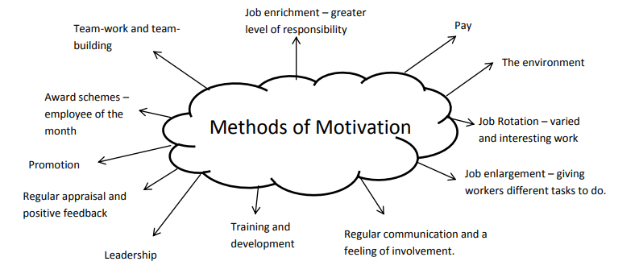

Relevent Theories of Motivation
Maslow’s Hierarchy of Needs – Maslow believed that people become more motivated as they move up the hierarchy of needs. Physiological needs are the basic needs and self-fulfillment or self-actualization is the highest need.
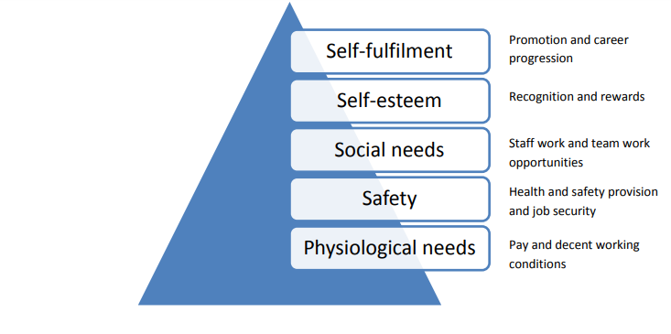
Fredrick Taylor – The theory that workers are mainly motivated by pay. Employees do not naturally
enjoy working so require constant supervision and control. This theory relates to autocratic
management.
Elton Mayo – This theory implies that workers are not only concerned with money, but having their
social needs met also. In an investigation, Mayo changed different factors of the working
environment to see how motivation levels changed among the workforce. The results from the study
showed that employees were best motivated by:
- Better communication
- Greater level of manager involvement
- Working in groups
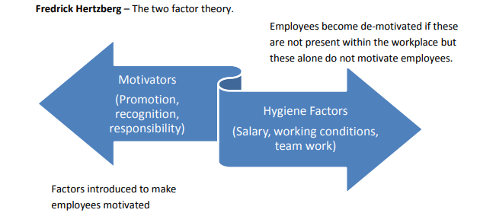

Activities
- State the methods of motivation being used in each of the following cases: -
- Software designers have been asked to work together to identify the kind of software that schools are likely to need in five years’ time and then to write it.
- Marston Football Club is at the bottom of the league. The players lack confidence and are dispirited by poor performance. A new manager has been appointed. He has introduced extra training and has told players that he will transfer anyone who fails to attend these sessions.
- The workers at a chocolate factory have been asked to do different jobs on different days of the week. All the work is considered to have the same level of responsibility.
- John is a doorman at the Empire Theatre. He has been given additional responsibility of meeting and greeting the celebrity visitors and escorting them to the special hospitality facilities. - City High School has built a new English block to replace the mobile huts previously used. The building is more comfortable and spacious than the mobile huts.

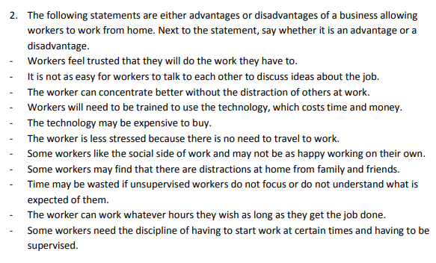
3.`
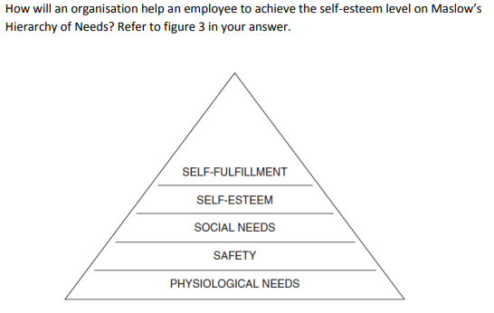

4.
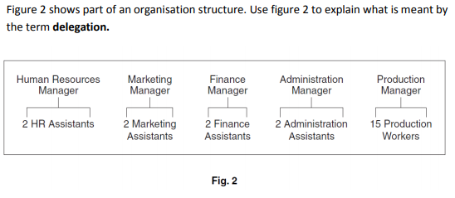
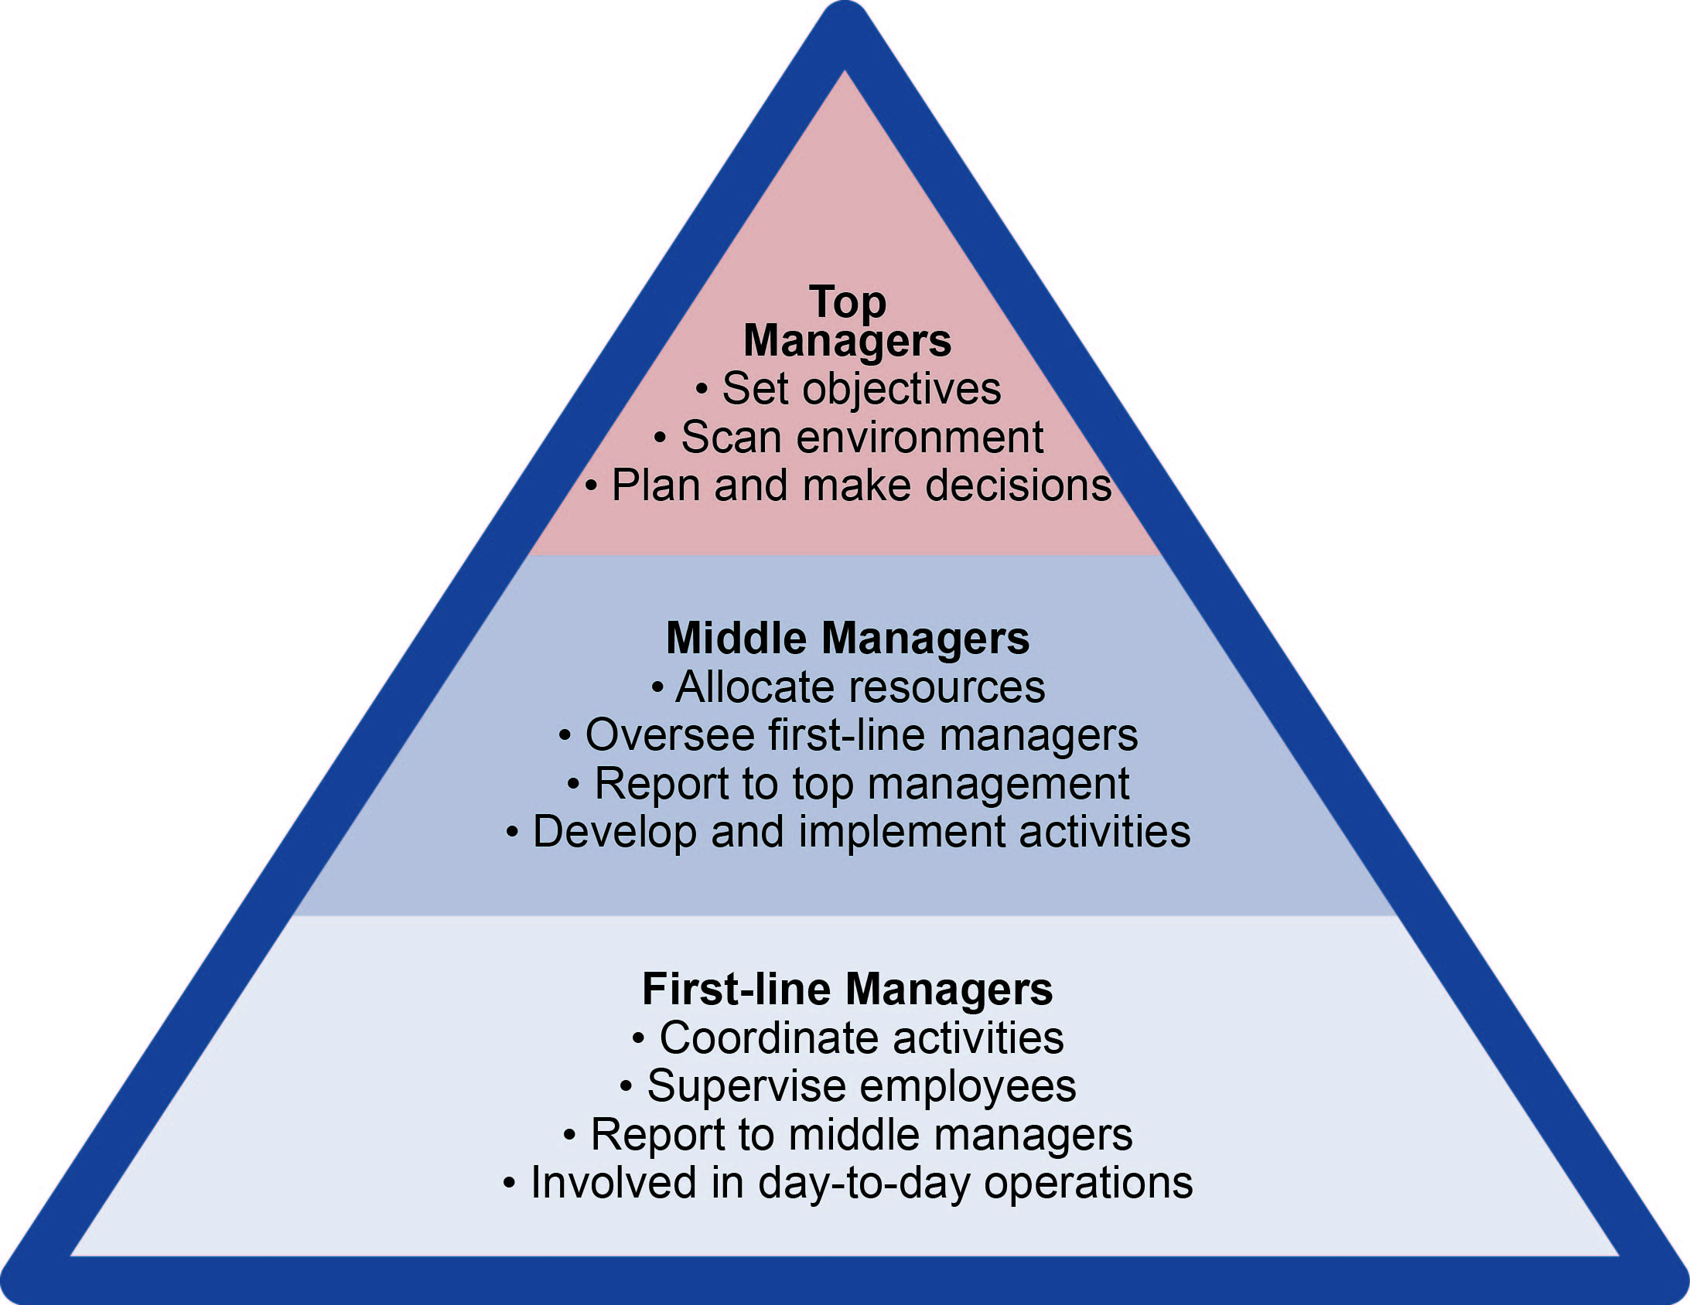
Functions of Managers

