Business Studies Blog Worksheet Class 9 31st January 31, 2020
Q1 Study the given figure and awnser the given questions.

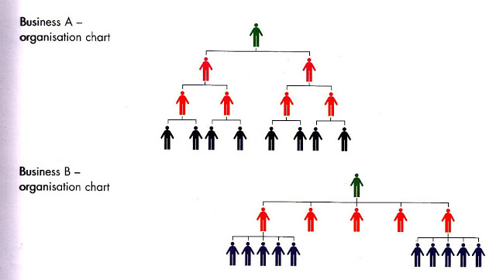

- What is organizational structure? [2]
- Define chain of command?[2]
- Identify and describe the organizational structure of Business A and Business B . [4]
- Outline and explain the the advantages of having above mentioned organizational struvcture? [6]
- To what extent delegation is significant for organization A and B?[6]

