Teacher Name: Lubna Tanweer

Class: 11 Subject: Computer Science Date: 16th October 2019

Questions from Chapter 4 “Operating System and computer architecture”

Specimen paper 2015

No question from this chapter

2210_s15_qp21

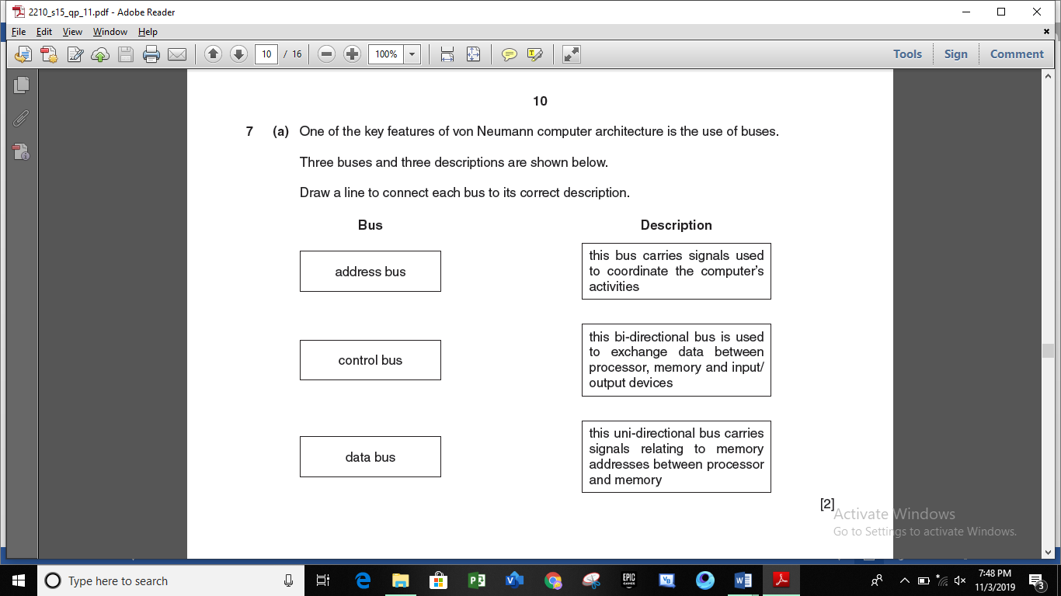

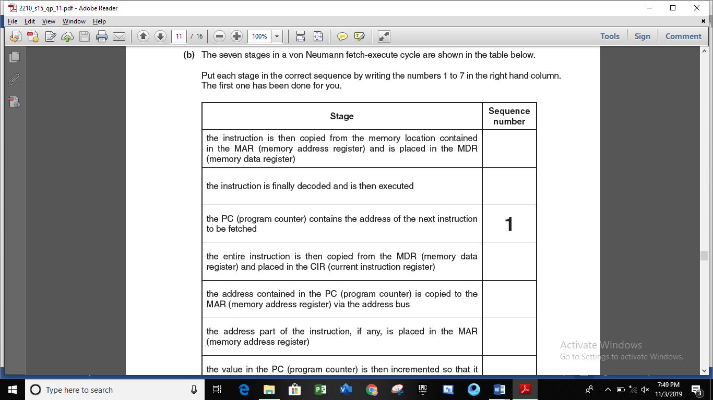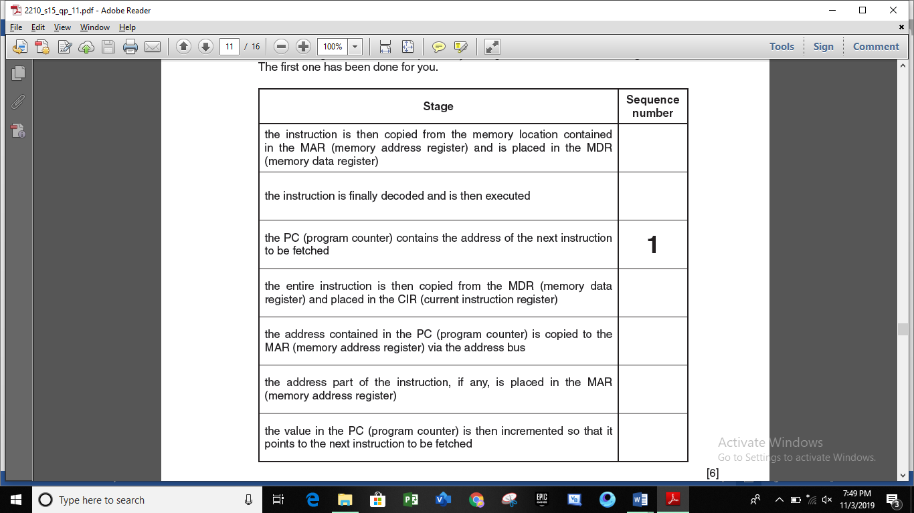

2210_s15_qp12

No question from this chapter

2210_w15_qp12

No question from this chapter

2210_w15_qp13

No question from this chapter

2210_s16_qp11

No question from this chapter

2210_s16_qp12

No question from this chapter

2210_w16_qp12

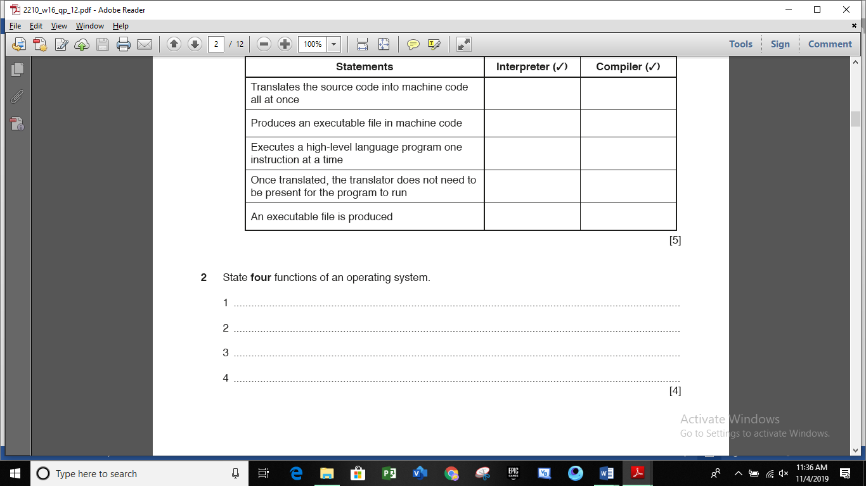

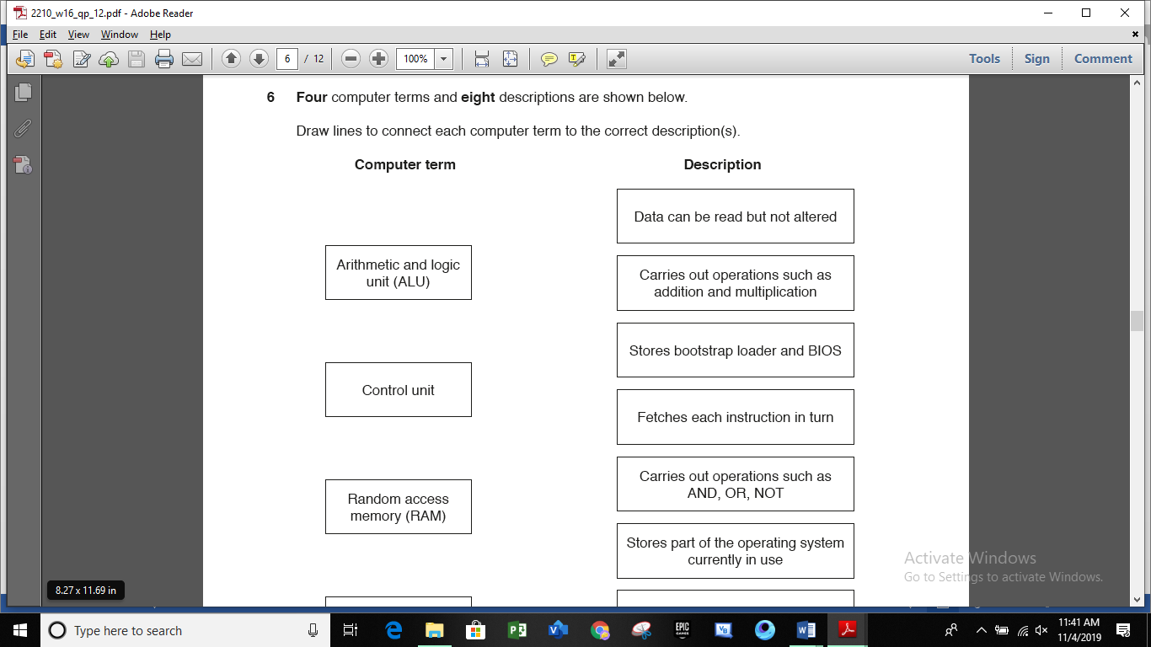 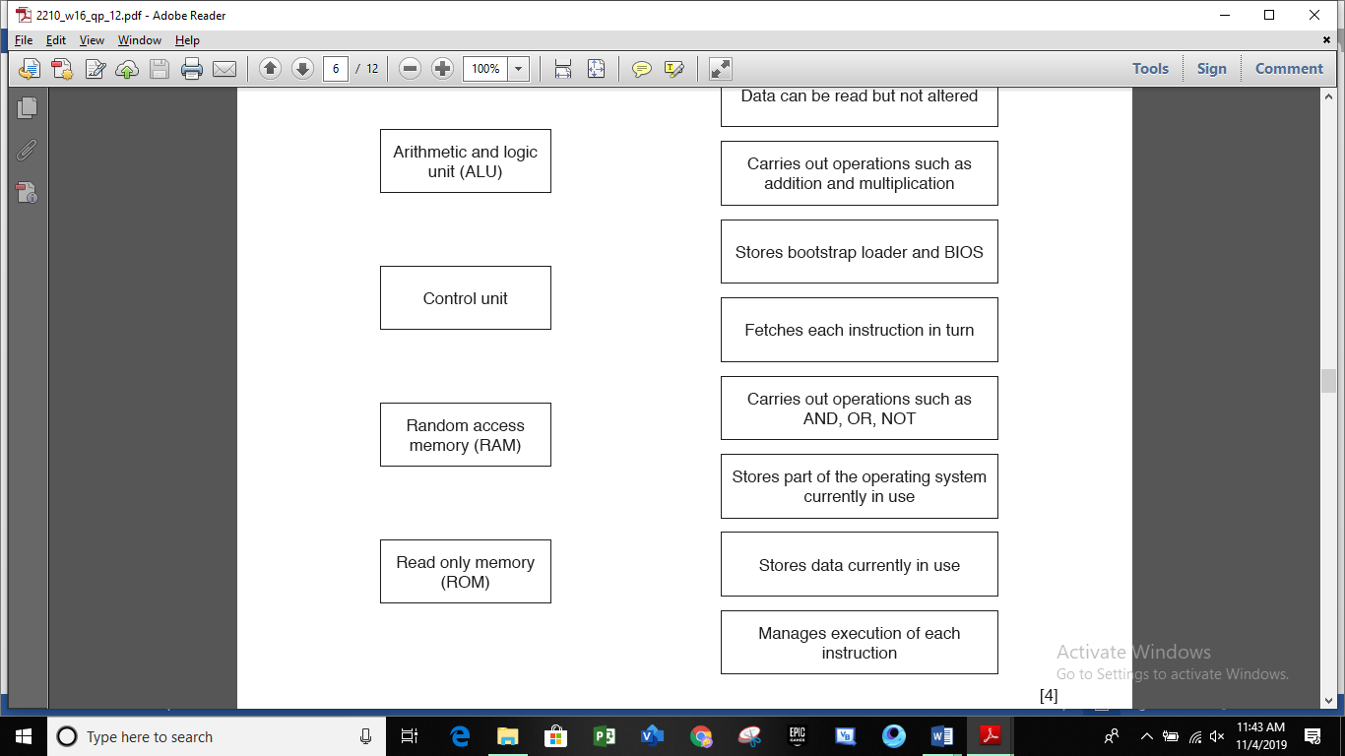

2210_w16_qp13

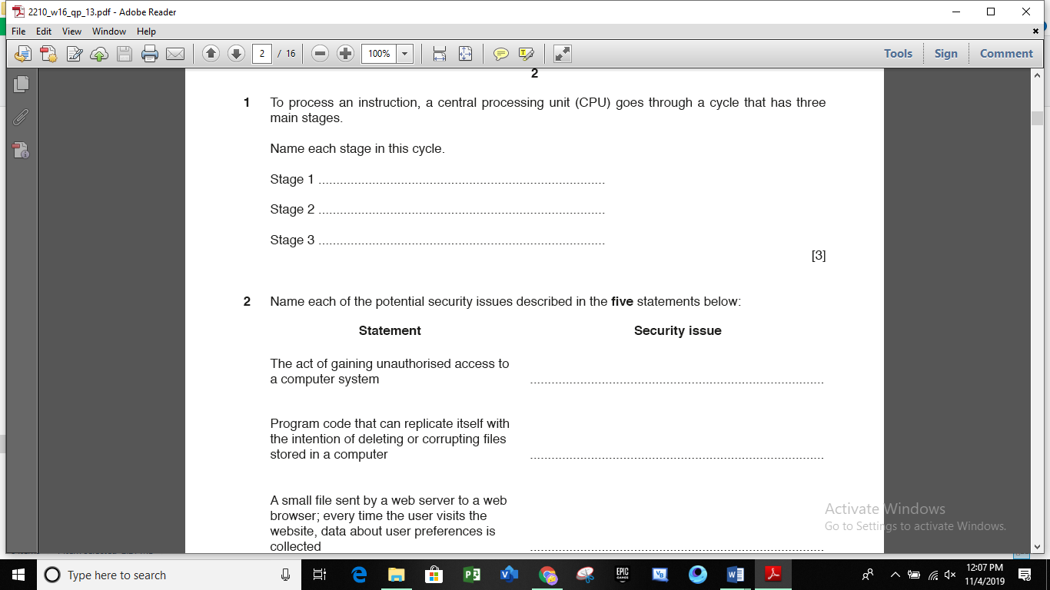

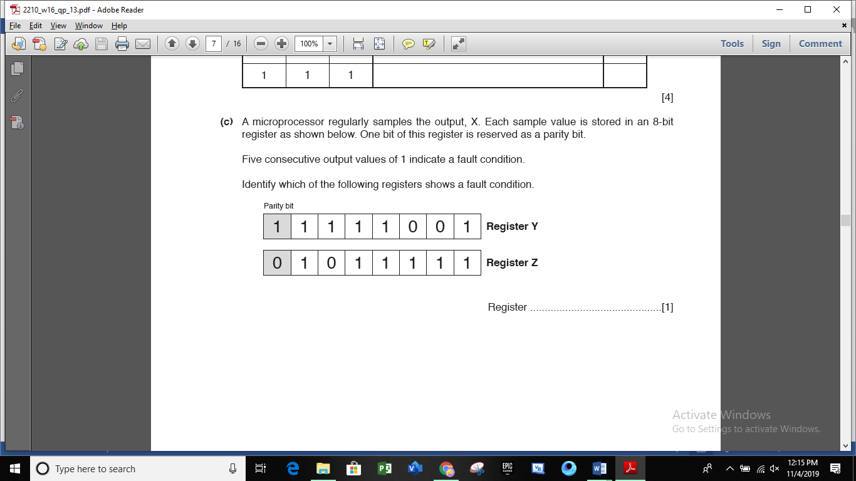

2210_s17_qp11

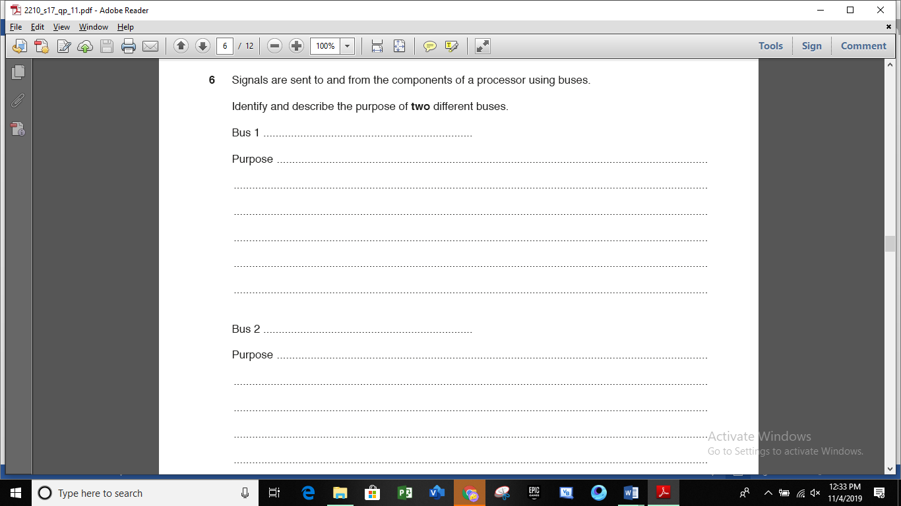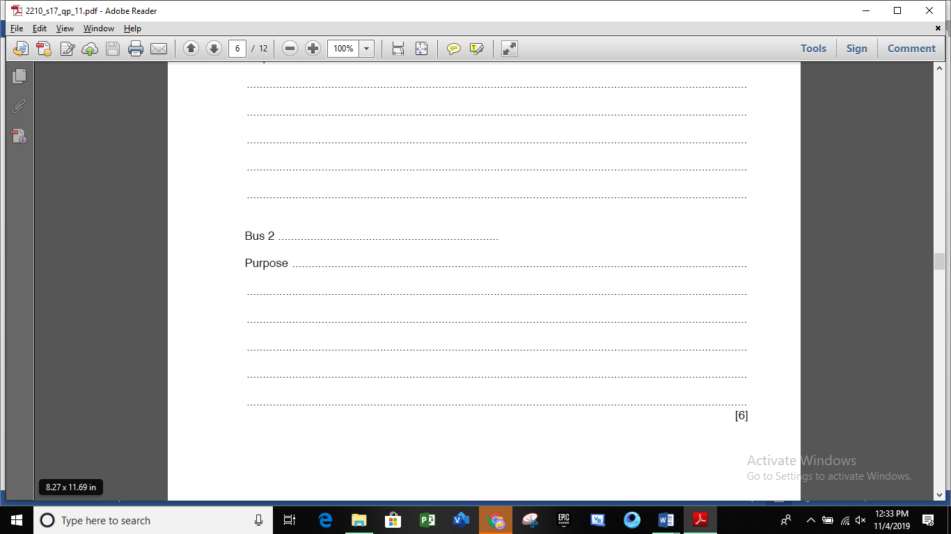

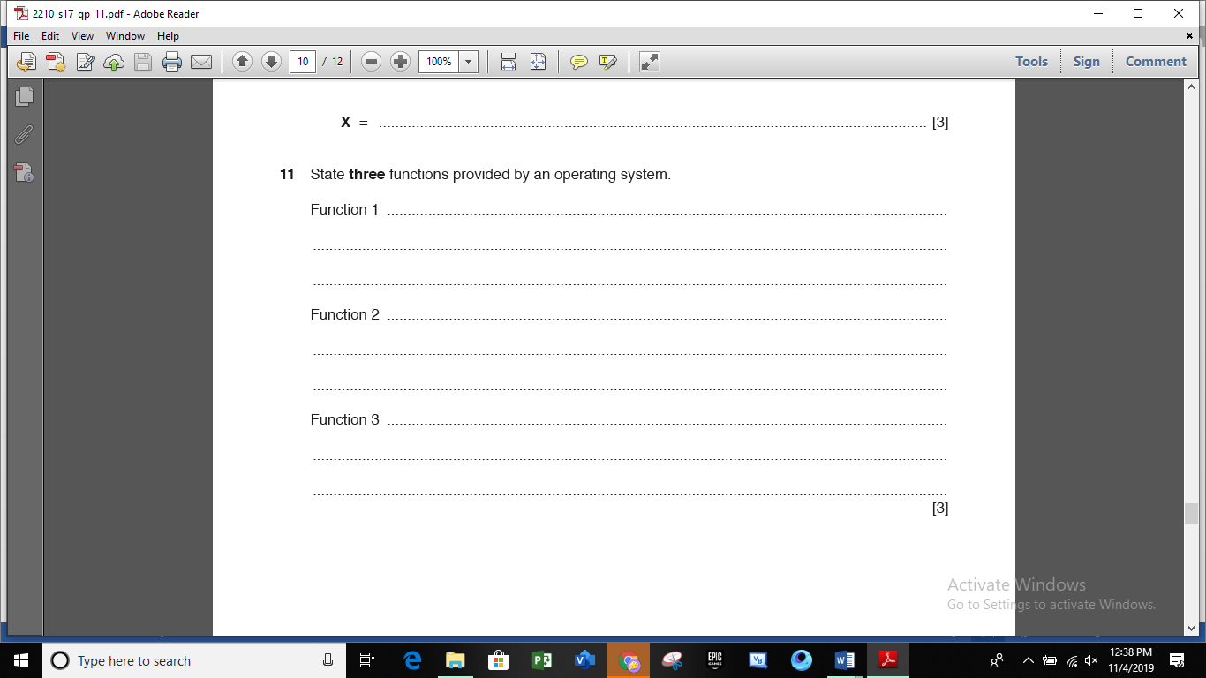

2210_s17_qp12

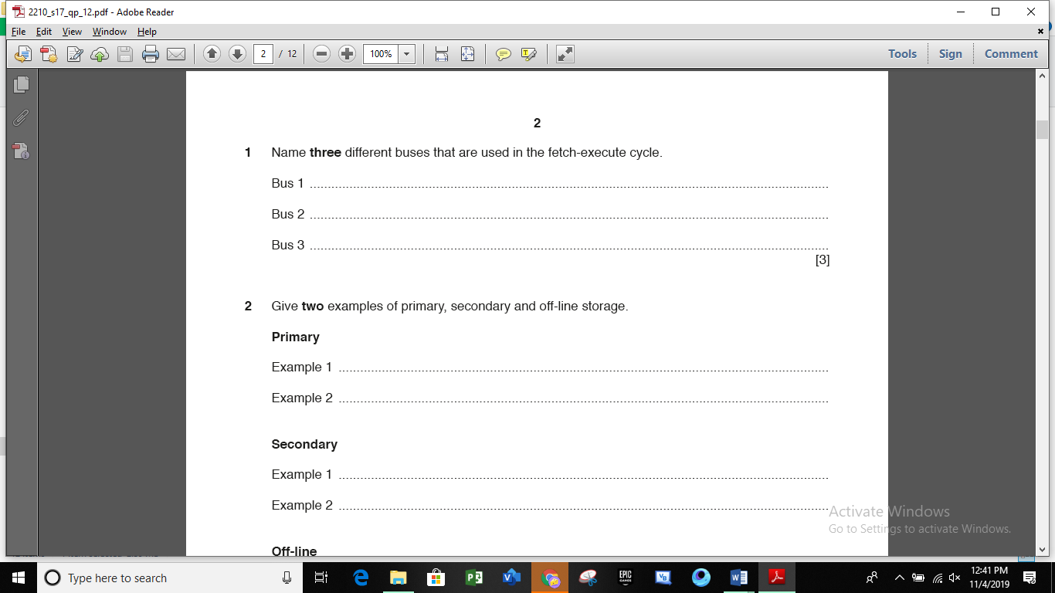

2210_w17_qp12

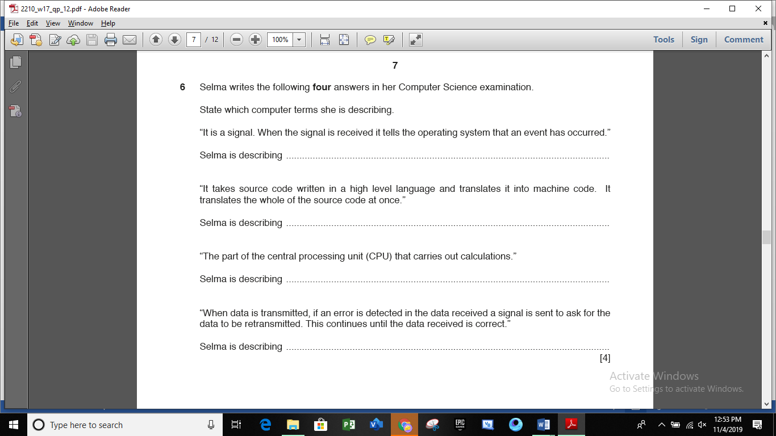

2210_w17_qp13

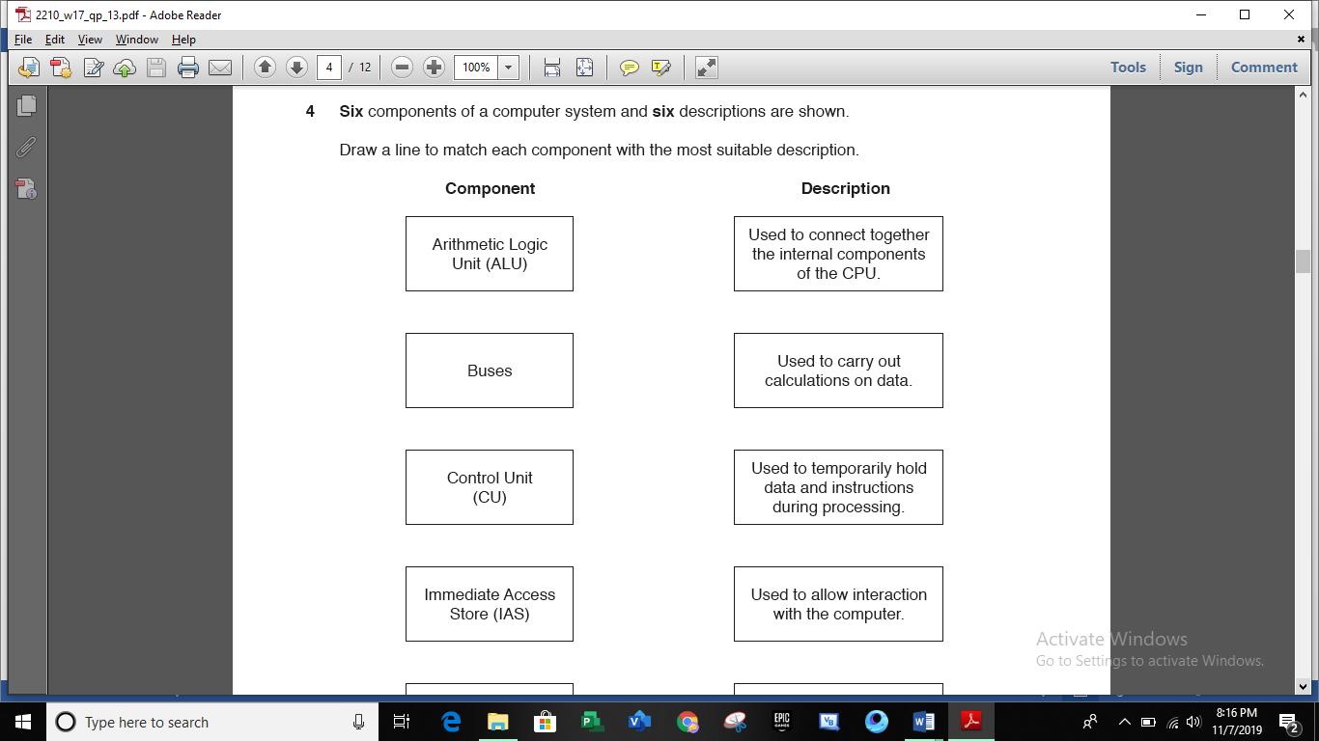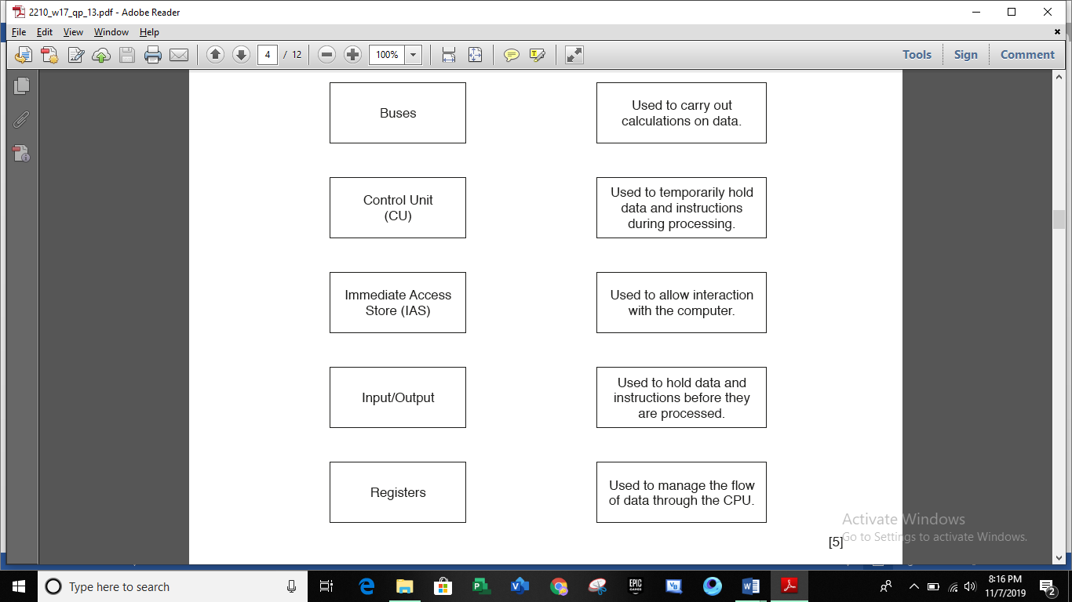

2210_s18_qp11

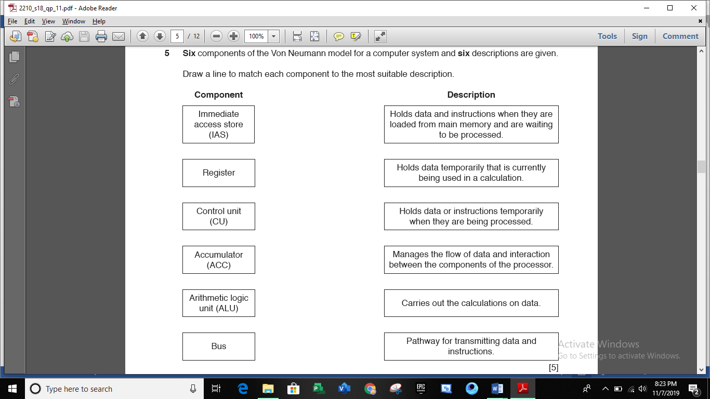

2210_s18_qp12

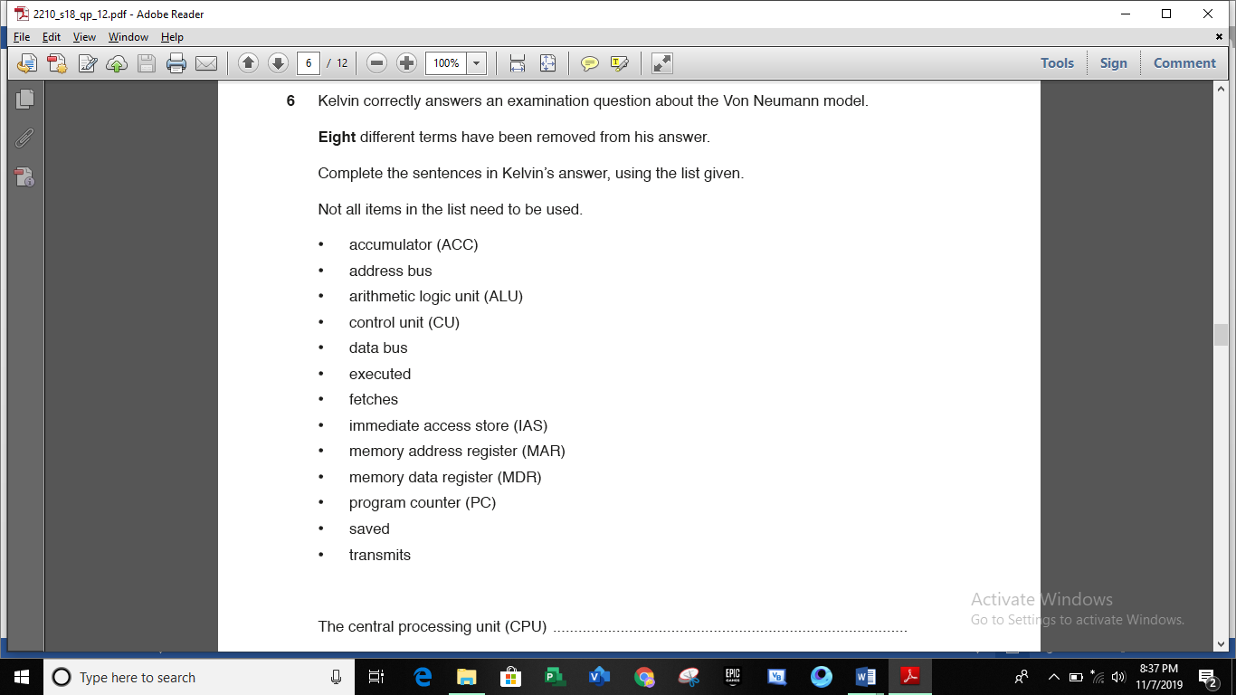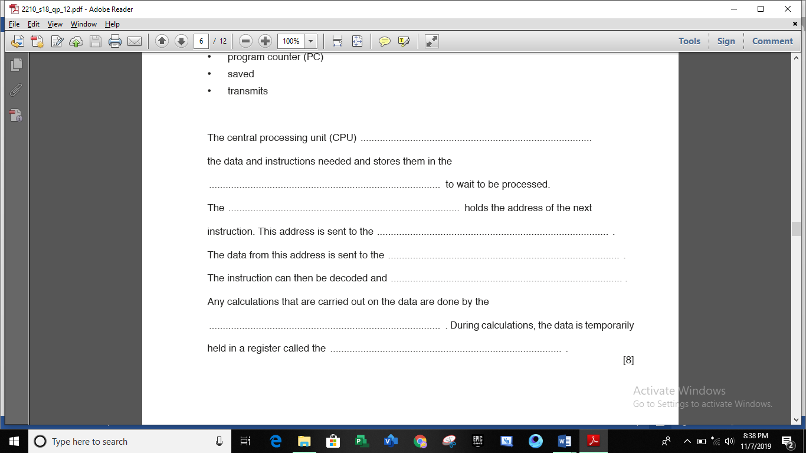

2210_w18_qp12

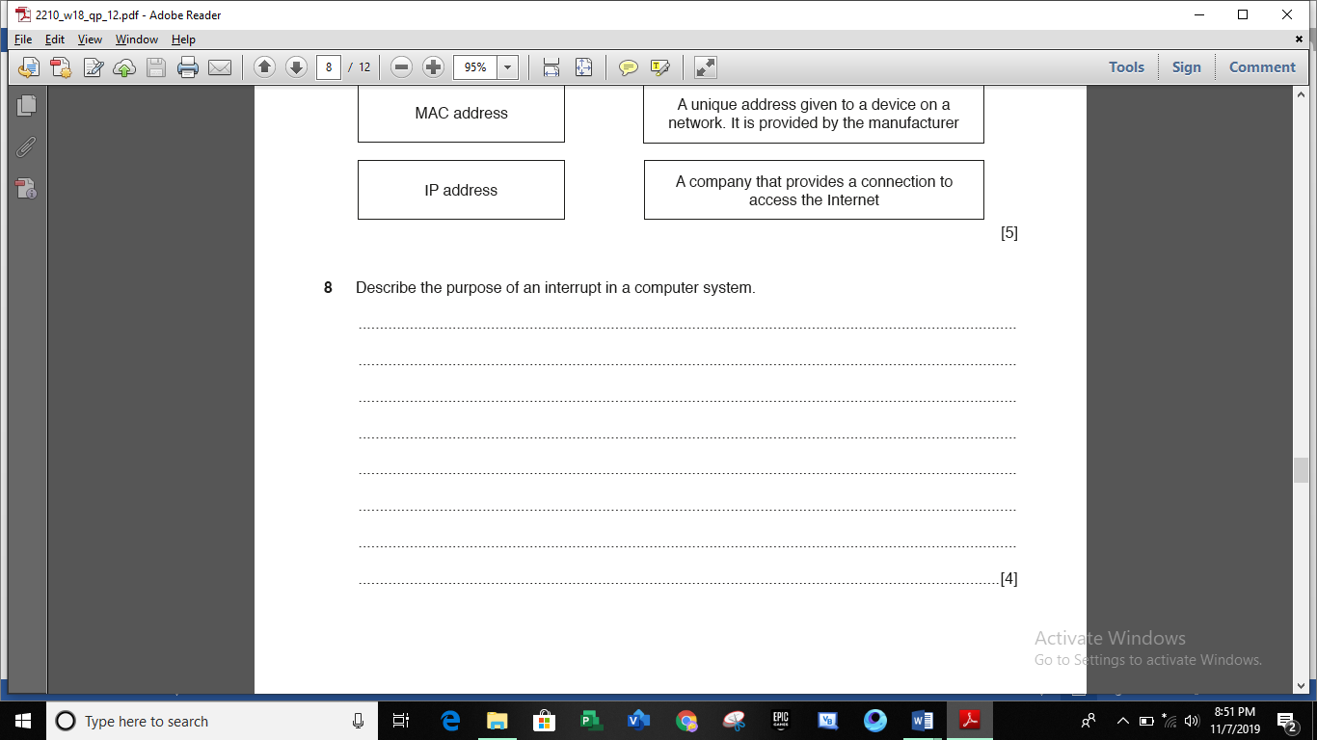

2210_w18_qp13

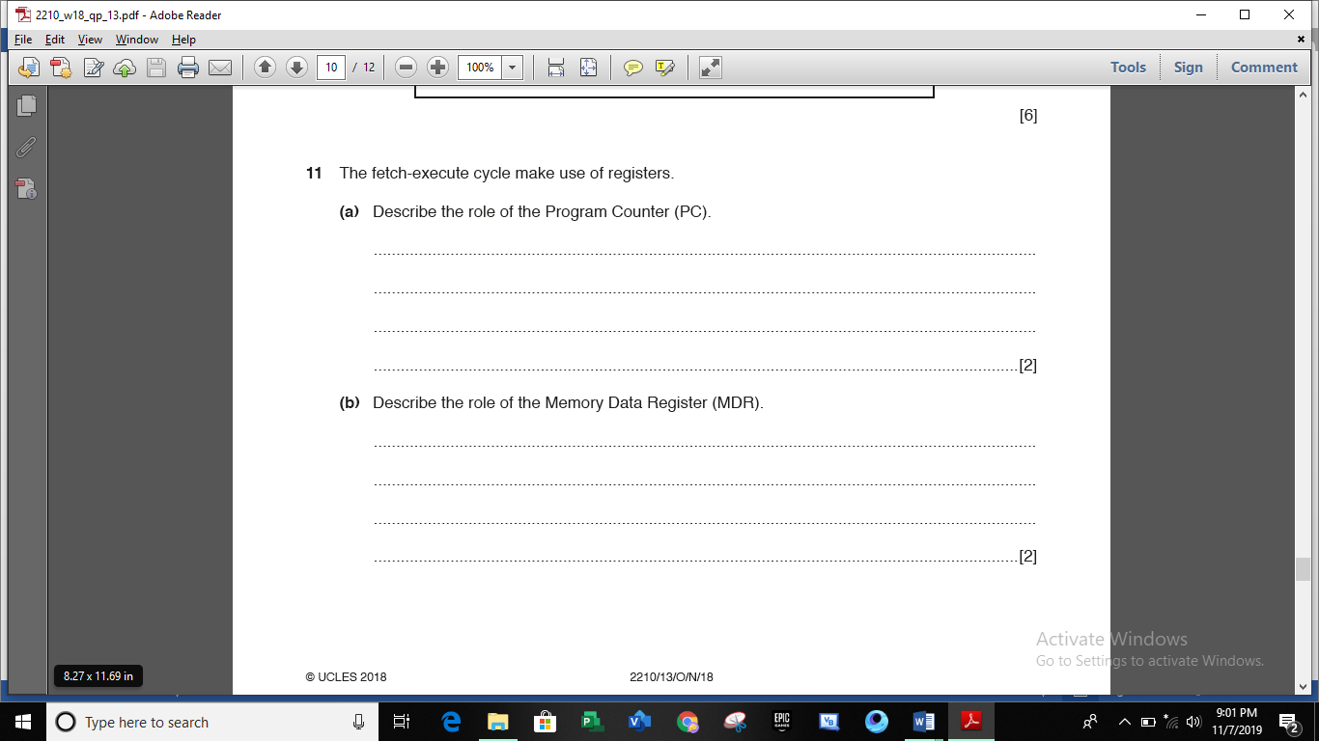

2210_s19_qp11

No question

2210_s19_qp12

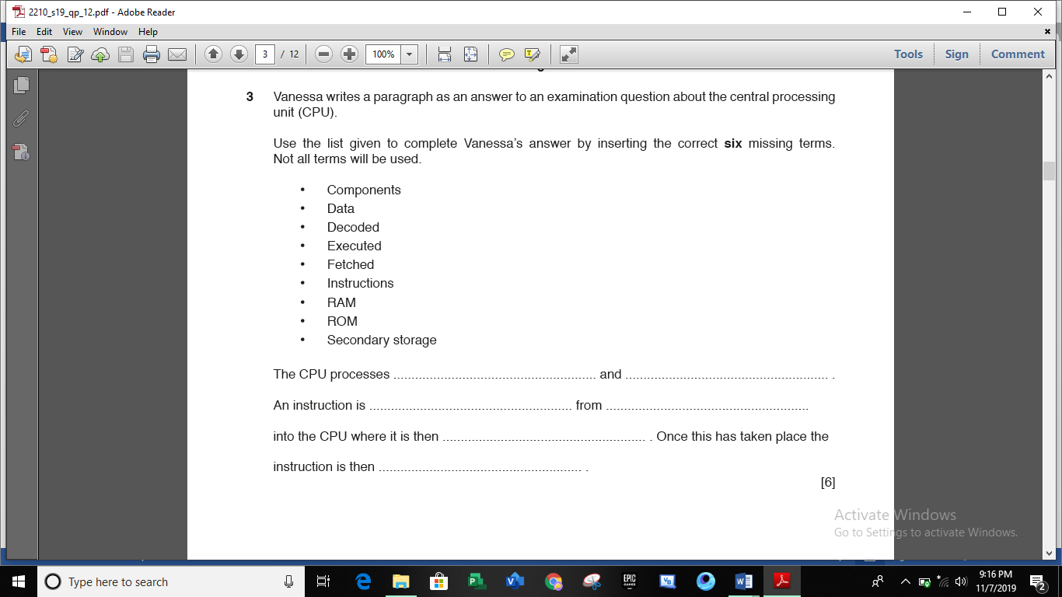

2210_w19_qp12

2210_w19_qp13