The city School
North Nazimabad Boys Campus
Computer worksheet
Date: 22-01-2016
Class: 11TH
Teacher: Kubna Tanweer
Chapter # 1
Explain the following concepts:
- Memory Dump
- Hexadecimal numbers as fault tracing tool
- Why only hexadecimal numbers used to represent colors
- Difference between Universally Administrated MAC Address and Locally Administrated MAC Address
Convert the following numbers into required number system.
- (11100101)₂=( )₁₆
- (11100101)₂=( )₁₀
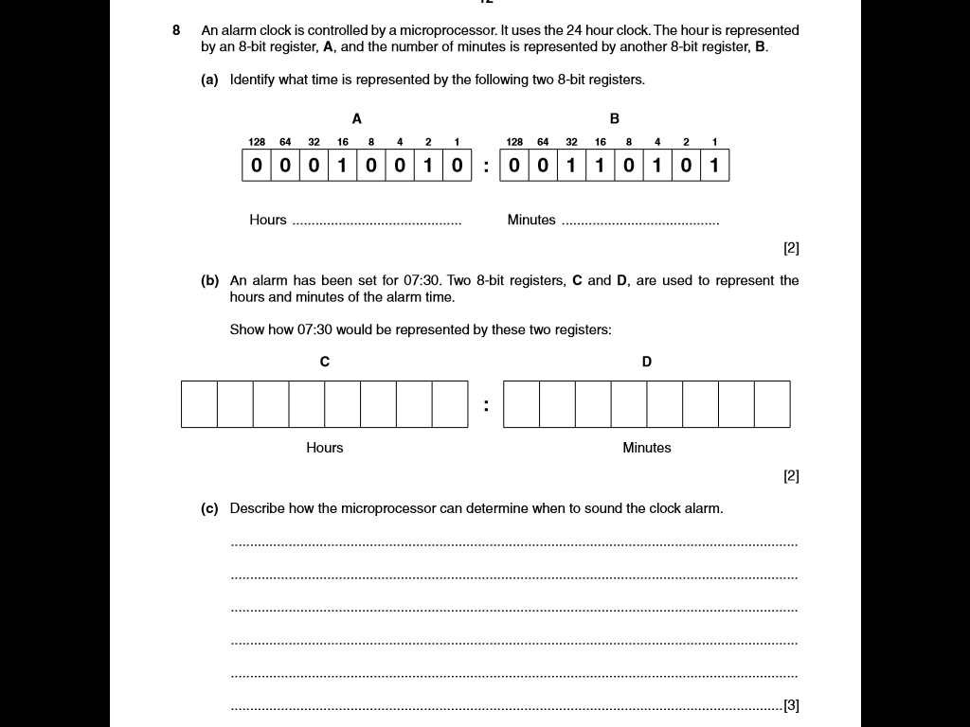
- (144)₁₀=( )₂
- (A00)₁₆=( )₂
- (AD89)₁₆=( )₁₀
- (5000)₁₀=( )₁₆

