BLOG WORKSHEET
CHEMISTRY CLASS 10

Teacher Name: Uzma Amer Class: 10 Chemistry Date: 13th Sep’19
Q.1. choose the best answers: Max. Marks: 10
- Which of the following is an endothermic reaction?
A the combustion of ethanol in air
B the formation of a carbohydrate and oxygen from carbon dioxide and water
C the oxidation of carbon to carbon dioxide
D the reaction between hydrogen and oxygen

- The energy profile diagram for the forward direction of a reversible reaction is shown:

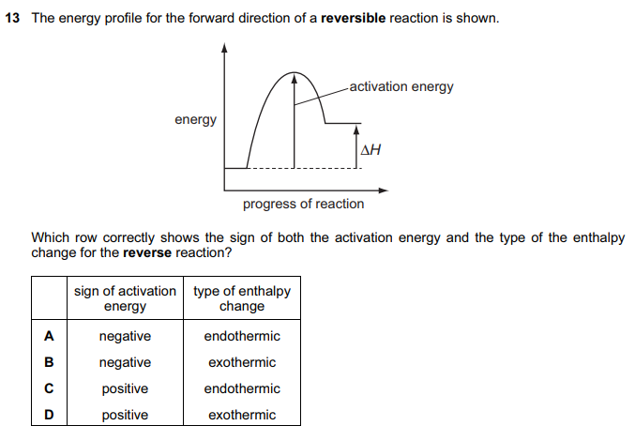
- The energy profile diagram for the reaction between hydrogen and chlorine is shown.
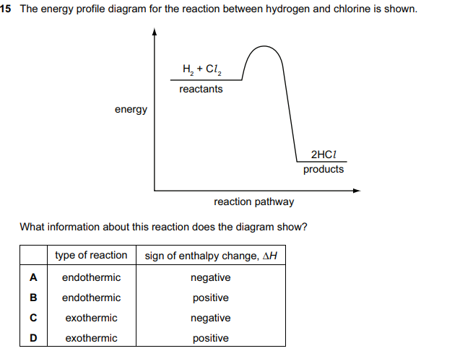

- Which pair of statements about the combustion of a carbohydrate and its formation by photosynthesis is not correct?
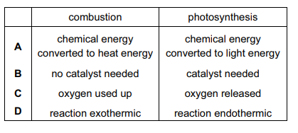
- The combustion of methane is exothermic. The equation is given below.
CH4 + 2O2 → CO2 + 2H2O
What can be deduced from the fact that the reaction is exothermic?
A Fewer bonds are broken than are made.
B Less energy is involved in breaking bonds than is involved in making bonds.
C More bonds are broken than are made.
D More energy is involved in breaking bonds than is involved in making bonds
- Measure of average kinetic energy of molecules is
- temperature
- energy
- internal energy
- enthalpy
- Which reactions are the examples of exothermic reaction only.
- Burning fossil fuels
- Respiration
- Photosynthesis
- Neutralization
- I only
- I,II& III only
- I,II &IV only
- All of above
- Change in energy between a chemical reaction and surroundings at constant temperature is called
- enthalpy change
- enthalpy
- enthalpy profile
- dynamic enthalpy

- Which one of the following statements best describes the enthalpy change of a reaction?
- The energy released when chemical bonds are formed during a chemical reaction
- The difference between the energy released by bond formation and the energy consumed by bond cleavage during a chemical reaction
- The increase in disorder of the system as a reaction proceeds
- The energy consumed when chemical bonds are broken during a chemical reaction

- . Heat transferred at constant pressure _____ the enthalpy of a system.
- Decreases
- Increases
- First decrease than increase
- First increase then decrease

