BLOG WORKSHEET
CHEMISTRY CLASS 9

Teacher Name: Uzma Amer Class: 9 Chemistry Date: 2nd Feb’18

Q.1.The structure of sodium chloride is drawn below.
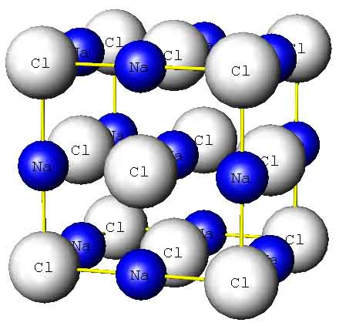

- Sodium chloride is an ionic solid. Draw the electronic structure of both a sodium ion and a chloride ion.
sodium ion chloride ion
- Sodium chloride has a melting point of about 801 °C. Explain why sodium chloride has a high melting point
- Calcium oxide (CaO) has a similar structure to sodium chloride. Suggest why the melting point of Calcium oxide is higher than that of sodium chloride.
- Explain why?
- Solid sodium chloride conducts electricity only in molten form and in aqueous solution.
- Crystal of sodium Chloride is brittle.

