BLOG WORKSHEET
CHEMISTRY CLASS 9

Teacher Name: Uzma Amer Class: 9 Chemistry Date: 26th April’19
Q.1. Balance the following equations:

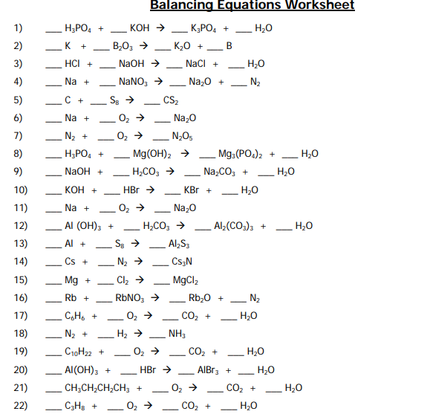
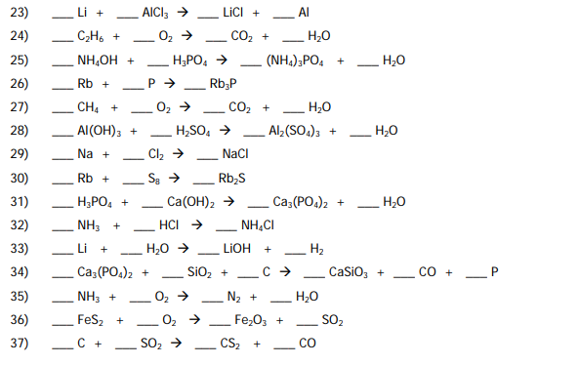

SOLUTIONS
