BLOG WORKSHEET
CHEMISTRY CLASS 9

Teacher Name: Uzma Amer Class: 9 Chemistry Date: 16th Feb’19
Q1. Write the electronic configurations of following elements referring to periodic table.
- Potassium ………………………..
- Chlorine……………………………..
- Oxygen………………………………
- Sulphur………………………………
- Nitrogen……………………………..
- Phosphorus…………………………..
Q.2. Look at the table below:
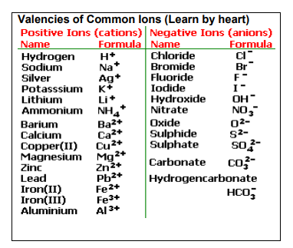
(a). Name the following ionic compounds using above table:
- PbF2 __________________________________________
- (NH4)2CO3 _____________________________________
- Li2S __________________________________________
- MgI2 _________________________________________

(b). Write the formulas for the following ionic compounds using above table:
- sodium iodide __________________________________________
- calcium oxide __________________________________________
- aluminum chloride __________________________________________
- potassium nitrate __________________________________________
- calcium carbonate __________________________________________
- lithium sulfate __________________________________________
- magnesium hydroxide _________________________________________
- sodium phosphate __________________________________________
- aluminum carbonate __________________________________________
- calcium chloride ___________________________________ ______ ___

Q.3. Draw Electron Dot diagrams of:
- H2
- F2
- HCl
- H2O
- CH4

