BLOG WORKSHEET
CHEMISTRY CLASS 9

Teacher Name: Uzma Amer Class: 9 Chemistry Date: 19-1-19
Q.1 Choose the best answer:
Filtration is useful when
- only one solid is soluble
- both solids are soluble
- both solids are insoluble
- when both liquids are miscible

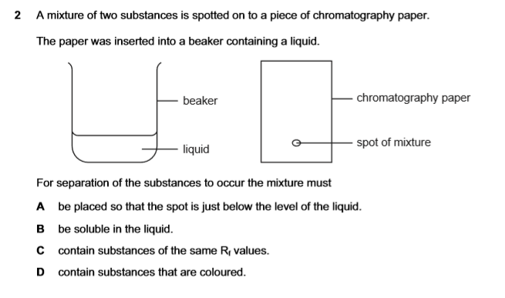
If Ammonium Chloride (NH₄Cl) and Sodium Chloride (NaCl) are heated gently,
- ammonium salt becomes a gas
- gaseous ammonia will become solid on a glass funnel
- sodium chloride is left behind
- all of these

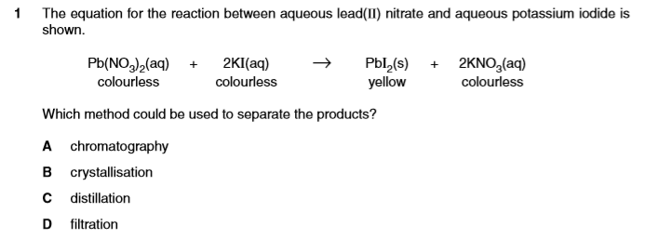

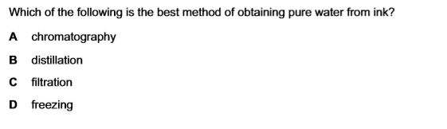

Q.2. Site 2 differences between simple distillation and fractional distillaion

Q.3.A student separated two alkanes, hexane (bp 69°C) and heptane (bp 98°C), using the apparatus shown below.
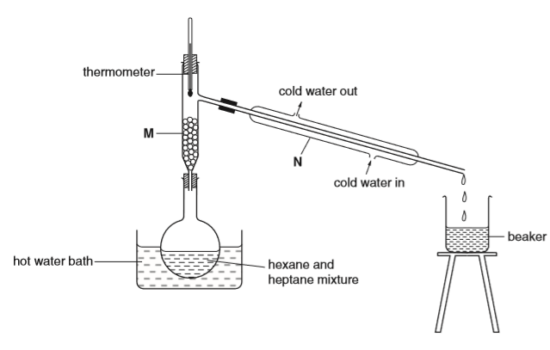

(a) What was the reading on the thermometer when the first few drop of distillate appeared in the beaker?
(b) Why was a hot water bath is used rather than aflame for heating the mixture?
(c) (i) Name the piece of apparatus labelled N
(ii) What is it used for?
(iii) Name the piece of apparatus labelled M
(iv) What is it used for?

