BLOG WORKSHEET 1
CHEMISTRY CLASS 9

Teacher Name: Uzma Amer Class: 9 Chemistry Date: 16th March’18

Q.1 (a) Define the following terms:
- Kinetic Energy
- Relative molecular mass
- Acids
- Base
- Alkali
(b).calculate the Relative molecular masses of the given compounds:
- A compound XCl having molecular mass (Mr) of 58.5.Find out Mr of XCO3.
- A compound X2O having molecular mass (Mr) of 62 Find out Mr of X2SO4
- A compound XCl2 having molecular mass (Mr) of 111.Find out Mr of X(NO3)2

BLOG WORKSHEET 2
CHEMISTRY CLASS 9

Teacher Name: Uzma Amer Class: 9 Chemistry Date: 16th March’18
WRITING A CHEMICAL EQUATION

A good way to think about a chemical reaction is the process of baking cookies. You mix the ingredients together, flour, butter, salt, sugar, and eggs, bake it and see that it changes into something new, cookies. In chemistry terms the equation is the recipe, the ingredients are "reactants," and the cookies are "products." All chemical equations look something like "A + B --> C (+ D..)," in which each letter variable is an element or a molecule (a collection of atoms held together by chemical bonds). The arrow represents the reaction or change taking place. To write the equations there are a number of important naming rules that you need to know.
WRITING A CHEMICAL EQUATION FOR COVALENT COMPOUNDS

- Memorize the prefixes for number of atoms. In naming compounds, Greek prefixes are used to indicate the number of atoms present for each element. Covalent compounds have the first element written out completely while the second element is named with the suffix “ide”. For example diphosphorus trisulfide has a chemical formula of P2S3.[1] Below are the prefixes for 1-10:
- 1: Mono-
- 2: Di-
- 3: Tri-
- 4: Tetra-
- 5: Penta-
- 6: Hexa-
- 7: Hepta-
- 8: Octa-
- 9: Nona-
- 10: Deca-
- Write the chemical symbol for the first element. When a compound has been written out, you must identify the elements and know their chemical symbols. The first element written is “first name” of the compound. Use the periodic table to find the chemical symbol for the element.[2]
- For example: Dinitrogen hexafluoride. The first element is nitrogen and the chemical symbol for nitrogen is N.
- Add the number of atoms as a subscript. To identify the number of atoms present for each element, you simply need to look at the prefix of the element. Memorizing the Greek prefixes will help you to be able to write chemical formulas quickly without looking anything up.[3]
- For example: Dinitrogen has a the prefix “di-“ which means 2; therefore, there are two atoms of nitrogen present.
- Write dinitrogen as N2.
- Write the chemical symbol for the second element. The second element is the “last name” of the compound and will follow the first element. For covalent compounds, the element name will have a suffix of “-ide” instead of the normal ending of the element.[4]
- For example: Dinitrogen hexafluoride. The second element is fluorine. Simply replace the “ide” ending with the actual element name. The chemical symbol for fluorine is F.
- Add the number of atoms present as a subscript. As you did with the first element, identify the number of atoms present in the second element by reading the prefix. Using this prefix, write the number of atoms as a subscript to the right of the chemical symbol.[5]
- For example: Hexafluoride has a prefix of “hexa-“ which means 6; therefore, there are 6 atoms of fluorine present.
- Write hexafluoride as F6.
- The final chemical formula for dinitrogen hexafluoride is N2F6.
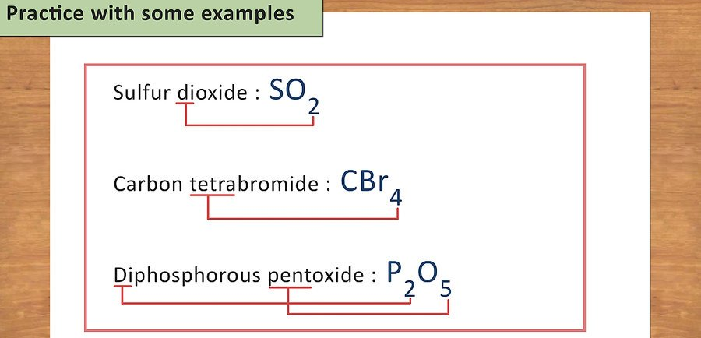

BLOG WORKSHEET 3
CHEMISTRY CLASS 9

Teacher Name: Uzma Amer Class: 9 Chemistry Date: 16th March’18

WRITING A CHEMICAL EQUATION FOR IONIC COMPOUNDS
- Identify the chemical symbols for the cations and anions. All chemicals have what you can call a first and last name. The first name is the cation (positive ion) while the last name is the anion (negative ion). Cations are written as the element name while anions are the element name ending with the suffix “ide”.[6]
- The chemical symbol for each element can be found on the periodic table.
- Unlike covalent compounds, Greek prefixes are not used to indicate the number of atoms of each element. You have to balance the charges of the elements to determine the atoms.
- For example: Lithium oxide is Li2O.
- Recognize polyatomic ions. Sometimes the cation or anion is a polyatomic ion. These are molecules that have two or more atoms with ionic groups. There’s no good trick to remembering these, you just need to memorize them.[7]
- There are only 3 cation polyatomic ions and they are ammonium (NH4+), hydronium (H3+), and mercury(I) (Hg22+). They all have a +1 charge.
- The rest of the polyatomic ions have negative charges ranging from -1 to -4. Some common ones are carbonate (CO32-), sulfate (SO42-), nitrate (NO3-), and chromate (CrO42-).
- Determine the valence charge of each element. The valence charge can be determined by looking at the position of the element on the periodic table. There are a few rules to keep in mind that help you identify the charges:[8]
- All group 1 elements at +1.
- All group 2 elements are +2.
- Transition elements will have Roman numerals to indicate their charge.
- Silver is 1+, zinc is 2+, and aluminum is 3+.
- Group 17 (7) elements are 1-.
- Group 16 (6) elements are 2-.
- Group 15 (5) elements are 3-.
- Remember, when working with polyatomic ions, just use the charge of the ion.
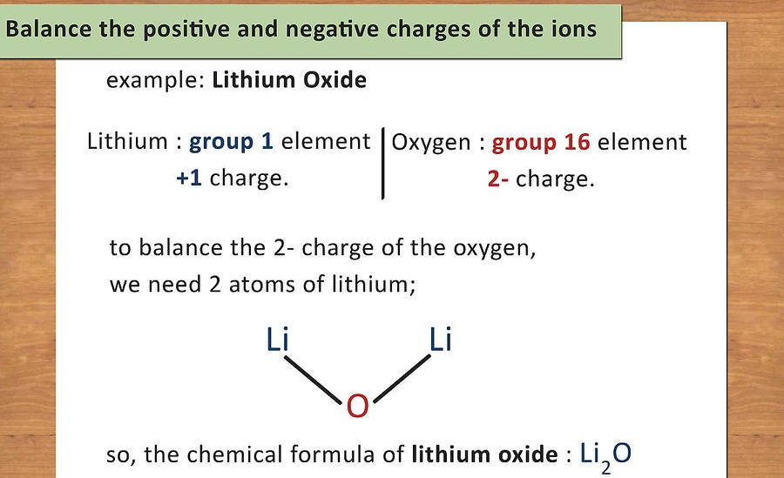
- Balance the positive and negative charges of the ions. Once you have identified the charge of each element (or polyatomic ion), you will use these charges to determine the number of atoms present of each element. You want the charge of the compound to equal zero so you will add atoms to balance the charges.[9]
- For example: Lithium Oxide. Lithium is a group 1 element and has a +1 charge. Oxygen is a group 16 [6] element and has a 2- charge. In order to balance the 2- charge of the oxygen, you need 2 atoms of lithium; therefore, the chemical formula of lithium oxide is Li2O.
- Practice with some examples. The best way to learn formula writing is to practice with lots of examples. Use examples in your chemistry book or look for practice sets online. Do as many as you can until you feel comfortable writing chemical formulas.
- Calcium Nitride: Symbol for calcium is Ca and symbol of nitrogen is N. Ca is a group 2 element and has a charge of +2. Nitrogen is a group 15 [5] element and has a charge of 3-. To balance this, you need 3 atoms of calcium (6+) and 2 atoms of nitrogen (6- ): Ca3N2.
- Mercury (II) Phosphate: Symbol for Mercury is Hg and phosphate is the polyatomic ion PO4. Mercury has a 2+ charge as indicated by the Roman numeral II next to it. Phosphate has a 3- charge. In order to balance them, you will need 3 atoms of mercury (6+) and 2 molecules of phosphate (6-): Hg3(PO4)2.

Determining the Products Given Reactants

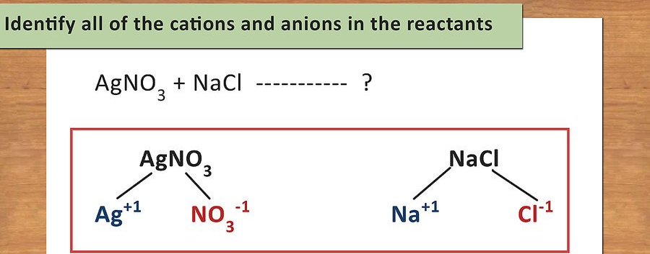
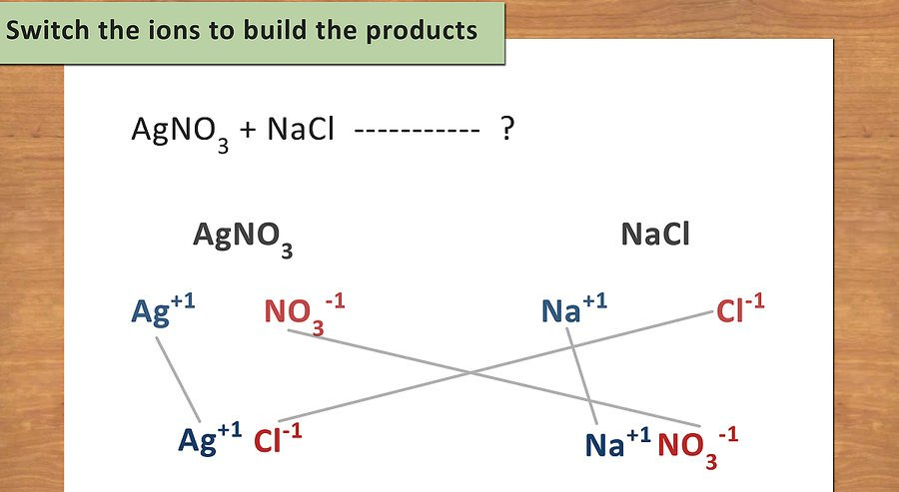
- Switch the ions to build the products. Once you have identified all of the ions and their charges, rearrange them so that the first cation is now paired with the second anion, and the second cation is now paired with the first anion. Remember the equation: AB + CD --> AD + CB.[11]
- Remember to balance the charges when forming new compounds.
- For example: AgNO3 + NaCl --> ?
- Ag+1 now pairs with Cl1- to form AgCl.
- Na+1 now pairs with NO31- to form NaNO3.

