BLOG WORKSHEET
CHEMISTRY CLASS 10

Teacher Name: Uzma Amer Class: 10 Chemistry Date: 12th jan’18

Q.1. Choose the best answers:

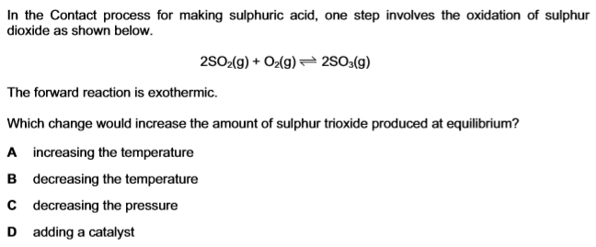

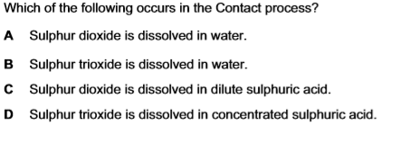
- Conversion of sulfur dioxide (SO₂) to sulfur trioxide (SO₃) is basically
- reversible reaction
- irreversible reaction
- dynamic reaction
- static reaction
- Sulfuric acid (H₂SO₄) is used in
- tanning leather
- pickling
- car batteries
- all of themAnswer D
- Excellent equilibrium yield of SO₃ at 450 °C is
- 10%
- 20%
- 79%
- 97%

Q.2.
Q.3.