BLOG WORKSHEET
CHEMISTRY CLASS 9

Teacher Name: Uzma Amer Class: 9 Chemistry Date: 12th jan’18
Q.1 Choose the best answer:
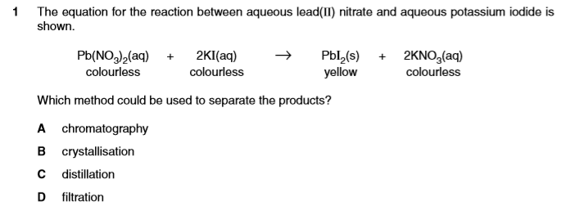
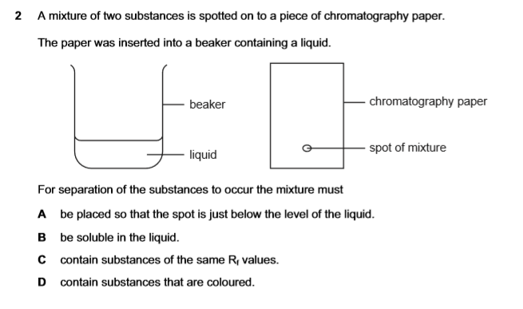
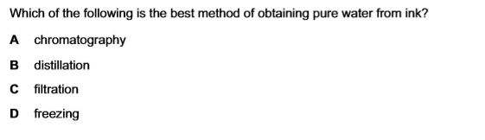

Q.2. Site 2 differences between simple distillation and fractional distillaion

