CHEMISTRY CLASS 9
REINFORCEMENT WORKSHEET
Ms. UZMA AMIR
Date: 15-5-2015

- Which two diagrams show two different types of atom of the same element?

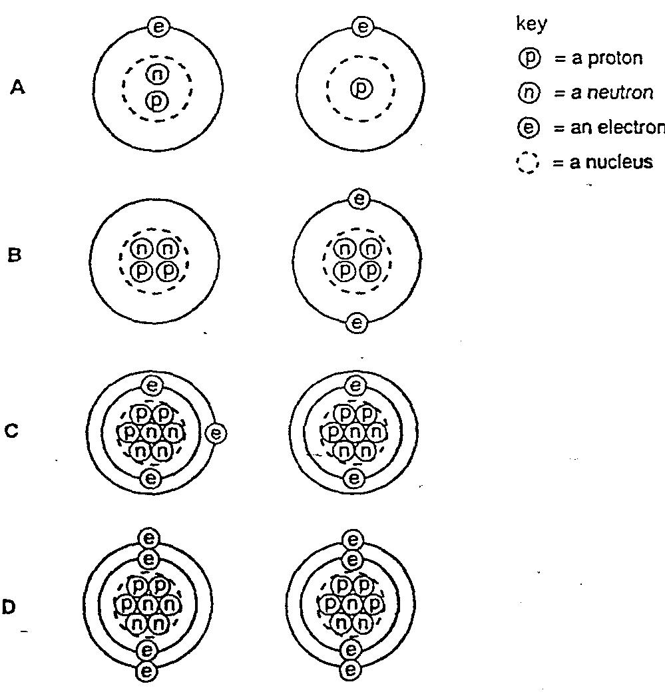

- Look at given atomic structures
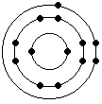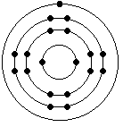
Which electron arrangement corresponds to the first element on period 2 of the Periodic Table?
- electron arrangement X
- electron arrangement Y
- electron arrangement W
- electron arrangement Z

- look at the periodic table;
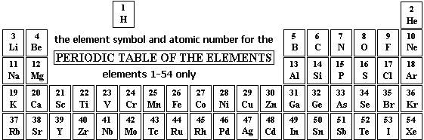
Where in the Periodic Table are you MOST LIKELY to find an element that is a low melting solid and a good conductor of heat?
- Group 7
- Group 1
- Transition series
- Group 4
- Which four quantities A, B, C and D are required to balance the equation? (Note: 1's are not written in the equation BUT they are needed in the 'balancing ratio thinking'.)
A Na₂O_{(s)} + B H₂SO_{4(aq)} ==> C Na₂SO_{4(aq)} +D H₂O_{(l)}
- 1 2 1 2
- 2 2 2 1
- 2 1 2 2
- 1 1 1

- Which is TRUE about the compound formed on combining an Alkali Metal with the Halogen element chlorine to form the metal chloride?
- the solution of it in water conducts electricity
- the solid conducts electricity
- insoluble in water
- is an ionic compound
- I is only
- I and II only
- I, II and III only
- I an IV only

- Which of the following is TRUE about the trend DOWN the Group 7 Halogens with increase in atomic number?
- the colour of the element gets darker
- the melting points decrease
- the reactivity increases
- the atoms get smaller

- The equation for the reaction between aqueous lead(II) nitrate and aqueous potassium iodide is shown.
Pb(NO3) 2(aq) + 2KI(aq) → PbI2(s) + 2KNO3(aq)
Colourless colourless yellow colourless
- Which method could be used to separate the products?
A chromatography
B crystallization
C distillation
D filtration
- How does a magnesium atom form a bond with an oxygen atom?
A by giving one pair of electrons to the oxygen atom
B by sharing one pair of electrons, both electrons provided by the magnesium atom
C by sharing two pairs of electrons, both pairs provided by the oxygen atom
D by sharing two pairs of electrons, each atom donating one pair of electrons

- What is the general relationship between lattice energy and ionic bond strength?
- The greater the lattice energy, the weaker the ionic bond
- there is no relationship
- the greater the lattice energy, the stronger the ionic bond
- the weaker the lattice energy, the stronger the ionic bond
- Magnesium oxide may be used for the lining of an electric furnace for making crockery. Which properties of magnesium oxide help to explain this use?

 | strong forces between particles | ionic bonding | electrical conductor
A  B  C  D | Yes  Yes  No  No | Yes  No  Yes  No | No  Yes  No  Yes
- The table shows the electronic structures of four atoms.

Atom | electronic structure
W  X  Y  Z | 2,8,1  2,8,4  2,8,7  2,8,8

Which two atoms combine to form a covalent compound?
- W and X
- W and Y
- X and
- D X and Z
- The following statement is about chemical bonds. Covalent bonds are formed by the …1… of electrons. Covalent substances have …2… electrical conductivity. Which words complete the statement?

 | 1 | 2
A  B  C  D | Sharing  Sharing  Transfer  Transfer | High  Low  High  Low

- Below are two statements about metals.
I .Metals contain a lattice of negative ions in a ‘sea of electrons’.
II. The electrical conductivity of metals is related to the mobility of the electrons in the structure. Which is correct?
- Both statements are correct and statement 1 explains statement 2.
- Both statements are correct but statement 1 does not explain statement 2.
- Statement 1 is correct and statement 2 is incorrect.
- Statement 2 is correct and statement 1 is incorrect
- Which of the following is NOT a trend that varies systematically in the periodic table?
- Electron Negativity
- symbols of elements
- ionization energy
- atomic radius
- following picture are showing some methods of Purification

