BLOG WORKSHEET
CHEMISTRY CLASS 9

Teacher Name: Uzma Amer Class: 9 Chemistry Date: 26th jan’18
Q.1. Choose the best answers:
- Which electron arrangement is that of a metallic element?
- 2,1 b) 2,7 c) 2,5 d) 2,4
II .Which of the following contains the same number of electrons as an atom of neon?
a) Cl⁻ b) Li⁺ c) C O⁻² d) Na
III. Use the Periodic Table to decide which element has all four of the properties shown.
* high melting point * good electrical conductivity
a) Caesium, Cs b) Chlorine Cl c) Iodine, I d) Strontium, Sr
- X and Y are diatomic elements. X is less reactive than Y.
What are elements X and Y?
Element X is solid at room temperature.
It needs one electron per atom to gain the electronic structure of a noble gas.
It is the least reactive element in its group.
What is the element X?
a) At b) Cs c) F d) Li
- The letters X, Y and Z represent different atoms.
atoms | Proton number | Nucleon number
X | 19 | 40
Y | 19 | 39
Z | 20 | 40
What can be deduced from the proton numbers and nucleon numbers of X, Y and Z?
- X and Y are the same element.
- X and Z are the same element.
- X has more protons than Y.
- Z has more neutrons than Y
Q.2. Define the following terms:
- Valancy
- Oxidation State
- Ion
- Electrostatic force
Q.2. Draw the electronic structure of both a sodium ion and a chloride ion.[2]

Sodium ion Chloride ion

Q.3. Look at the given picture and answer the following questions:

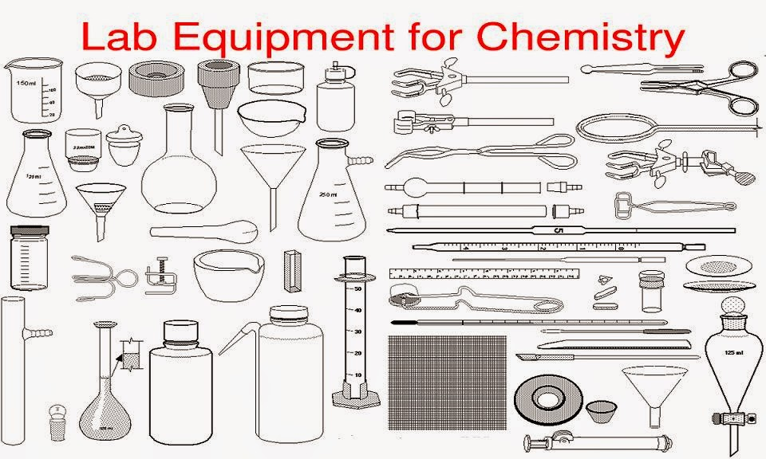
- Identify at least five equipments and write down their names:
- Describe the uses of those equipments:

