BLOG WORKSHEET
CHEMISTRY CLASS 9

Teacher Name: Uzma Amer Class: 9 Chemistry Date: 9th Feb’18
Q.1 Choose the best answer:
- Look at the pictures and find out the correct sequence in the given table.
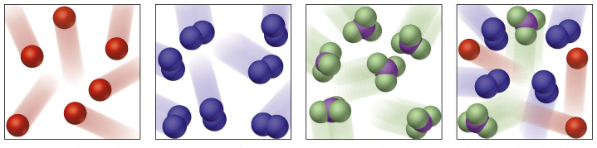

 | Mixture | Molecule of Elements | Molecule of compounds
A  B  C  D | X  Z  W  Z | Y  X  X  W | Z  Y  Y  X

- Which diagram represents the structure of the sodium Chloride?
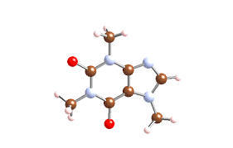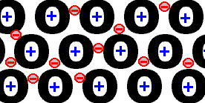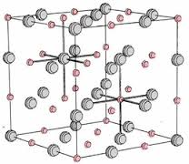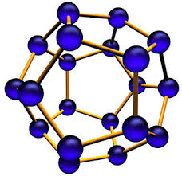
A B C D
- Which is TRUE about the compound formed on combining an Alkali Metal with the Halogen element chlorine to form the metal chloride?
- the solution of it in water conducts electricity
- the solid conducts electricity
- insoluble in water
- is an ionic compound

- I is only
- I and II only
C. I, II and III only
D. I an IV only
- How does a magnesium atom form a bond with an oxygen atom?

- by giving one pair of electrons to the oxygen atom
- by sharing one pair of electrons, both electrons provided by the magnesium atom
- by sharing two pairs of electrons, both pairs provided by the oxygen atom
- by sharing two pairs of electrons, each atom donating one pair of electrons
- The bond between two identical non-metal atoms has a pair of electrons:

- transferred fully from one atom to another
- equally shared between them
- with identical spins
- unequally shared between the two.

Q. 2. Sodium Chloride is used as common salts at homes
- Suggest the type of bonding that is present in sodium chloride.
- What is the oxidation number of sodium in sodium chloride?
- Why sodium chloride has high melting point?

