The City School
North Nazimabad Boys Camp
Ammonia And Reversible Reactions
Class :10
1:Ammonia is made by the Haber process using an iron catalyst.
N2 + 3H2 2NH3 ΔH= –92 kJ/mol
(a) On the same axes draw energy profile diagrams to show both the catalysed and the
uncatalysed reaction. Label the diagram to show
• the catalysed and uncatalysed reactions,
• the reactants and products,
• the enthalpy change for the reaction. [3]
(b) The raw materials for the Haber process can be obtained from the air and from hydrocarbons produced by the distillation of petroleum.
(i) Describe how pure nitrogen can be separated from other gases in the air.
………………………………………………………………………………………………………………………………………………….. [1]

(ii) Describe how hydrogen can be made from hydrocarbons.
…………………………………………………………………………………………………………………………………………………..
…………………………………………………………………………………………………………………………………………………… [2]
(c) Explain how the position of equilibrium in the Haber process is altered by
(i) an increase in pressure,
…………………………………………………………………………………………………………………………………………………. [2]
(ii) an increase in temperature.
………………………………………………………………………………………………………………………………………………… [2]
[Total: 10]
2: When hydrogen and iodine are heated in a sealed container an equilibrium is reached
with the product, hydrogen iodide.
H2(g) + I2(g) 2HI(g) ΔH = – 9.6 kJ / mol
(i) Predict the effect of the following on this equilibrium:
increasing the temperature,
…………………………………………………………………………………………………………………………………………………… [1]
decreasing the concentration of hydrogen iodide.
......................................................................................................................................................... [1]
(ii) At 400 °C the equilibrium mixture contains 0.4000 moles of hydrogen, 0.07560 moles
of iodine and 1.344 moles of hydrogen iodide.
Calculate the percentage of iodine molecules, I2, by mass in this equilibrium
mixture.
[2]
[Total:4]

3: Ammonia is manufactured by the Haber process.
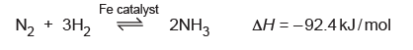

The table below shows how the percentage yield of ammonia at equilibrium varies with both
temperature and pressure
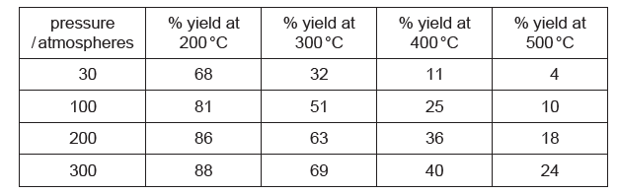

(a) Describe how, and explain why, the percentage yield of ammonia at equilibrium changes with
temperature.
...................................................................................................................................................
...................................................................................................................................................
............................................................................................................................................... [2]
(b) Describe how, and explain why, the percentage yield of ammonia at equilibrium changes with
pressure.
...................................................................................................................................................
...................................................................................................................................................
............................................................................................................................................... [2]
(c) Explain why the conditions for the synthesis of ammonia in most chemical plants are between
350–450 °C and 200–300 atmospheres pressure.
...................................................................................................................................................
...................................................................................................................................................
...................................................................................................................................................
............................................................................................................................................... [2]
(d) Explain how using a catalyst in the Haber process has an economic advantage.
...................................................................................................................................................
...................................................................................................................................................
............................................................................................................................................... [2]

(e) Ammonia is used to make fertilisers such as ammonium phosphate, (NH4)3PO4.
Calculate the percentage by mass of nitrogen in ammonium phosphate. [2]

[Total: 10]

