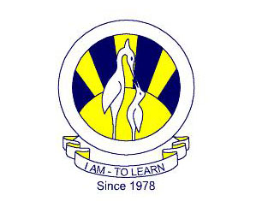
The City School
North Nazimabad Boys Branch

Teacher: Uzma Aamir

Syllabus second scheduled test oct’17
CHEMMISTRY 9
- ELEMENTS COMPOUNDS AND MIXTURES.
- ATOMIC STRUCTRUE
CHEMISTRY 10
- RATE OF REACTION.

