Teacher Name: Class: Subject: Date:
Khurram khan 10 chemistry 15th January 2018.
reference year: nov 2010/p2/22
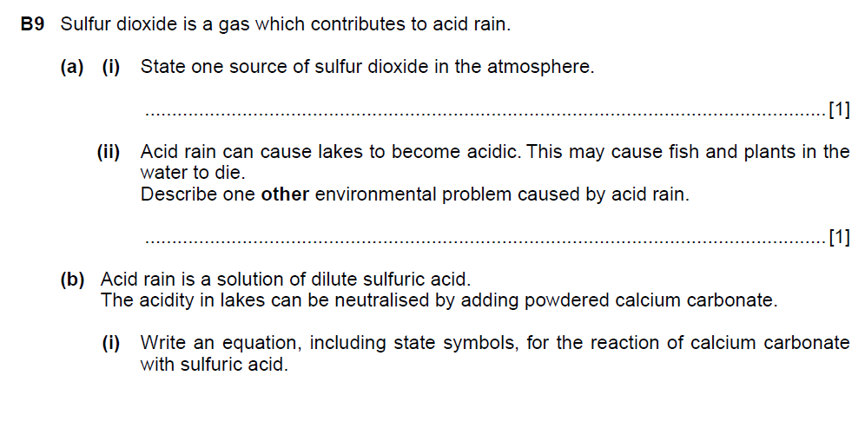

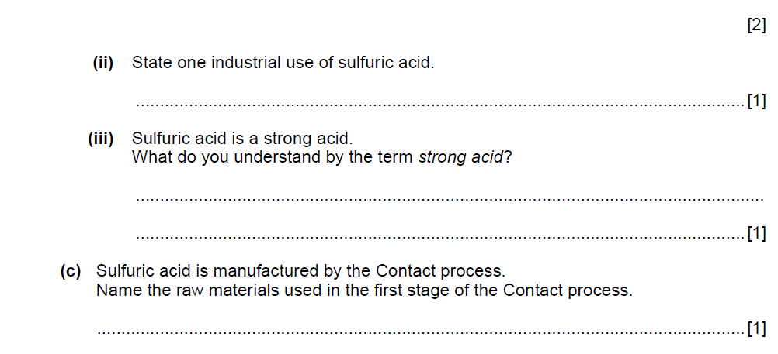

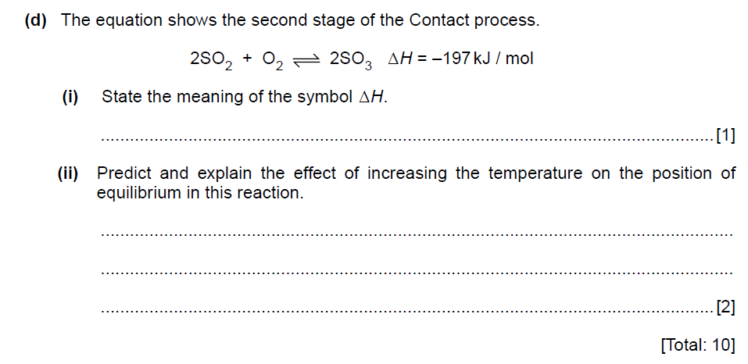

Teacher Name: Class: Subject: Date:
Khurram khan 10 chemistry 15th January 2018.

Reference; nov 2012/p2/21
