The City School
North Nazimabad Boys Branch
Subject: Computer Science/ Class: 9
Question Bank

Q1: State two suitable applications for each printer below. A different application must be given for each printer.
Inkjet printer................................................................................................................................................................
……………………………….. ...................................................................................................................................................
3D printer.....................................................................................................................................................................
................................................................................................................................................................................
Q2: Automatic doors in a building are controlled by the use of infrared sensors and a microprocessor.
Describe how the sensors and the microprocessor are used to automatically open a door as a person approaches.

Q3: The steps to print a document using a laser printer are shown in the table below.
Put each step in the correct order. The first step has been done for you.

Q4: The LCD (liquid crystal display) on the clock face is back-lit using blue LEDs (light emitting diodes). The brightness of the clock face is determined by the level of light in the room. The amount of light given out by the LEDs is controlled by a control circuit.
- Describe how the sensor, microprocessor and LEDs are used to maintain the correct brightness of the clock face. /4

- Modern LCD monitors and televisions use LED back-lit technology. Give two advantages of using this new technology compared to the older cold cathode fluorescent lamp (CCFL) method with the reason. /4

Q.5 An infrared touchscreen is used to view and navigate the supermarket stock system. Explain how the infrared touch screen detects a user’s touch.
…………………………………………………………………………………………………………………………………………………………………………………………………………………………………………………………………………………………………………………………………………………………………………………………………………………………………………………………………………………………………………………………………………………………………………………………………………………………………………………………………………………………………………………………………………………………………………………………………………………………………………………………………………………………………………………………………………………………………………………………………………………………………………………………………………………………………………………………………………………………………………………………………………………………………………………………………………………………………………………………………………………………………………………………………………………………………………………………………………………………………………………………………………………………………………………………………………………………………………………………………………………………………………………………………………………………………………………………………………………………………………………………………………………………………………………………………………………………………………………………………………………………………………………………………………………………………………………………………………………………………

Q.6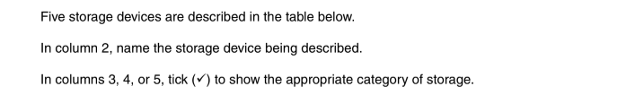
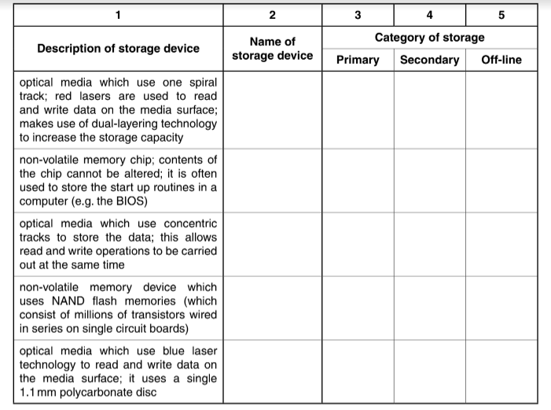

Q.7
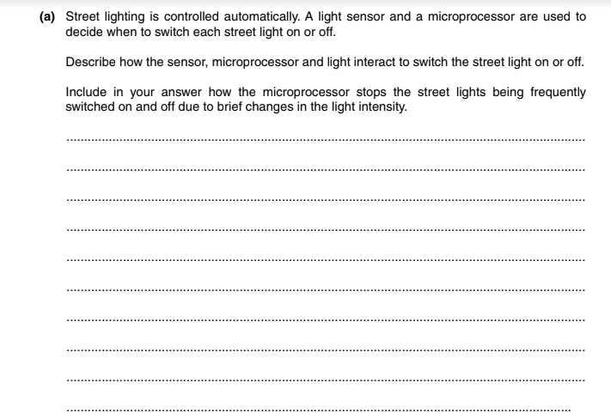
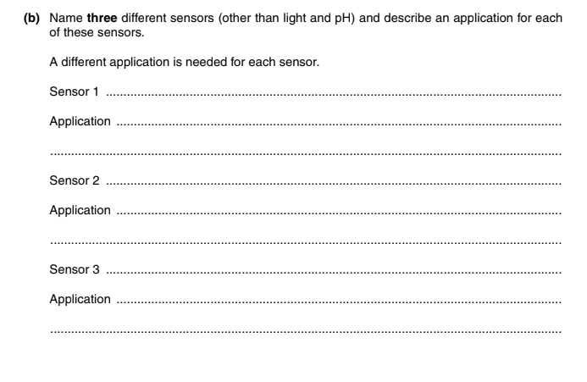

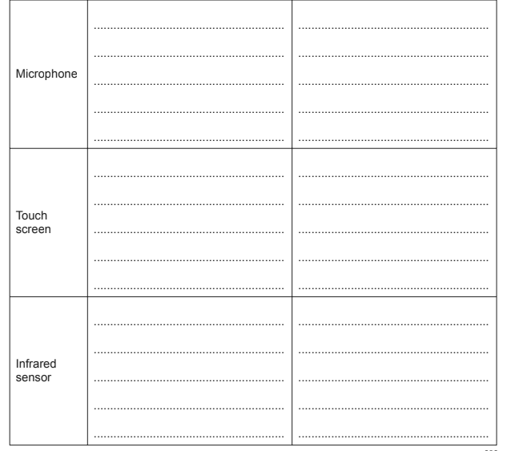
Q.8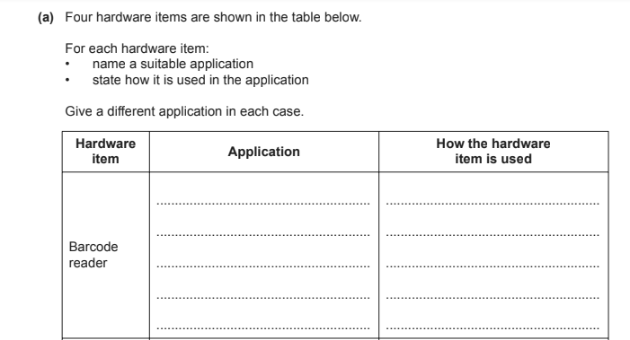

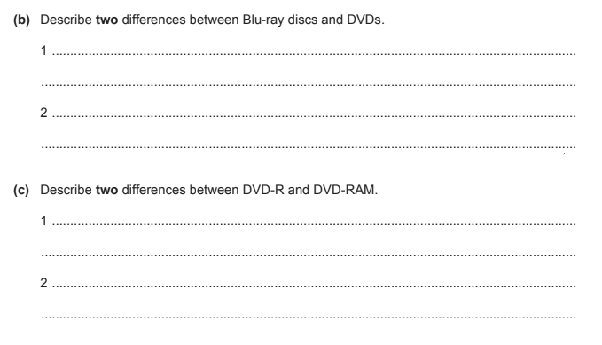

Q.9
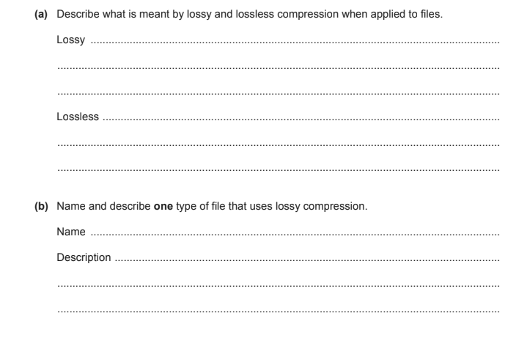
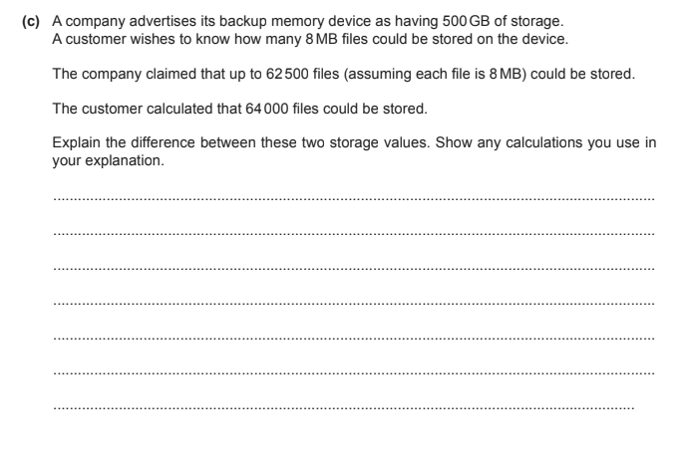
Q.10
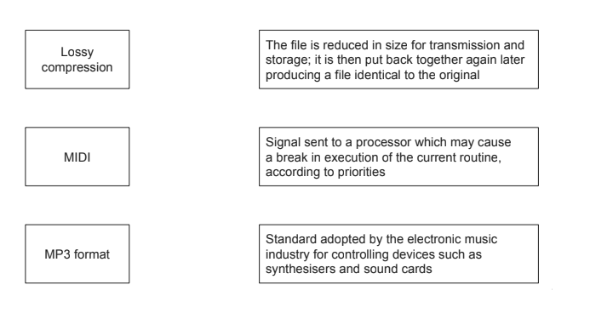
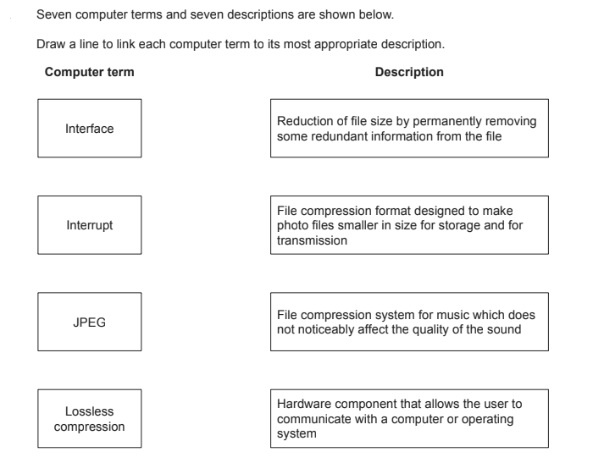

Q.11

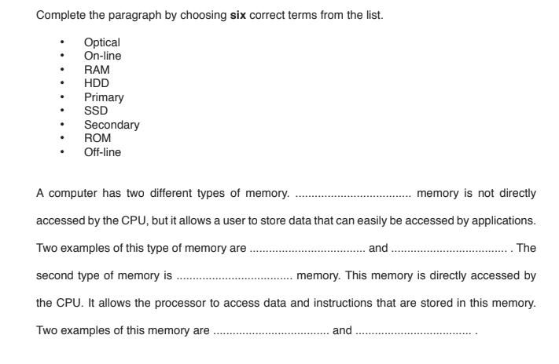
Q.12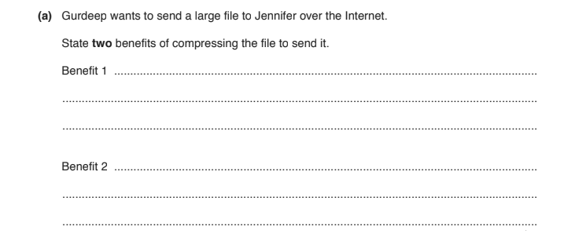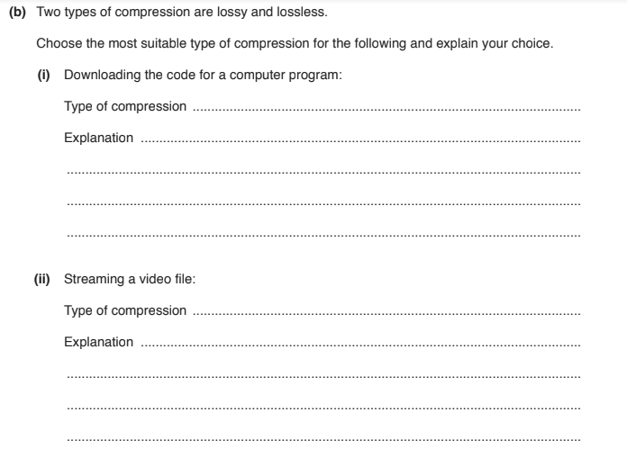

Q.13
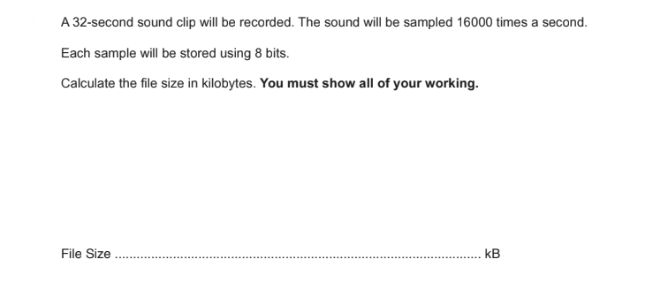
Q.14
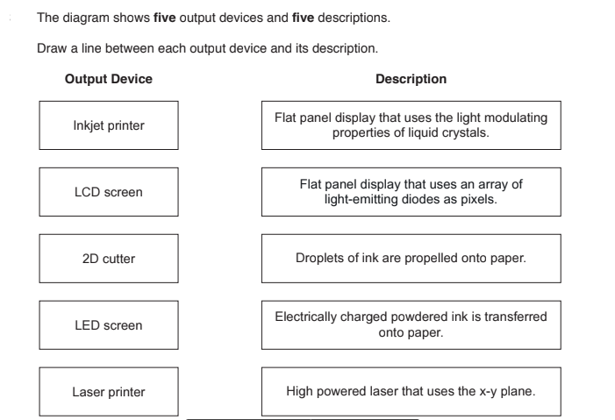

Q.15
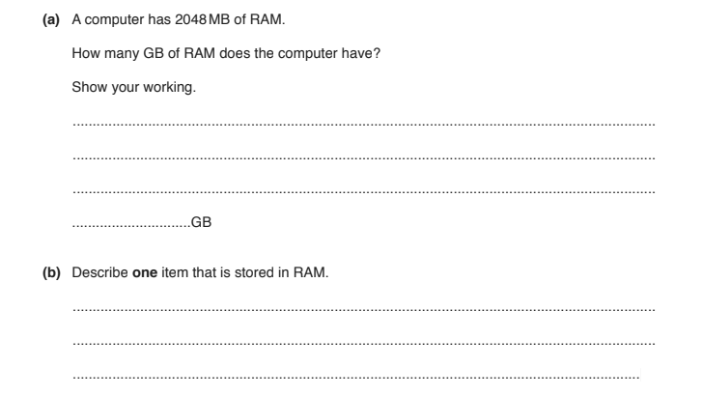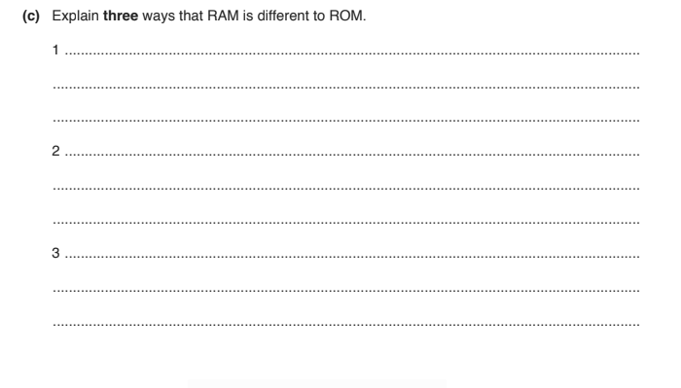

Q.16

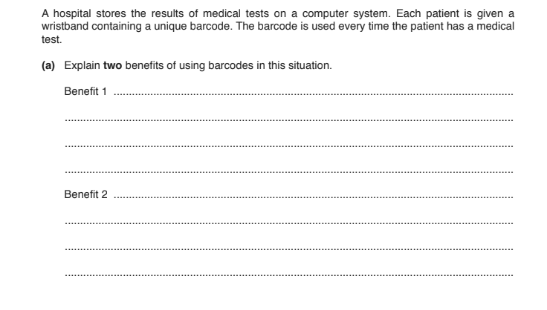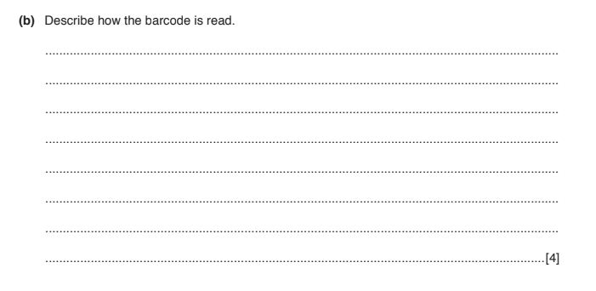

Q.17
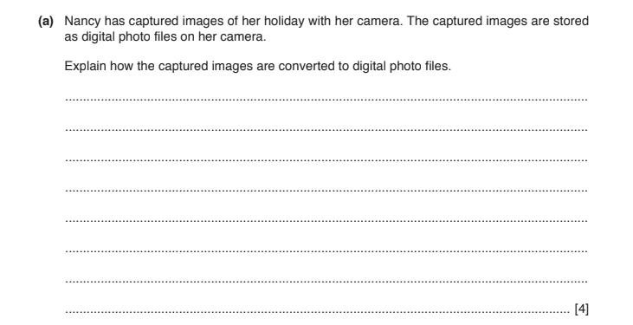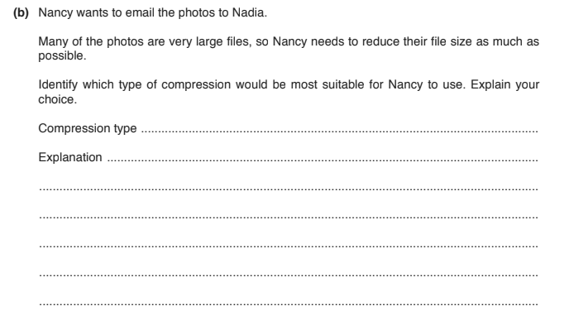

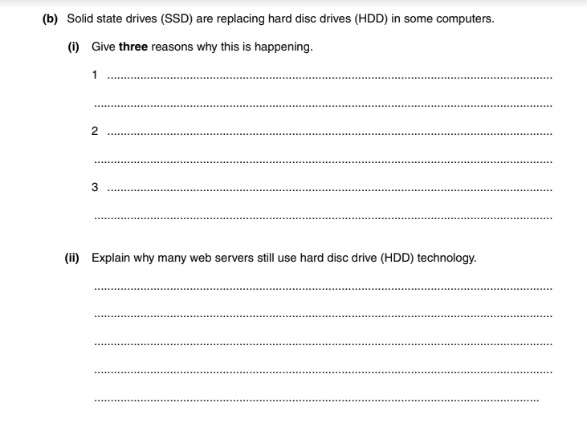
Q.18