The City School
North Nazimabad Boys Campus
Comprehensive Worksheet
Mathematics
Class 9
Ms Sheema
Paper 1
Q1: The sides of a rectangle plot of land are measured correct to the nearest metre. the measurements are given as 20m by 3m.
- Write down the upper bound of the length of the plot of land.
- ii) Find the least possible perimeter of the plot.

Q2: a) Find the lowest common multiple of 12, 30 and 66.
b) Three lightships flash simultaneously at 6 00 a.m. , the first lightship flashes every 12 seconds, the second light ship every 30 seconds and the third lightship every 66 seconds. At what time will the lightships next flash together?

Q3: a) The first four terms of a sequence are 8, 13, 18 and 23.
- Write down the 10th term.
- The nth term is 5n +k. Find the value of k.
b) The nth term of another sequence is 7n + 1.
Find the value of the term of this sequence which is closest to 1999.
c) i) Express as single fraction $\frac{2x}{5}$ - $\frac{x}{4}$
ii) Simplify $\frac{3a}{5c^{2}}$×$\frac{10c^{3}}{a^{2}}$
d) A clock gains s seconds in one hour. Write down, in its simplest form, an expression in terms of s and d for the number of minutes it gains in d days.

Q4: a) the numbers (x- 1), x and (x+1) are three successive positive integers. When they are multiplied together, the product of the three numbers is 120 times their sum.
- Use this information to form an equation, in terms of x, and show that it simplifies to $x^{3}$- 361x = 0
- Factorise completely $x^{3}$- 361 x.
- Find the three integers.
b) Make k the subject of the formula
c = $\frac{k^{2}+ h^{2}}{h}$
Q5: The diagram shows the point A(1,2), B( 4,6) and D( -5, 2)
- Find the coordinates of the midpoint of AB.
- Calculate the length of AB.
- Calculate the gradient of the line AB.
- Find the equation of the line AB.
- The triangle ABC has line of symmetry x=4. Find the coordinates of C.
- Find the value of cosine DAB.

Q6: A

10

X
B 8 D
C

In the Diagram, ABCD is a quadrilateral with BA parallel to CD.
AC and BD meet at X where CX = 8 cm and XA =10cm.
- Given that BD = 27, find the length BX.
- Find the ratio: area of triangle BXC: area of triangle AXD.

Q7: The base of a pyramid is a square with diagonals of length 6cm. the sloping faces are isosceles triangles with equal sides of length 7cm. the height of the pyramid is √l cm.
Calculate l.

A

Q8: Important question: Ref (D98 P1/Q22)

Q9: In the diagram, BCD is a straight line. BC=5cm , AB=12cm and AC = 13cm and ABC=90◦.
Find:
- Tan BAC.
- Cos ACD. Give both answers as fractions.

Q10:

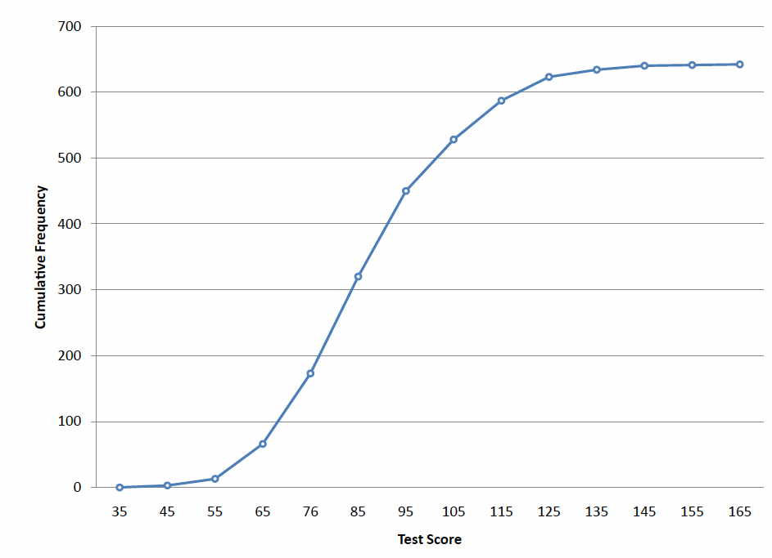
Find
- The median,
- The upper quartile,
- The number of pupil with marks in the range of 65< m ≤ 72.

Paper 2
Q1: In 2001 the price of one litre of petrol was 72 cents.
- 65% of this is “tax” and the remainder is other cost,
- Find, in simplest form, the ratio of tax to other costs. Give3 your answer in the form m:n, where m and n are integers.
- Calculate how much tax is paid on one litre of petro;\l.
- Moureen brought as many complete litres of petrol as she could with a $20 note ( $1= 100 cents).
- Calculate how many litres she bought.
- Calculate how much change she received.
Q2: a) Factorise completely 2tv + t -10v -5.
- Make k the subject of the formula
- √$\frac{h}{k}$ = 3
- Solve the equation $x^{2}$ - 23x + 81 = 0, giving both answers correct to two decimal places.
Q3:

X x+3
Rectangle A Rectangle B
Two rectangles, A and B, each have an area of 11 ${cm}^{2}$. The length of rectangle A is x cm. the length of rectangle B is ( x+3) cm.
- Find, in terms of x, an expression for the width of i) Rectangle A.
- Rectangle B.

