The City School

North Nazimabad Boys Campus

# Subject: Mathematics

# Comprehensive Test Paper 1 (40 min)

# Final Term 2015

# Name_______________________ Class9/Sec: ________Date:___________ Max.Marks ( /40)

**Electronic Calculators Must Not Be Used In This Paper**

Q1: There were 365 days in the year 2000. The first day of the year was a Saturday. On what day of the week did 2001 begin? (1)

Q2: The price of a box of shampoo increased from $2.50 to $2.65. Calculate the percentage increase in the price. (2)

Q3: a) Express 0.65 as a fraction. (1)

b) Express $200 as a percentage of $500. (1)

Q4: a) Expand and simplify (x $-$ 1)($x^{2}$ +x+1) (2) Q5: The diagram shows the point A(1,2), B(4,6) and D(-5, 2).

.B(4,6)

.D(-5, 2) .A(1,2)

a) Find the coordinate of the midpoint of AB. (1)

b) Calculate the length of AB. (2)

c) Calculate the gradient of the line AB. (1)

d) Find the equation of the line AB. (2)

e) The triangle ABC has line of symmetry x $=$ 4. Find the coordinate of C. (2)

Q6: The diagrams below show the first three patterns in a sequence.

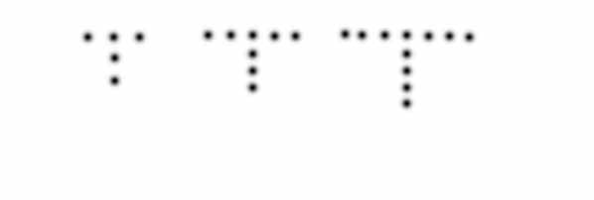

1. Complete the table. (1)

|  |  |  |  |  |  |
| --- | --- | --- | --- | --- | --- |
| Pattern number | 1 | 2 | 3 | 4 | 5 |
| Number of dots | 5 | 8 |  |  |  |

1. Find an expression, in terms of n, for the number of dots in Pattern n. (1)
2. In this sequence, Pattern p has 83 dots. Find the value of p. (2)

Q7: Eleven people work for a company. Five office workers each have a car allowance of $10000. Six managers have car allowance of:

$ 12000, $ 18000, $ 20000, $24000, $ 28000, $35000.

1. State
2. The median car allowance. (2)
3. The mode of this distribution. (1)
4. Calculate the mean car allowance. (2)

Q8: A car travels 144 km in *h* hours. Write down, in its simplest form, an expression in terms of *h* for its average speed in metres per second. (2)

Q9:a) Find the value of (2)



$\sqrt{121}$

$\sqrt[3]{-27}$

b) Write the following numbers in order of size, starting with the smallest. (2)

$2^{3} 3^{2} 4^{0}$ $5^{-1}$

c)Evaluate ${16}^{\frac{3}{2}}$ (1)

Q10: A man who is 1.8m tall stands on horizontal ground 50m from a vertical tree. The angle of elevation of the top of the tree from his eyes is 30˚. Use as much of the information below as is necessary to calculate an estimate of the height of the tree. Give the answer to a reasonable degree of accuracy. ( sin 30˚= 0.5, cos 30˚=0.866, tan 30˚=0.577) (4)

30˚ *h*

tree

man

1.8 m

50m

# Q13: a)Solve the following inequality, illustrating each solution by a number line:

# 5( 1 – 2x ) ≥ 6 ( 2 – x ) (2)

# b) Determine whether the triangles are congruent or not. If the triangles are congruent,

# i) Write down the congruency (1)

# ii) State the case of congruency (1)

# iii) Name the three pairs of equal measurements. (1)

# 

# T S

# 9cm 9cm

# 

# P 4cm Q 4cm R

# 

The City School

North Nazimabad Boys Campus

# Subject: Mathematics

# Comprehensive Test Paper 2 (60 min)

# Final Term 2015

# Name_______________________ Class9/Sec: ________ Date:____________ Max.Marks ( /60)

Q1: a)These are the prices for a ride in an amusement park.

|  |
| --- |
| Adults $\$$ 3.60 |
| Child $\$$ 2.25 |

1. A family of two adults and three children went on the ride. They paid with a $\$$ 20 note. Calculate the change they received. (4)
2. Express $\$$ 2.25 as a percentage of $\$$ 3.60. (4)

b)Diagram II shows part of the ride. The carriage that carried the family was 4.6m long. It was travelling at a constant speed of 15 m/s as it passed the point F.

i) Calculate, correct to the nearest hundredth of a second, the time taken for the carriage to pass the point F. (4)

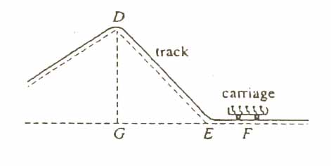ii)Express 15m/s in kilometers per hour. (4)

Q2:a) the point A and B are (-2,1) and (6,-5) respectively. Calculate:

1. The gradient of the line AB, (4)
2. The equation of the line through A and B. (4)

b)the point C and D are (4,5) and (p ,q) respectively.

i) Write down, in terms of p and q, the coordinates of the midpoint of CD. (4)

ii) Given that the midpoint of CD is (7, 1), find the coordinated of D. (4)

Q3:One hundred and sixty students took an examination. The table shows the marks needed for each grade. The cumulative frequency curve shows the distribution of their marks.

|  |  |
| --- | --- |
| Grade A | 70 ˂ marks |
| Grade B | 55 ˂ marks ≤ 70 |
| Grade C | 40 ˂ marks ≤ 55 |
| Grade D | 20 ˂ marks ≤ 40 |
| Grade E | Marks ≤ 20 |

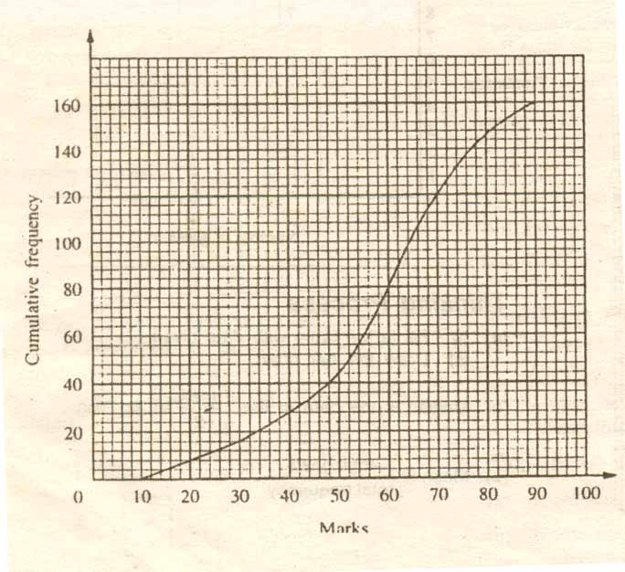

1. Use the graph to estimate
2. the median, (4)
3. the inter quartile range, (4)
4. the number of students who were awarded a Grade C. (4)
5. 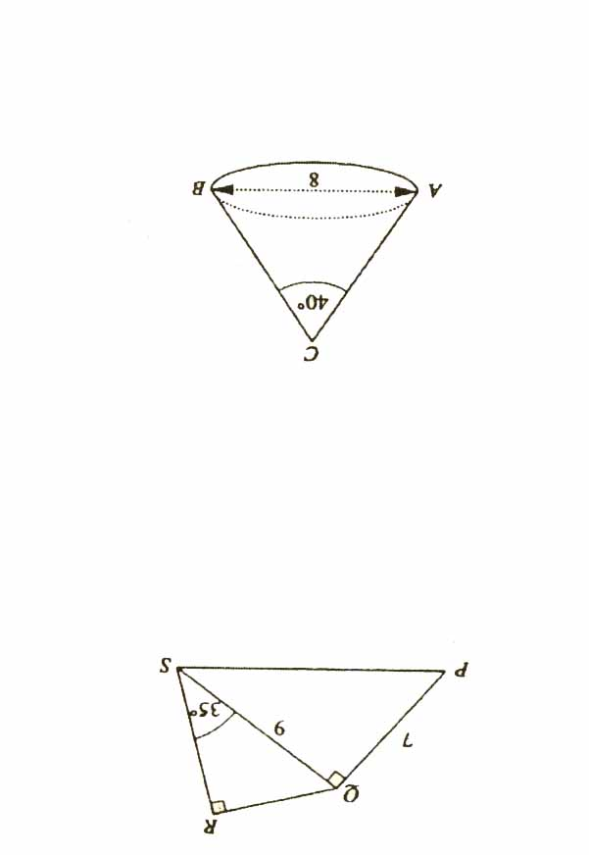A pie chart was drawn to illustrate the graph awarded to the students. Calculate the angle of the sector which represented the number of students who were awarded a Grade C. (4)

Q4:

In the quadrilateral PQRS, PQ=7cm and QS = 9cm. PQS =QRS=90ᵒ and QSR=35ᵒ.

1. SPQ . (3)
2. RS. (3)

b)[The area of the curved surface of a cone of radius r and slant height *l* is $π$ r*l* ]

The diagram shows a cone ABC. The diameter AB=8cm and ACB=40.

Calculate the curved surface area of this cone. (4)