** The City School**

North Nazimabad Boys Campus

# Subject: Chemistry

# Comprehensive Test (1 hour)

# Name___________________________ Class9/Sec: ________ Date:___________ Max. Marks (50)

Q.1.The structure of sodium chloride is drawn below.

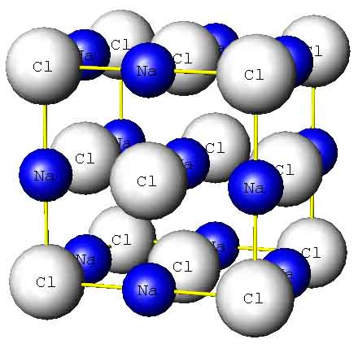

1. Sodium chloride is an ionic solid. Draw the electronic structure of both a sodium ion and a chloride ion.

sodium ion chloride ion [2]

1. Sodium chloride has a melting point of about 801 °C. Explain why sodium chloride has a high melting point [2]
2. Calcium oxide (CaO) has a similar structure to sodium chloride. Suggest why the melting point of Calcium oxide is higher than that of sodium chloride. [2]
3. Explain why? [4]
4. Solid sodium chloride conducts electricity only in molten form and in aqueous solution.
5. Crystal of sodium Chloride is brittle.

Q.2 (a) Define the following terms: [2]

1. Mole
2. Relative molecular mass

(b).calculate the Relative molecular masses of the given compounds: [3]

1. A compound XCl having molecular mass (Mr) of 58.5.Find out Mr of XCO3.
2. A compound X2O having molecular mass (Mr) of 62 Find out Mr of X2SO4
3. A compound XCl2 having molecular mass (Mr) of 111.Find out Mr of X(NO3)2

Q.3.Look at following diagrams: [4]

[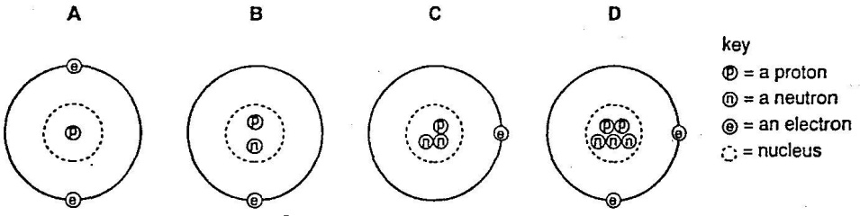](http://2.bp.blogspot.com/-E61SWW8gi9c/UZ8EmByoW3I/AAAAAAAABUY/A9UaPGwU_xA/s1600/w986.jpg)

1. Which atom has a mass of 5?
2. Which atoms are isotopes of each other?
3. What is the charge on above atoms?
4. Explain your answer of part c.

Q. 4. Following pictures are showing some methods of Purification

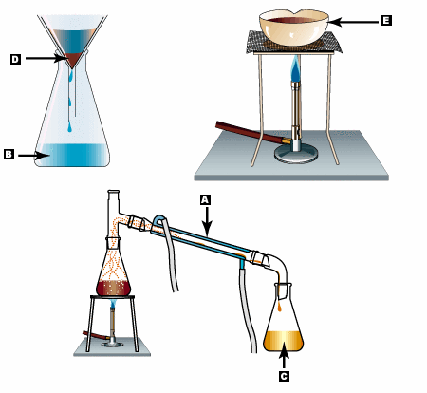

1. Label the marked apparatus : (any 3) [3]
2. State names the methods of purifications shown in the above pictures: [3]
3. Identify the applications of the above purification techniques: [6]

Q.5. Part of the reactivity series of metals is shown below.

Most reactive

|  |  |
| --- | --- |
| 1 | Potassium |
| 2 | Sodium |
| 3 | Calcium |
| 4 | Aluminum |
| 5 | Zinc |
| 6 | Lead |

Least reactive

Use the information above.

1. Which two metals would react with calcium chloride in a displacement reaction? [2]
2. Write down symbol equations for the above displacement reactions: [2]
3. What does **Displacement reaction** mean? [2]

Q.6. when acid reacts with carbonates a gas is produced:

1. Name the gas produced during the reaction. [1]
2. Describe a chemical test for this gas. [2]
3. Write the equation for the reaction of calcium carbonate and sulphuric acid. [1]
4. Lime can control the acidity in soil. Why? Explain in terms of neutralization. [2]
5. Name one product that forms when it is used. [2]
6. Write general equation of neutralization. [1]
7. Cite one difference between bases and alkalis. [2]
8. Complete the given table using the oxides given below: [2]

CO,CaO,CO2,Al2O3,NO,PO4,ZnO,FeO

|  |  |  |  |  |
| --- | --- | --- | --- | --- |
|  | Acidic oxide | Basic oxide | Amphoteric oxide | Neutral oxide |
|  |  |  |  |  |
|  |  |  |  |  |
|  |  |  |  |  |