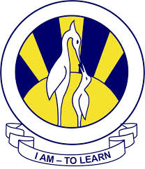
North Nazimabad Boys Campus
Subject = Computer Science Topic= Binary System and Hexadecimal
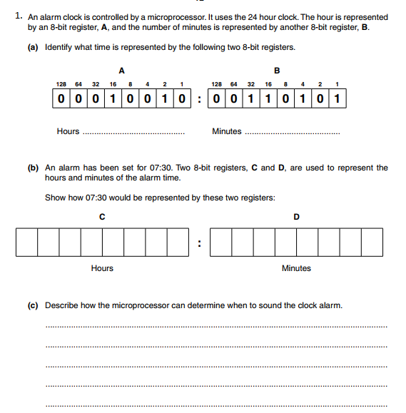
Level= 9 Date= 12/1/2018

