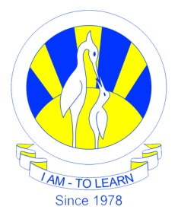
The City School
North Nazimabad Boys Campus
MYE Syllabus Session 2016-17
Date: 16-11-2016
Subject: Computer Science
Class: 10
Teacher: Lubna Tanweer
Chapter 3: Logic Gates and Logic Circuits
Chapter 4: Operating System and Computer Architecture
Chapter 10: Pseudo code and flowchart

