The City School
North Nazimabad Boys Campus

Date: 05-11-2016 Class: 10 Subject: Computer Science Teacher: Lubna Tanweer

Console. A console program has no graphics. It is text. Easy to develop, it uses few resources and is efficient. It will win no visual design awards.
These programs, however, will readily accomplish an analytical or processing task. We invoke WriteLine and Write. We can use ReadLine for input. Numbers and strings are handled.
An example. This program uses Console.WriteLine. It prints "Hello world" to the screen. The program is contained in a module named Module1. The Sub Main is the entry point of the program.

First program
Module Module1
Sub Main()
' Say hi in VB.NET.
Console.WriteLine("Hello world")
Console.ReadKey()

End Sub
End Module

ReadLine. Writing is most common with the Console type. But we can also read lines, from the keyboard, with ReadLine. The ReadLine Function returns a String.
Here:This program repeatedly calls ReadLine. It tests the input after the return key is pressed.
If Then
Info:We see if the user typed "1" or "2" and pressed return. We also display the output.
VB.NET program that uses ReadLine

Module Module1
Sub Main()
While True

' Read value.
Dim s As String = Console.ReadLine()

' Test the value.
If s = "1" Then
Console.WriteLine("One")
ElseIf s = "2" Then
Console.WriteLine("Two")
End If

' Write the value.
Console.WriteLine("You typed " + s)

End While
End Sub
End Module

Output

1
One
You typed 1
2
Two
You typed 2
3
You typed 3

Data Types Available in VB.Net

Module DataTypes
Sub Main()
Dim b As Byte
Dim n As Integer
Dim si As Single
Dim d As Double
Dim da As Date
Dim c As Char
Dim s As String
Dim bl As Boolean
b = 1
n = 1234567
si = 0.12345678901234566
d = 0.12345678901234566
da = Today
c = "U"c
s = "Me"
If ScriptEngine = "VB" Then
bl = True
Else
bl = False
End If
If bl Then
'the oath taking
Console.Write(c & " and," & s & vbCrLf)
Console.WriteLine("declaring on the day of: {0}", da)
Console.WriteLine("We will learn VB.Net seriously")
Console.WriteLine("Lets see what happens to the floating point variables:")
Console.WriteLine("The Single: {0}, The Double: {1}", si, d)
End If
Console.ReadKey()
End Sub

End Module
When the above code is compiled and executed, it produces the following result:
U and, Me
declaring on the day of: 12/4/2012 12:00:00 PM
We will learn VB.Net seriously
Lets see what happens to the floating point variables:
The Single:0.1234568, The Double: 0.123456789012346

Accepting Values from User
The Console class in the System namespace provides a function ReadLine for accepting input from the user and store it into a variable. For example,
Dim message As String
message = Console.ReadLine
The following example demonstrates it:
Module variablesNdataypes
Sub Main()
Dim message As String
Console.Write("Enter message: ")
message = Console.ReadLine
Console.WriteLine()
Console.WriteLine("Your Message: {0}", message)
Console.ReadLine()
End Sub
End Module
When the above code is compiled and executed, it produces the following result (assume the user inputs Hello World):
Enter message: Hello World
Your Message: Hello World

VB.Net - Constants and Enumerations
The constants refer to fixed values that the program may not alter during its execution. These fixed values are also called literals.
Constants can be of any of the basic data types like an integer constant, a floating constant, a character constant, or a string literal. There are also enumeration constants as well.
The constants are treated just like regular variables except that their values cannot be modified after their definition.
An enumeration is a set of named integer constants.

Declaring Constants
Where, each constant name has the following syntax and parts:
constantname [ As datatype ] = initializer
- constantname: specifies the name of the constant
- datatype: specifies the data type of the constant
- initializer: specifies the value assigned to the constant
For example,
'The following statements declare constants.'
Const maxval As Long = 4999
Public Const message As String = "HELLO"
Private Const piValue As Double = 3.1415

Example
The following example demonstrates declaration and use of a constant value:
Module constantsNenum
Sub Main()
Const PI = 3.14149
Dim radius, area As Single
radius = 7
area = PI * radius * radius
Console.WriteLine("Area = " & Str(area))
Console.ReadKey()
End Sub
End Module
When the above code is compiled and executed, it produces the following result:
Area = 153.933

VB.Net - Modifiers
The modifiers are keywords added with any programming element to give some especial emphasis on how the programming element will behave or will be accessed in the program
For example, the access modifiers: Public, Private, Protected, Friend, Protected Friend, etc., indicate the access level of a programming element like a variable, constant, enumeration or a class.
Private | Specifies that one or more declared programming elements are accessible only from within their declaration context, including from within any contained types.
 | Protected | Specifies that one or more declared programming elements are accessible only from within their own class or from a derived class.
 | Public | Specifies that one or more declared programming elements have no access restrictions.

VB.Net - Statements
A statement is a complete instruction in Visual Basic programs. It may contain keywords, operators, variables, literal values, constants and expressions.
Statements could be categorized as:
- Declaration statements - these are the statements where you name a variable, constant, or procedure, and can also specify a data type.
- Executable statements - these are the statements, which initiate actions. These statements can call a method or function, loop or branch through blocks of code or assign values or expression to a variable or constant. In the last case, it is called an Assignment statement.

Declaration Statements
The declaration statements are used to name and define procedures, variables, properties, arrays, and constants. When you declare a programming element, you can also define its data type, access level, and scope.
The programming elements you may declare include variables, constants, enumerations, classes, structures, modules, interfaces, procedures, procedure parameters, function returns, external procedure references, operators, properties, events, and delegates.
Following are the declaration statements in VB.Net:
S.N | Statements and Description | Example
1 | Dim Statement  Declares and allocates storage space for one or more variables. | Dim number As Integer  Dim quantity As Integer = 100  Dim message As String = "Hello!"
2 | Const Statement  Declares and defines one or more constants. | Const maximum As Long = 1000  Const naturalLogBase As Object  = CDec(2.7182818284)
3 | Enum Statement  Declares an enumeration and defines the values of its members. | Enum CoffeeMugSize  Jumbo  ExtraLarge  Large  Medium  Small  End Enum
4 | Class Statement  Declares the name of a class and introduces the definition of the variables, properties, events, and procedures that the class comprises. | Class Box  Public length As Double  Public breadth As Double  Public height As Double  End Class
5 | Structure Statement  Declares the name of a structure and introduces the definition of the variables, properties, events, and procedures that the structure comprises. | Structure Box  Public length As Double  Public breadth As Double  Public height As Double  End Structure
6 | Module Statement  Declares the name of a module and introduces the definition of the variables, properties, events, and procedures that the module comprises. | Public Module myModule  Sub Main()  Dim user As String =  InputBox("What is your name?")  MsgBox("User name is" & user)  End Sub  End Module
7 | Interface Statement  Declares the name of an interface and introduces the definitions of the members that the interface comprises. | Public Interface MyInterface  Sub doSomething()  End Interface
8 | Function Statement  Declares the name, parameters, and code that define a Function procedure. | Function myFunction  (ByVal n As Integer) As Double  Return 5.87 * n  End Function
9 | Sub Statement  Declares the name, parameters, and code that define a Sub procedure. | Sub mySub(ByVal s As String)  Return  End Sub
10 | Declare Statement  Declares a reference to a procedure implemented in an external file. | Declare Function getUserName  Lib "advapi32.dll"  Alias "GetUserNameA"  (  ByVal lpBuffer As String,  ByRef nSize As Integer) As Integer
11 | Operator Statement  Declares the operator symbol, operands, and code that define an operator procedure on a class or structure. | Public Shared Operator +  (ByVal x As obj, ByVal y As obj) As obj  Dim r As New obj  ' implemention code for r = x + y  Return r  End Operator
12 | Property Statement  Declares the name of a property, and the property procedures used to store and retrieve the value of the property. | ReadOnly Property quote() As String  Get  Return quoteString  End Get  End Property
13 | Event Statement  Declares a user-defined event. | Public Event Finished()
14 | Delegate Statement  Used to declare a delegate. | Delegate Function MathOperator(  ByVal x As Double,  ByVal y As Double  ) As Double

Executable Statements
An executable statement performs an action. Statements calling a procedure, branching to another place in the code, looping through several statements, or evaluating an expression are executable statements. An assignment statement is a special case of an executable statement.
Example
The following example demonstrates a decision making statement:
Module decisions
Sub Main()
'local variable definition '
Dim a As Integer = 10

' check the boolean condition using if statement '
If (a < 20) Then
' if condition is true then print the following '
Console.WriteLine("a is less than 20")
End If
Console.WriteLine("value of a is : {0}", a)
Console.ReadLine()
End Sub
End Module
When the above code is compiled and executed, it produces the following result:
a is less than 20;
value of a is : 10

VB.Net - Decision Making
Decision making structures require that the programmer specify one or more conditions to be evaluated or tested by the program, along with a statement or statements to be executed if the condition is determined to be true, and optionally, other statements to be executed if the condition is determined to be false.
Following is the general form of a typical decision making structure found in most of the programming languages:
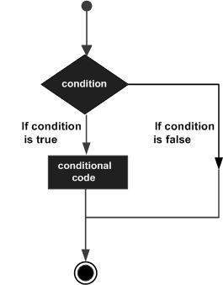
VB.Net provides the following types of decision making statements. Click the following links to check their details.
Statement | Description
If ... Then statement | An If...Then statement consists of a boolean expression followed by one or more statements.
If...Then...Else statement | An If...Then statement can be followed by an optional Else statement, which executes when the boolean expression is false.
nested If statements | You can use one If or Else if statement inside another If or Else if statement(s).
Select Case statement | A Select Case statement allows a variable to be tested for equality against a list of values.

VB.Net - Loops
There may be a situation when you need to execute a block of code several number of times. In general, statements are executed sequentially: The first statement in a function is executed first, followed by the second, and so on.
Programming languages provide various control structures that allow for more complicated execution paths.
A loop statement allows us to execute a statement or group of statements multiple times and following is the general form of a loop statement in most of the programming languages:
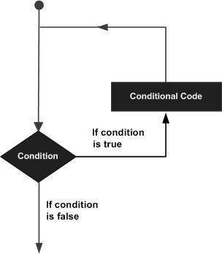
VB.Net provides following types of loops to handle looping requirements. Click the following links to check their details.
Loop Type | Description
Do Loop | It repeats the enclosed block of statements while a Boolean condition is True or until the condition becomes True. It could be terminated at any time with the Exit Do statement.
For...Next | It repeats a group of statements a specified number of times and a loop index counts the number of loop iterations as the loop executes.
For Each...Next | It repeats a group of statements for each element in a collection. This loop is used for accessing and manipulating all elements in an array or a VB.Net collection.
While... End While | It executes a series of statements as long as a given condition is True.

VB.Net - If...Then Statement
It is the simplest form of control statement, frequently used in decision making and changing the control flow of the program execution. Syntax for if-then statement is:
If condition Then
[Statement(s)]
End If
Where, condition is a Boolean or relational condition and Statement(s) is a simple or compound statement. Example of an If-Then statement is:
If (a <= 20) Then
c= c+1
End If
If the condition evaluates to true, then the block of code inside the If statement will be executed. If condition evaluates to false, then the first set of code after the end of the If statement (after the closing End If) will be executed.

Flow Diagram:
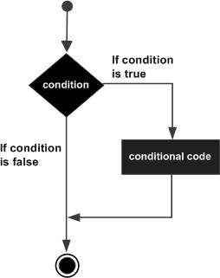

Example:
Module decisions
Sub Main()
'local variable definition
Dim a As Integer = 10

' check the boolean condition using if statement
If (a < 20) Then
' if condition is true then print the following
Console.WriteLine("a is less than 20")
End If
Console.WriteLine("value of a is : {0}", a)
Console.ReadLine()
End Sub
End Module
When the above code is compiled and executed, it produces the following result:
a is less than 20
value of a is : 10

VB.Net - If...Then...Else Statement
An If statement can be followed by an optional Else statement, which executes when the Boolean expression is false.

Syntax:
The syntax of an If...Then... Else statement in VB.Net is as follows:
If(boolean_expression)Then
'statement(s) will execute if the Boolean expression is true
Else
'statement(s) will execute if the Boolean expression is false
End If
If the Boolean expression evaluates to true, then the if block of code will be executed, otherwise else block of code will be executed.

Flow Diagram:
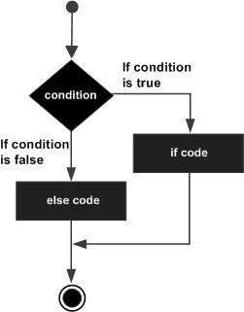

Example:
Module decisions
Sub Main()
'local variable definition '
Dim a As Integer = 100

' check the boolean condition using if statement
If (a < 20) Then
' if condition is true then print the following
Console.WriteLine("a is less than 20")
Else
' if condition is false then print the following
Console.WriteLine("a is not less than 20")
End If
Console.WriteLine("value of a is : {0}", a)
Console.ReadLine()
End Sub
End Module
When the above code is compiled and executed, it produces the following result:
a is not less than 20
value of a is : 100

The If...Else If...Else Statement
An If statement can be followed by an optional Else if...Else statement, which is very useful to test various conditions using single If...Else If statement.
When using If... Else If... Else statements, there are few points to keep in mind.
- An If can have zero or one Else's and it must come after an Else If's.
- An If can have zero to many Else If's and they must come before the Else.
- Once an Else if succeeds, none of the remaining Else If's or Else's will be tested.

Syntax:
The syntax of an if...else if...else statement in VB.Net is as follows:
If(boolean_expression 1)Then
' Executes when the boolean expression 1 is true
ElseIf( boolean_expression 2)Then
' Executes when the boolean expression 2 is true
ElseIf( boolean_expression 3)Then
' Executes when the boolean expression 3 is true
Else
' executes when the none of the above condition is true
End If

Example:
Module decisions
Sub Main()
Dim a As Integer = 100
If (a = 10) Then
Console.WriteLine("Value of a is 10")
ElseIf (a = 20) Then
Console.WriteLine("Value of a is 20")
ElseIf (a = 30) Then
Console.WriteLine("Value of a is 30")
Else
Console.WriteLine("None of the values is matching")
End If
Console.WriteLine("Exact value of a is: {0}", a)
Console.ReadLine()
End Sub
End Module
When the above code is compiled and executed, it produces the following result:
None of the values is matching
Exact value of a is: 100

VB.Net - Select Case Statement
A Select Case statement allows a variable to be tested for equality against a list of values. Each value is called a case, and the variable being switched on is checked for each select case.

Syntax:
The syntax for a Select Case statement in VB.Net is as follows:
Select [ Case ] expression
[ Case expressionlist
[ statements ] ]
[ Case Else
[ elsestatements ] ]
End Select
Where,
- expression: is an expression that must evaluate to any of the elementary data type in VB.Net, i.e., Boolean, Byte, Char, Date, Double, Decimal, Integer, Long, Object, SByte, Short, Single, String, UInteger, ULong, and UShort.
- expressionlist: List of expression clauses representing match values for expression. Multiple expression clauses are separated by commas.
- statements: statements following Case that run if the select expression matches any clause in expressionlist.
- elsestatements: statements following Case Else that run if the select expression does not match any clause in the expressionlist of any of the Case statements.

Flow Diagram:
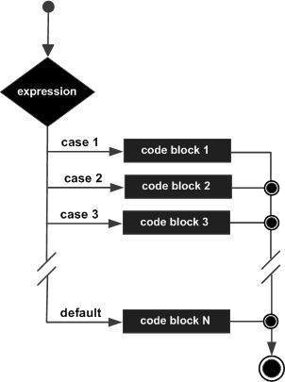

Example:
Module decisions
Sub Main()
'local variable definition
Dim grade As Char
grade = "B"
Select grade
Case "A"
Console.WriteLine("Excellent!")
Case "B", "C"
Console.WriteLine("Well done")
Case "D"
Console.WriteLine("You passed")
Case "F"
Console.WriteLine("Better try again")
Case Else
Console.WriteLine("Invalid grade")
End Select
Console.WriteLine("Your grade is {0}", grade)
Console.ReadLine()
End Sub
End Module
When the above code is compiled and executed, it produces the following result:
Well done
Your grade is B

VB.Net - Do Loop
It repeats the enclosed block of statements while a Boolean condition is True or until the condition becomes True. It could be terminated at any time with the Exit Do statement.
The syntax for this loop construct is:
Do { While | Until } condition
[ statements ]
[ Continue Do ]
[ statements ]
[ Exit Do ]
[ statements ]
Loop
-or-
Do
[ statements ]
[ Continue Do ]
[ statements ]
[ Exit Do ]
[ statements ]
Loop { While | Until } condition

Flow Diagram:
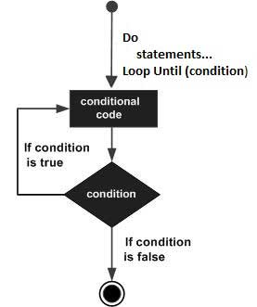

Example:
Module loops
Sub Main()
' local variable definition
Dim a As Integer = 10
'do loop execution
Do
Console.WriteLine("value of a: {0}", a)
a = a + 1
Loop While (a < 20)
Console.ReadLine()
End Sub
End Module
When the above code is compiled and executed, it produces the following result:
value of a: 10
value of a: 11
value of a: 12
value of a: 13
value of a: 14
value of a: 15
value of a: 16
value of a: 17
value of a: 18
value of a: 19
The program would behave in same way, if you use an Until statement, instead of While:
Module loops
Sub Main()
Dim a As Integer = 10
'do loop execution
Do
Console.WriteLine("value of a: {0}", a)
a = a + 1
Loop Until (a = 20)
Console.ReadLine()
End Sub
End Module
When the above code is compiled and executed, it produces the following result:
value of a: 10
value of a: 11
value of a: 12
value of a: 13
value of a: 14
value of a: 15
value of a: 16
value of a: 17
value of a: 18
value of a: 19

VB.Net - For...Next Loop
It repeats a group of statements a specified number of times and a loop index counts the number of loop iterations as the loop executes.
The syntax for this loop construct is:
For counter [ As datatype ] = start To end [ Step step ]
[ statements ]
[ Continue For ]
[ statements ]
[ Exit For ]
[ statements ]
Next [ counter ]

Flow Diagram:
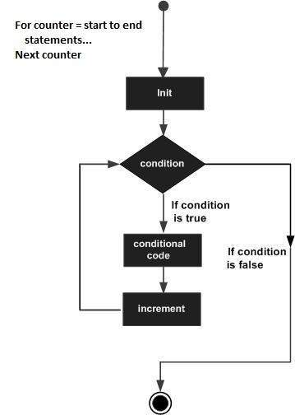

Example
Module loops
Sub Main()
Dim a As Byte
' for loop execution
For a = 10 To 20
Console.WriteLine("value of a: {0}", a)
Next
Console.ReadLine()
End Sub
End Module
When the above code is compiled and executed, it produces the following result:
value of a: 10
value of a: 11
value of a: 12
value of a: 13
value of a: 14
value of a: 15
value of a: 16
value of a: 17
value of a: 18
value of a: 19
value of a: 20
If you want to use a step size of 2, for example, you need to display only even numbers, between 10 and 20:
Module loops
Sub Main()
Dim a As Byte
' for loop execution
For a = 10 To 20 Step 2
Console.WriteLine("value of a: {0}", a)
Next
Console.ReadLine()
End Sub
End Module
When the above code is compiled and executed, it produces the following result:
value of a: 10
value of a: 12
value of a: 14
value of a: 16
value of a: 18
value of a: 20

VB.Net - While... End While Loop
It executes a series of statements as long as a given condition is True.
The syntax for this loop construct is:
While condition
[ statements ]
[ Continue While ]
[ statements ]
[ Exit While ]
[ statements ]
End While
Here, statement(s) may be a single statement or a block of statements. The condition may be any expression, and true is logical true. The loop iterates while the condition is true.
When the condition becomes false, program control passes to the line immediately following the loop.

Flow Diagram:
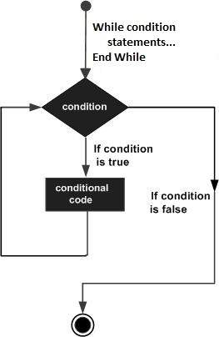
Here, key point of the While loop is that the loop might not ever run. When the condition is tested and the result is false, the loop body will be skipped and the first statement after the while loop will be executed.

Example 11
Module loops
Sub Main()
Dim a As Integer = 10
While a < 20
Console.WriteLine("value of a: {0}" & a)
a = a + 1
End While
Console.ReadLine()
End Sub
End Module
When the above code is compiled and executed, it produces the following result:
value of a: 10
value of a: 11
value of a: 12
value of a: 13
value of a: 14
value of a: 15
value of a: 16
value of a: 17
value of a: 18
value of a: 19

Q8 Chapter 10
A small café sells five types of items:
Bun $0.50
Coffee $1.20
Cake $1.50
Sandwich $2.10
Dessert $4.00
Write a program, which
- Input every item sold during the day
- Uses an item called “end” to finish the day’s input
- Adds up the daily amount taken for each type of item
- Outputs the total takings ( for all items added together ) at the end of the day
- Output the item that had the highest takings at the end of the day
VB program

Module Module1
Sub Main( )
Dim Tbun, Tcoffee, Tcake, Tsandwich, Tdessert, quantity, TotalTakings, HighestTaking As Integer = 0
Dim Item As String
while ( Item < > “end” )
Console.writeline ( “Enter the item in lower case only”)
Item = console.readline( )
Console.writeline ( “Enter its quantity”)
quantity = Int(console.readline( ))
Select Item
Case “bun”
Tbun = Tbun + quantity
Case “coffee”
Tcoffee = Tcoffee + quantity
Case “cake”
Tcake = Tcake + quantity
Case “sandwich”
Tsandwich = Tsandwich + quantity
Case “dessert”
Tdessert = Tdessert + quantity
Case Else
Console.writeline(“ Enter relevant product ”)
End Select
End While
TotalTakings = Tbun + Tcoffee + Tcake + Tsandwich + Tdessert
Console.writeline(“The total takings of the whole day” & TotalTakings)
If (Tbun > HighestTaking) Then
HighestTaking = Tbun
Item = “Bun”
ElseIf (Tcoffee > HighestTaking) Then
HighestTaking = Tcoffee
Item = “Coffee”
ElseIf ( Tcake > HighestTaking) Then
HighestTaking = Tcake
Item = “Cake”
ElseIf ( Tsandwich > HighestTaking) Then
HighestTaking = Tsandwich
Item = “Sandwich”
ElseIf (Tdessert > HighestTaking) Then
HighestTaking = Tdessert
Item = “Dessert”
End If
Console.writeline(“The item which has the highest sales today is : ” & Item)
Console.readkey( )
End Sub( )
End Module( )

Q7: A school is doing a check on the heights and weights of the students. The school has 1000 students. Write an Pseudocode and program in VB, which:
- Input height and weight of all 1000 students
- Output the average height and weight
- Include any necessary error traps for the input
Begin
TotalWeight =0
TotalHeight =0
For x= 1 to 1000
Repeat
Input height, weight
Until (height > 30) and (height < 80) and (weight > 30 ) and ( weight < 100)
TotalWeight = TotalWeight + weight
TotalHeight = TotalHeight + height
Next
AverageHeight = TotalHeight / 1000
AverageWeight = TotalWeight / 1000
Output “ Average height of the students is : ”, AverageHeight
Output “ Average weight of the students is : ”, AverageWeight
End

VB.Net - Arrays
An array stores a fixed-size sequential collection of elements of the same type. An array is used to store a collection of data, but it is often more useful to think of an array as a collection of variables of the same type.
All arrays consist of continuous memory locations. The lowest address corresponds to the first element and the highest address to the last element.
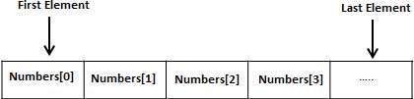

Creating Arrays in VB.Net
To declare an array in VB.Net, you use the Dim statement. For example,
Dim intData(30) As Integer ' an array of 31 elements
Dim strData(20) As String ' an array of 21 strings
You can also initialize the array elements while declaring the array. For example,
Dim intData() As Integer = {12, 16, 20, 24, 28, 32}
Dim names() As String = {"Karthik", "Sandhya", _
"Shivangi", "Ashwitha", "Somnath"}
The elements in an array can be stored and accessed by using the index of the array. The following program demonstrates this:

Module Module1
Sub Main()
Dim n(10) As Integer ' n is an array of 11 integers '
Dim i, j As Integer
For i = 0 To 10
n(i) = i + 100
Next i
' output each array element's value '
For j = 0 To 10
Console.WriteLine("Element({0}) = {1}", j, n(j))
Next j
Console.ReadKey()
End Sub
End Module
When the above code is compiled and executed, it produces the following result:
Element(0) = 100
Element(1) = 101
Element(2) = 102
Element(3) = 103
Element(4) = 104
Element(5) = 105
Element(6) = 106
Element(7) = 107
Element(8) = 108
Element(9) = 109
Element(10) = 110

