North Nazimabad Boys Campus
Topic= Binary Number System
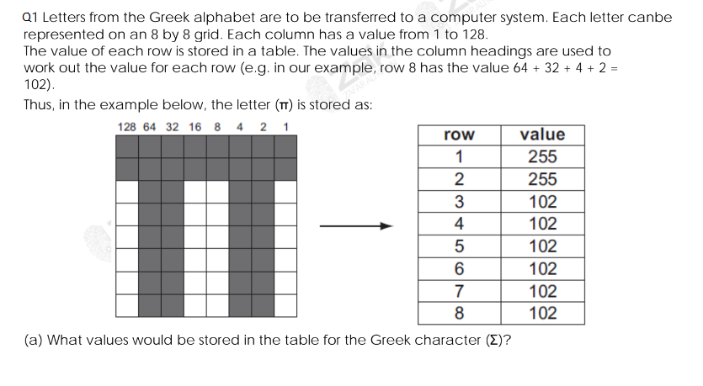
Teacher Name= Shumaila Ali Class = 9 Subject= Computer Science Date=9/2/2018

