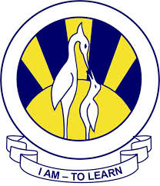
North Nazimabad Boys Campus
Subject = Computer Science Topic= Binary System and Hexadecimal
Level= 9 Date= 23/2/2018
