Teacher Name: Ms. Maira Arif Class: 10 Subject: Pak. Std. History Date: 14th Sept’18
Source A
- If, God forbidden, domination by infidels continues, Muslim will forget Islam and within a short time become such a nation that there will be nothing left to distinguish them from non-Muslims.’
Shah Waliullah expressing his fears to Afghan King, Ahmed ShahAbdali
- What does Source A tells us about the fears of ShahWaliullah? [3]
2. 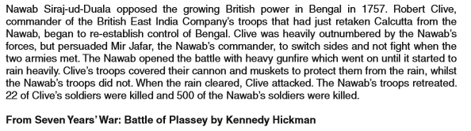
(a) According to Source A, what reasons are suggested for the British victory at the battle of Plassey in 1757? [3]
Source B
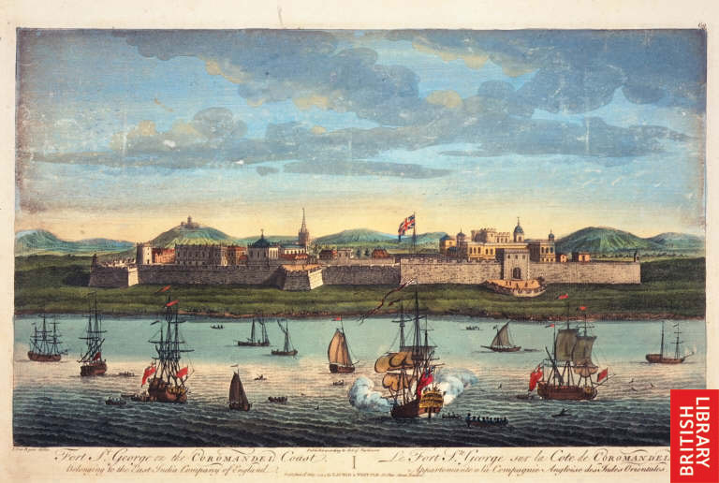
EIC Setup in India: Stronghold: Fort George, India's first English fortress, by Jan Van Ryne, 18th century
Q. What does the source tells us about the EIC in 18th century? [5]

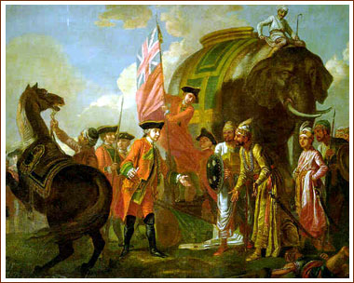
Robert Clive And Mir Jafar After The Battle Of Plassey 1757
Q. According to the Source B, what happened at the battle of Plassey? [5]

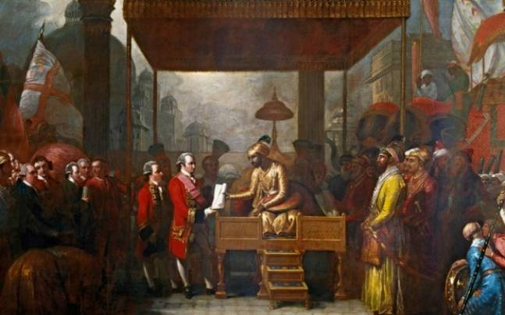
The Treaty of Allahabad was signed on August 12, 1765, and it was one of the turning point of Indian history
Q. According to Source B, What was the turning point of Indian History? [5]

