Teacher Name: Ms. Maira Arif Class: 9 Subject: Pak. Std. History Date: 14th Sept’18
Source B
Use the given example marking scheme to answer the question below
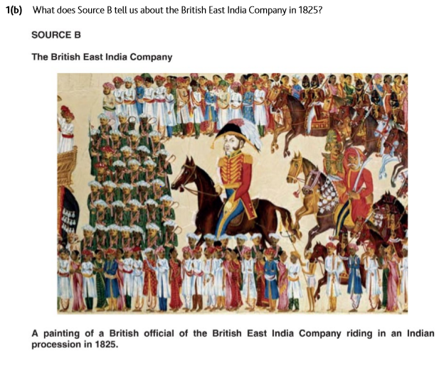
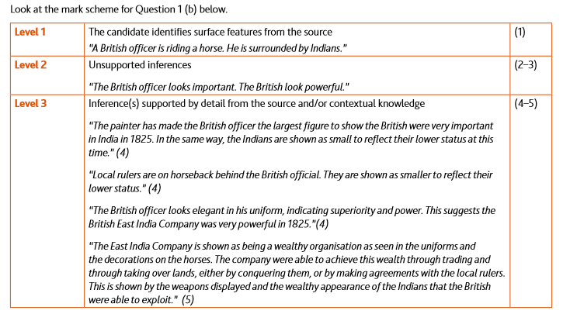
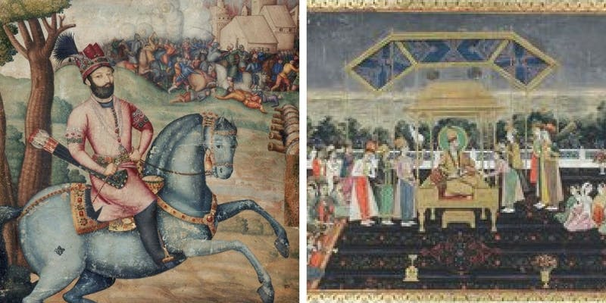
The invasion Persia (1738-39) Photo Source: Durand
Q. According to Source B, Who is challenging the Mughal Authority in 1738-39?

