Teacher Name: Shaheryar Khan Class: 9 Subject: Physics Date: 16, April, 2019

- Fig. shows the horizontal forces as a cyclist travels forwards.
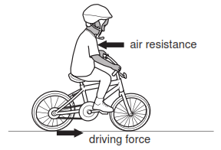
The cyclist produces the driving force that acts on the back wheel.
In this question, you may ignore any frictional force acting on the front wheel.
(a) The bicycle accelerates until a constant speed is reached.
(i) Describe how the size of the air resistance changes during this time.
(ii) Compare the sizes of the two horizontal forces when the bicycle is accelerating.
(b) The total mass of the bicycle and the cyclist is 75 kg. At one instant, the speed of the bicycle is 4.0 m / s, the driving force is 30 N and the air resistance is 20 N.
Calculate:
(i) The total kinetic energy of the bicycle and the cyclist,
(ii) The acceleration of the bicycle and the cyclist.
(c) As the bicycle moves, energy is transmitted from the pedals to the back wheel.

Fig. shows what happens to the energy input to the pedals.
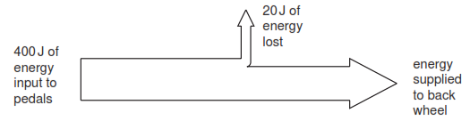
(i) As energy is transmitted to the back wheel, some is lost. Explain how this happens.
(ii) Calculate the efficiency of the bicycle in transmitting energy from the pedals to the back wheel.
(d) Some bicycles are made from low density materials. Explain why this is an advantage.

