Teacher Name: Shaheryar Khan Class: 9 Subject: Physics Date: 16, April, 2019

- Water at the top of a hot-water tank is heated and the water becomes hot. No water enters or leaves the tank.
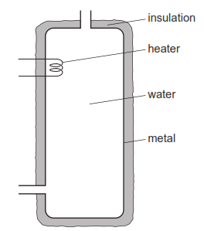
Water at the bottom of the tank stays cold for some time.
Why is this?
A Cold water at the top of the tank falls to the bottom.
B Hot water at the bottom of the tank rises to the top.
C Water is a poor conductor of heat.
D The insulation is a poor conductor of heat.

- Fig. shows a metal pan containing water on a cooker. The hotplate heats the water.
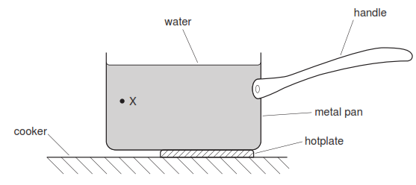
(a) (i) State the method of heat transfer through the metal pan.
............................................................................................................................. [1]
(ii) Describe how the molecules transfer heat through the metal pan.
..................................................................................................................................
..................................................................................................................................
.............................................................................................................................
(b) (i) On Fig. 2.1, draw an arrow to show the direction of movement of the water at point X.
(ii) Explain why the water moves in this direction.
..................................................................................................................................
..................................................................................................................................
..................................................................................................................................
..................................................................................................................................
..................................................................................................................................
.............................................................................................................................

- (a) No thermal energy (heat) is transferred from the surface of the Sun to the Earth by either conduction or convection.
Explain why this is so.
..........................................................................................................................................
..........................................................................................................................................
...................................................................................................................................... [2]
(b) In a certain country, the climate is very sunny and hot during the day and extremely cold during the night.
Explain how painting the houses white helps to maintain a comfortable temperature both during the day and during the night.
During the day: .................................................................................................................
..........................................................................................................................................
..........................................................................................................................................
During the night: ...............................................................................................................
..........................................................................................................................................
..........................................................................................................................................

