Teacher Name: Lubna Tanweer
Class: 11 Subject: Computer Science Date: 10th October 2019
Error Detection
Specimen paper 2015
2210_s15_qp21
2210_s15_qp22

2210_w15_qp22
2210_w15_qp23
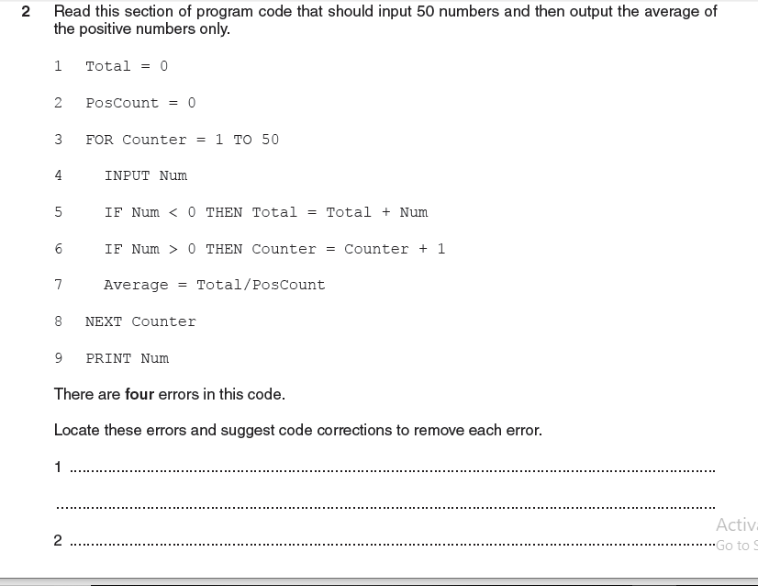

2210_s16_qp21
2210_s16_qp22
2210_w16_qp22
2210_w16_qp23

2210_s17_qp21
2210_s17_qp22

2210_w17_qp22
No question from Error Detection in this paper

2210_w17_qp23

2210_s18_qp21
No question from Error Detection in this paper

2210_s18_qp22
No question from Error Detection in this paper

2210_w18_qp22
No question from Error Detection in this paper

2210_w18_qp23

2210_s19_qp21
2210_s19_qp22
2210_w19_qp22
2210_w19_qp22

