NAME : _____________________________________ GRADE :
SUBJECT : BIOLOGY DATE : _________________
TOPIC : EXCRETION IN HUMANS AND HOMEOSTASIS
RESOURCE : PAST PAPERS
PAPER – I
- A patient has dye injected into the blood supply to his kidneys. The dye appears in his excretory system as shown.
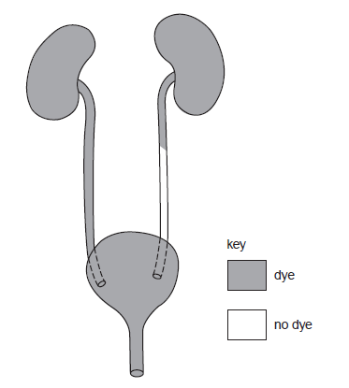
Which part is blocked?
A one kidney B one ureter C the bladder D the urethra
- In which organ is urea formed and through which tube does it leave the body?
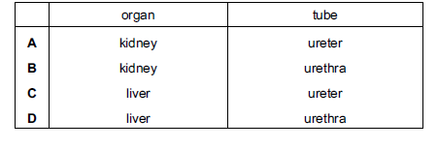
- Which substances are usually found in the urine of a healthy person?
A glucose and proteins C salts and water
B salts and amino acids D water and proteins

- During a long-distance race, the body temperature of an athlete begins to rise.
Which changes occur to help return the body temperature to normal?
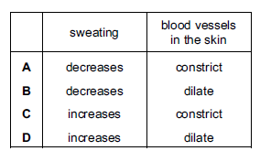
- The diagram shows structures associated with the human urinary system. Which structure is the urethra?
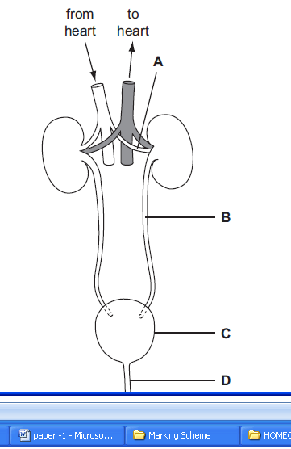

- How do sweat glands and blood vessels near the skin surface respond when body temperature rises above normal?
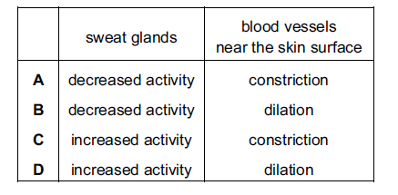

- A person has a high-protein diet.
What describes the level of urea in the blood leaving the liver and in the urine
leaving the kidneys?
