Food test 1 - Starch test
The brown Iodine solution reacts with starch and changes it to a blue-black color. This test helps you to find out if a food contains starch.
Process
- add Iodine solution to a solution or directly onto materials such as bread, potato, crackers...
- a BLUE-BLACK COLOR is a positive result: starch is present
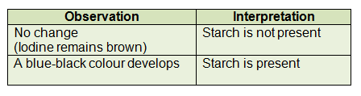
Explanation
Starch can be separated into two fractions- amylose and amylopectin.
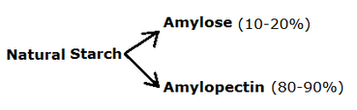
Amylose in starch is responsible for the formation of a deep blue color in the presence of iodine. The iodine molecule slips inside of the amylose coil to give a special color.

Food test 2 - Benedict's test for Reducing Sugars
All simple sugars (e.g.glucose) are reducing sugars. They will react with a blue liquid called Benedict's solution to give a brick red color. We can use this reaction to find out if a food or other substance contains a reducing sugar.

Process
- add a few drops of Benedict's solution
- heat the mixture for 2-3 minutes in boiling water bath
- a BRICK RED/ORANGE COLOR is a positive result: glucose is present
- The closer the color is to brick red, the more reducing sugar is present.

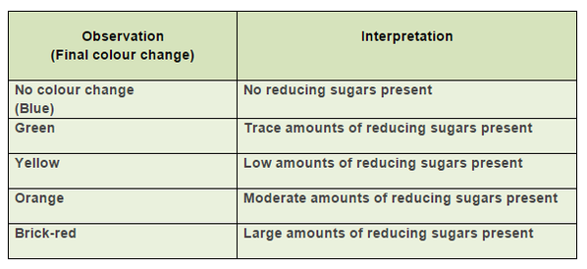
Explanation
- Reducing Sugars are sugars that contain aldehyde groups, that are oxidised to carboxylic acids (R-COOH).
- They are classified as reducing sugars since they reduce the blue Cu2+(copper II ions) to to Cu+ (copper I ions). These are precipitated in form of red Cu2O (copper oxide), insoluble in water.

Food test 3 - Emulsion (ethanol) test for Fats
This test is done to show the presence of lipids in a substance. The substance is first dissolved in ethanol. This solution is then dissolved in water. If lipids are present in the mixture, it will precipitates and forms an emulsion.

Process
- Add the food sample to 2 cm3 of ethanol, shake well.
- Allow to settle in a test tube rack for 2 minutes for food to dissolve in ethanol.
- Empty any clear liquid into a test tube containing 2 cm3 of distilled H2O.
- A MILKY-WHITE EMULSION is a positive result: lipid is present.
- If the mixture remains clear, there are no fats present in the sample
Explanation
- Lipids are insoluble in water and soluble in ethanol (an alcohol).
- After lipids have been dissolved in ethanol and then added to H2O, they will form tiny dispersed droplets in the water. This is called an emulsion.
- These droplets scatter light as it passes through the water so it appears white and cloudy.
Illustration

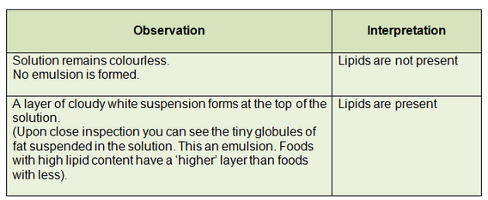

Food test 4 - Biuret test for Proteins
The Biuret Test is done to show the presence of peptide bonds, which are the basis for the formation of proteins. These bonds will make the blue Biuret reagent turn purple.
Process
- add an equal amount of NaOH to a solution of the food, mix carefully.
- add a few drops of 1% CuSO4, do not shake the mixture.
- a PURPLE/MAUVE COLOR is a positive result: protein is present.

Explanation
- The reagent used in the Biuret Test is a solution of copper sulfate (CuSO4) and sodium hydroxide (NaOH).
- The NaOH is there to raise the pH of the solution to alkaline levels; the crucial component is the copper II ion (Cu2+) from the CuSO4.
- When peptide bonds are present in this alkaline solution, the Cu2+ions will form a coordination complex with 4 nitrogen atoms from peptide bonds.
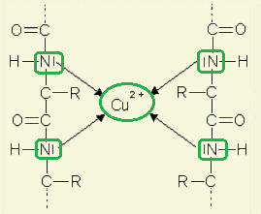
- The complex of Cu2+ ions and nitrogen atoms make the color of CuSO4 solution changes from blue to violet.
- This color change is dependent on the number of peptide bonds in the solution, so the more protein, the more intense the change.

