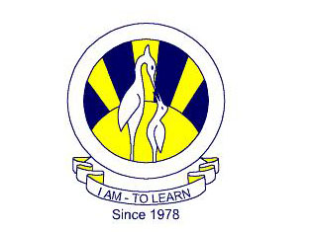
The City School
North Nazimabad Boys Branch
Grade 9 & 10
Pakistan Studies
Ms Aziza Wajahat
Date: 28-01-2017
Grade 9: Do pages 16-19 from the skills book
Class 10:
http://papers.xtremepapers.com/CIE/Cambridge%20International%20O%20Level/Pakistan%20Studies%20(2059)/2059_s13_qp_2.pdf
http://papers.xtremepapers.com/CIE/Cambridge%20International%20O%20Level/Pakistan%20Studies%20(2059)/2059_w13_qp_2.pdf
Do solve these papers of 2013.

