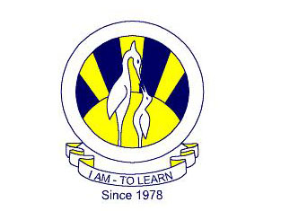
The City School
North Nazimabad Boys Branch
Geography
Date: 9th March 2018
Class 9
Ms Aziza Wajahat
Solve Q 3:
http://papers.xtremepapers.com/CIE/Cambridge%20International%20O%20Level/Pakistan%20Studies%20(2059)/2059_w14_qp_2.pdf

