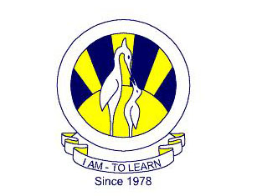
The City School
North Nazimabad Boys Branch
Pakistan Studies
Ms Aziza Wajahat
Date: 4-2-2017
Class: 9
Suject: Pakistan Studies
Skill book Page No 16 17

