The City School
North Nazimabad Boys Campus
Teacher Name: Aziza Wajahat Class: 9 Subject: Geography Worksheet 1
Q 1 Locate the Northern and the Western Mountains on the map.
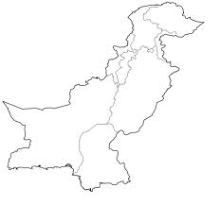

Q 2 Explain the importance of the Northern areas.
Q 3 Describe the journey of the river Indus.
Q 4 With reference to relief and drainage, explain how the Northern Mountains are different from Western Mountains.
Q 5 ‘If Baluchistan is developed, it can feed the whole of Pakistan.’ Give five reasons in favor or against this statement.

Teacher Name: Aziza Wajahat Class: 9 Subject: Geography Worksheet 2
Q1(a) The map, shows the locations of two weather stations, and their records of rainfall and mean monthly temperature.
- Compare the amount and seasonal distribution of rainfall at Quetta and Lahore.
- Give reasons for the differences in amount and seasonal distribution of rainfall at Quetta and Lahore.
(b) (i) Compare the mean monthly temperatures of Quetta and Lahore.
(ii) What are the benefits and problems for farmers in the area around Lahore which results from the rainfall?
(iii) Choose one of the problems from b(ii) and explain how it can be reduced.

