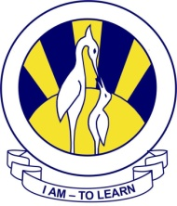
The City School
North Nazimabd Boys Campus
GEOGRAPHY
Date: 26-08-2016
Class: 9 & 10
Teacher: Ms Aziza Wajahat
Q Locate the following on the map of Pakistan.
- The tropic of Cancer, latitudes 30⁰N, 36⁰N, longitudes 64⁰E, 70⁰E and 76⁰E
- The Arabian Sea
- The countries sharing a border with Pakistan, and Pakistan’s position in relation to others in South and Central Asia.
- The provinces, Northern Areas ( Gilgit-Baltistan ) and FATA
- Named cities: Islamabad, Murree, Rawalpindi, Gujranwala, Lahore, Faisalabad, Multan, Sialkot, Peshawar, Chitral, Gilgit, Hyderabad, Karachi, Quetta and Gawadar.
- Landforms: Balochistan Plateau, Sulaiman Range, Safed Koh, Potwar Plateau, Salt Range, Hindu kush, Karakoram and Hamalaya mountain ranges
- Named rivers: Indus, Jehlum, Chenab, Ravi, Sutlej, Kabul, Hub and Dasht
- Named Deserts: Thar, Thal and Kharan

